Computer Science NEA – Great Escape:



*~ By Reuben Waysome*

Contents

Contents 2

Analysis: 4

1) Problem Identification 4

2) Stakeholders 7

3) Researching the Problem 9

6) Features of The Proposed Solution 16

7) Limitations 18

8) Requirements 19

Design: 23

1) Hierarchy Diagram 23

1) Game Feature Design 27

2) Usability Features 29

3) Algorithms 36

4) Variable Table 42

5) Files 43

6) Validation 44

7) Testing Milestones 45

8) Testing Milestones 51

Developing The Coded Solution: 52

1) Milestone 1 – Main Menu Interface 52

2) Milestone 2 – How To Play Interface 58

3) Milestone 3 – Level 62

4) Milestone 4 – Move Thief 66

5) Milestone 5 – Move Security Guard 71

6) Milestone 6 – Coins 76

7) Milestone 7 – Game Over Interface 80

8) Milestone 8 – Game Won Interface 84

9) Milestone 9 – Diamond & Dynamite Powerup 88

10) Milestone 10 – Clock 92

11) Milestone 11 – Game Completed Interface 102

Evaluation: 108

1) Post Development Testing – Function & Robustness 108

2) Usability Features & Testing 110

3) Evaluation of Success Criteria 114

4) Limitations & Improvements 122

References: 123

# Analysis:

# Problem Identification

Background:

Maze games have been around since the early 1970s and have been popular amongst children and adults alike with famous examples such as ‘Pac-Man’. Today, video games entertain millions of people and transcend age, culture, and gender. However, according to Valdellon (2023), the average game can barely retain 2.4% of users by day 30. This is due to reasons such as “unintuitive gameplay” and having a “confusing interface” (Kevuru Games, 2023).

As a result, I wish to create a game with a straightforward interface that requires users of all ages to use their problem-solving and strategic thinking skills to win, whilst being entertaining and engaging to maintain user retention.

The solution is a two-dimensional action maze chase game incorporating entertainment and strategic thinking. The theme of the game will revolve around ‘cops and robbers' with the thief being the character the user controls. Around the maze, are coins which the user will have to collect to unlock the door and progress to the next level. However, within each level, are a set number of security guards that are controlled by AI (Artificial Intelligence) that will chase the user. If the player comes in contact with a security guard, the game restarts from the current level.

Additionally, the player will have power-ups that the thief can collect to aid in level completion, these will spawn randomly at the start of every level. Collecting a diamond provides the player with an increase to the thief’s speed for a short duration whilst dynamite opens new paths in the maze.

The game has many features that are best represented using a software program making it ideal for a computer-based solution.

Problem Suitability:

This problem is amenable to a computational approach as there are several benefits that can be implemented using a computer which cannot be experienced with a human alternative:

**Complex Calculations:**

The solution will have a number of complex calculations that need to be executed in real-time. For example, the maze used to store the game objects can be represented using a 2D array. Each coordinate will correspond with an object to be presented. Retrieving the coordinates of objects requires an important level of accuracy that computer systems can perform with ease, in comparison to humans who would struggle to complete the task to the degree of accuracy and respond in real-time that the solution requires.

**Data Storage:**

The problem will also require the handling of large volumes of data as there will be a high score system based on the time it takes for a user to complete the level. A computer system is ideal for handling large volumes of data, as the time can be saved in a database and retrieved when the user runs the program again.

**Decomposition:**

The problem can be solved using decomposition as the problem can be broken down into smaller sub-problems that perform an individual task. For example, the maze the user plays on will be a sub-procedure where grid width and length will be specified. These subproblems will be worked on individually before being joined together to complete the original problem to save more time.

**Abstraction:**

The project will utilise Procedural Abstraction meaning parts of the code will be independent from the user interface and will simply return a value. For example, when the user moves the thief, the thief sprite is displayed in its new location without showing the details and procedures conducted to successfully move the character.

**Data Structures:**

The problem uses data structures within its solution. For example, coins can be stored in an array as when the coins are collected, they are enqueued to the array. Once the queue is full the player can progress through the door.

# Stakeholders

**The Client:**

The primary stakeholder is the client. The client is a 17-year-old girl who is a student in Sixth Form. She has put forth a request for this proposed solution as she would like a new single-player video game which is both entertaining and encourages them to act fast using strategic thinking and problem-solving skills.

This is because she finds herself losing interest in games which are not entertaining or challenging enough. The solution must also fit into her busy schedule so she can play during school breaks or when she is taking a break from revising. The client will utilise the game to entertain and test their strategic thinking and problem-solving skills. The game will account for their needs by making it difficult for the security guards to manoeuvre past whilst having a wide range of game mechanics which must be taken into consideration to beat the game.

**Their Involvement:**

The client will be involved in the project throughout its development and will suggest additional ideas for game mechanics that will ensure my success criteria are met.

She will also be involved in the iterative development of the game providing feedback at each milestone which will influence the development of my project. Finally, when the game is developed, the client will beta-test the solution and create a review on how well the solution has met the proposed criteria.

The project is also aimed at a broad range of ages from children to adults who vary in gaming skills from casual to competitive players…

**Casual Players:**

Another stakeholder is the casual players. Casual players are children aged 7-12, who enjoy engaging gameplay and desire a simple game with straightforward rules and controls. As they are children, they want a game that does not take a long time to complete due to their hectic schedule, which involves completing homework and getting to bed early. They will utilise this game to entertain them at the weekends or after school during the weekdays.

**Why is the solution appropriate to their needs?**

The game will account for their needs by having simplistic graphics, controls, and rules. The game will be broken down into levels that can be completed individually to ensure that it accounts for their busy schedule.

**Adults/Competitive Players:**

Adults and competitive players aged 14+ desire a more challenging experience and want a game that allows them to use their competitiveness. Adults and competitive players will use this game to challenge themselves and enhance their cognitive skills.

**Why the solution is appropriate to their needs?**

The game will account for their needs as the AI security guards act as a challenge preventing the user from completing the level with ease. Additionally introducing a high score system and increasing the difficulty of levels to allow for a rewarding experience for competitive players.

The testers will be chosen from each of the stakeholder groups. A child aged 11 will represent the casual player base and a student aged 17 will represent the competitive player base. Testers will provide feedback on the design of each feature as well as suggestions on what to improve. They will also ensure that each feature of the game is consistent with their requirements.

# Researching the Problem

Interview:

**Questions about project plans and outcome:**

1. From the proposed solution I have put forth, would you change anything?

Jacob (Child) – I like the theme of the game a lot, I think it is something that me and my friends will play.

Leroy (Adult) – I like the ideas of the game. Maze chase games are always appealing to a wide range of people encompassed with the theme of the game will make for an engaging experience. I would like it to be more challenging perhaps with the addition of a high score system.

1. What are your expectations for this project?

Jacob (Child) – I just want a game that I can play

Leroy (Adult) – I would like a functional game that is very challenging and has lots of replay ability.

**Questions about gameplay preference:**

1. Do you prioritise a challenging or fun experience in a game?

* Jacob (Child) – “I like games that are fun because even when I find them challenging if they are fun it encourages me to play more.”
* Leroy (Adult) – “Challenging games are more of a priority for me as fun games that lack a challenge will eventually become boring.”

1. Would you like the game to have a storyline or a more straightforward arcade-style gameplay?

* Jacob (Child) – “I think games with a simple theme are good so that I can create the story rather than it just be given to me.”
* Leroy (Adult) – “I prefer games that are more straight forward as games with a story line can be very slow to complete or there is less priority on the games functionality which ultimately makes the game less engaging.”

**Questions about users’ hardware:**

1. Which device do you play games on?

Jacob (Child) – “I play internet games on my laptop as I don’t really have much space to download game. If I do download a game, it will have little storage.”

Leroy (Adult) – “I play games on my desktop computer. I mostly play games that require a lot of storage, so I have built my setup around handling their requirements.”

Based on these responses:

* I understand how stakeholders feel about the proposal and their future expectations.
* I know greater information about the different stakeholders and their gameplay preferences – This will influence the development of my game.
* I know what the minimum hardware and software requirements are for my game that will satisfy all stakeholders.

Bomberman (NES):

Usability Interface

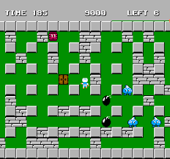

Bomb that is used to destroy walls

Door used to escape to next level

Chris Cullion. (2017). *THE COMPLETE HISTORY OF BOMBERMAN*. [Online]. TiredOldHack. Last Updated: February 2017. Available at: <https://tiredoldhack.com/2017/02/26/the-complete-history-of-bomberman/> [Accessed 13 November 2023].:

**Overview:**

Bomberman is a mazed-based action game where the player controls a character called Bomberman. The game has two modes, single-player, and battle mode.

The single-player mode has several levels which you must complete. In each level, there are enemies which can be defeated by placing bombs which detonate after a set duration and spread in a cross-shaped pattern. However, if the player is caught in the explosion radius the game is over. Bombs can also destroy walls that create new pathways and may uncover powerups which improve the bomb's capability, such as increasing its blast radius. To progress to the next level, the player must clear all the enemies and locate the exit. The exit is hidden by walls that can be uncovered using the bombs.

The battle mode is a two-player game mode where each player spawns at either side of the maze and the aim is to be the last man standing by blowing the other player up.

**Features that can be applied to my solution:**

Bomberman’s top-down 2D point of view will be added to my project. This is because this point of view is a straightforward way of presenting the maze and allows players to see what they are doing with ease. This will satisfy my target audience as it will be beneficial for causal players who may struggle to understand and navigate from a first-person point of view. The 2D point of view will also benefit competitive players and adults who will be able to see the whole maze and plan quick strategic actions which they enjoy.

I also intend to adopt features of the bomb game mechanic; I will use these features to create my own powerup called ‘dynamite.’ This is because breaking down walls to open new pathways means that users are not limited to the predetermined space which is allocated for them to play in. Power-ups can both benefit casual and competitive players as they make completing a level easier and trigger strategic thinking when used correctly for the best outcome.

**Features that I will avoid:**

Although there are similarities between my solution and Bomberman, my project will revolve more around avoidance rather than clearing obstacles and defeating enemies. Avoidance makes the game challenging because players know there is no feasible way to defeat the enemies, so they must tackle the game from a new perspective which will be fun for competitive players.

Pac-Man:

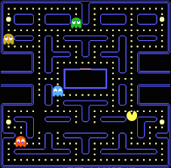

Ghost (Enemy)

Jennifer Rosenberg. (2020). Pac-man video game history and background. [Online]. ThoughtCo.. Last Updated: March 2020. Available at: <https://www.thoughtco.com/pac-man-game-1779412> [Accessed 13 November 2023].

**Overview:**

Pac-Man is a 2D classic arcade game where the goal is to move ‘Pac-Man’ around a maze to collect all the points whilst trying to avoid 4 ghosts that are released from a cage at the centre of the map. If the player comes in contact with the ghost, they lose one of their 3 lives and the game restarts. However, around the maze are 4 large circles which act as power-ups. Collecting these allows the player to encounter the ghosts and defeat them, returning them to their cage, instead of losing a life. The player moves to the next level once all the points in the maze are collected. The game ends when the player loses all their lives.

**Features that can be applied to my solution:**

The ghosts in Pac-Man are a constant threat and can prove difficult for even the most skilled players. As a result, I plan to adopt this feature for my project and implement my own enemies who provide a similar threat level, to satisfy competitive players and adults who want a more challenging experience.

Additionally in Pac-Man, the player must collect all the dots to progress to the next level. This feature will also be in my game with the core mechanic being the coins that will act in an equivalent way to the dots in Pac-Man. The coins will provide users with a primary objective that is both entertaining and challenging, which satisfies my target audience.

**Features that I will avoid:**

Pac-Man’s map does not change throughout the game, this feature may bore some users. My solution will have various levels each with its own unique map. Dynamic changes to the game will meet my target audience as they will not feel as though the game is repetitive.

Knights Quest:

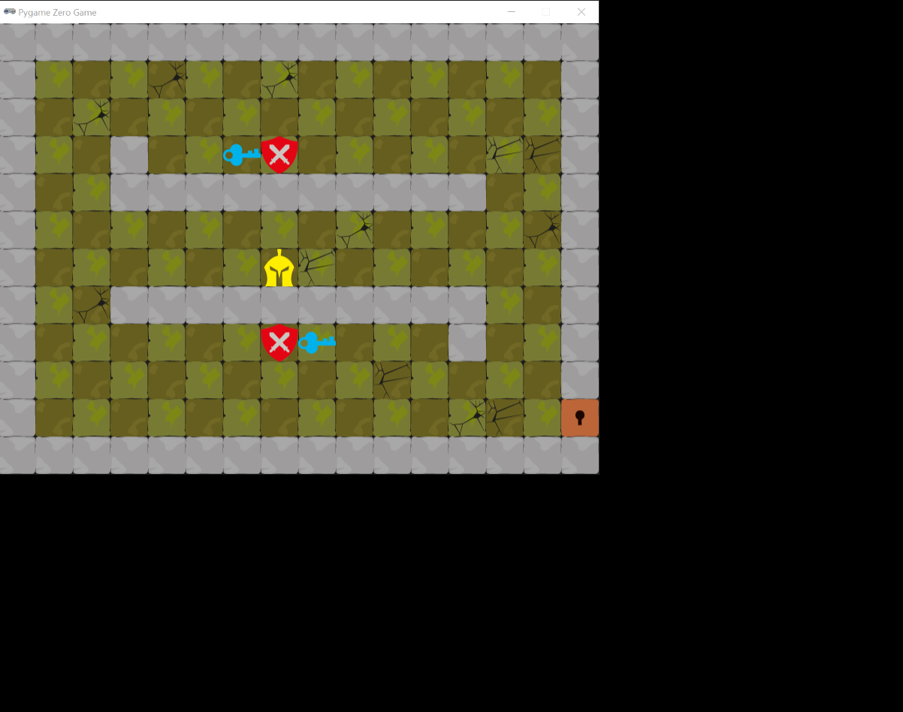

Player

Key that acts as win condition

Guard

Kate Russell. (2020). *Beginner's Step-By-Step Coding Course*. London: DK. pp.178-202.

**Overview:**

This game is a 2D maze game which requires strategic thinking and the ability to think fast. The objective is to navigate a knight around the maze collecting keys whilst evading guards that move towards the knight. If the Knight collides with the guards, the game ends. To win, the player must collect all the keys and reach the door.

**Features that can be applied to my solution:**

Knights Quest was developed using Pygame which means I can access their library called Blockly and use blocks of code of features that I want to use for my game.

I believe the key feature will be a good addition to my project as like the points feature in Pac-Man, both provide a primary objective for the end user, this can be added with other features such as enemies and powerups to create a fun and competitive game that satisfies my target audience.

**Features that I will avoid:**

A feature of this game that I will not be included is the One Level System. This game only has one level, this is far too simple for my solution. This may also mean that end users finish this game quickly and will not gain the satisfaction of a competitive game as the singular level may be too easy for some. My solution will have multiple levels which will increase difficulty by changing the number of security guards or the size of the maze to ensure that it satisfies the target audience requirements.

# Features of The Proposed Solution

**Maze:**

The game will be played in a 2D maze that contains the player (thief), the security guards, the powerups and coins. The size and intricacy of the map change depending on the level.

The 2D maze view is a prominent feature in both my research as it is a simple and effective way of presenting the maze to players. It allows them to easily see and understand the maze layout, making it particularly useful for casual players who may struggle with a first-person view.

Also, the 2D view provides competitive players and adults with an advantage, as they can quickly strategize and plan their actions by seeing the maze. Overall, the 2D maze view can satisfy the needs of all players, regardless of their preferences or skill levels.

**Single Player**:

The player will control the thief, collecting coins and power-ups whilst evading the security guards to progress to the next level.

Developing a single-player game keeps my client satisfied as the client requested that the game should be able to be played anytime, anywhere. Furthermore, single-player games allow for the introduction of a main character (Protagonist). A main character keeps the game engaging as they can identify with the character. This was demonstrated in both Pac-man and Bomber man who both use a main character throughout the game.

**Security Guards**

The security guards will adopt features from the ghosts in Pac-Man and the guards in Knights Quest. There will be a set number of security guards, within each level, that are controlled by AI that will chase the user. If the player comes in contact with a security guard, the game restarts from the current level.

The security guard feature will be added to the game to satisfy competitive players and adults who want a more challenging experience, whilst keeping it entertaining for casual players who may enjoy the thrill of being chased.

**Coins**:

Coins are scattered around the maze which the player will have to collect to unlock the door and progress to the next level. This is based on the points feature in Knights Quest which had a similar mechanic.

I have decided on this feature as it provides users with a primary objective that is both entertaining and challenging, which satisfies my target audience.

**Power-ups**:

Power-ups will spawn randomly throughout each level and will differ from dynamite and diamonds. Collecting a diamond provides the player with an increase to the thief’s speed for a short duration whilst dynamite opens new paths in the maze. The dynamite feature has been adopted from Bomber-Man and the diamond power-up is an adaptation of the power-up in Pac-Man.

I believe that power-ups will suit my solution as effective use of power-ups not only makes completing levels easier but also triggers strategic thinking, making them an essential tool for both casual and competitive players to beat the level.

**Levels**:

My solution will have 10 levels in total which the user will progress through by reaching to door and having collected all the coins in the current level. The maze in each level will change and increase in difficulty, some having more guards and coins to collect.

I have added levels to the solution as I believe that both my client and target audience will not find the game repetitive due to the dynamic changes. Since the levels increase in difficulty it meets competitive players' requirements as they want a game that is challenging. Also, a level system means that one level can be completed in a short space of time, which is ideal for my client who has asked for a solution that fits in with her busy schedule.

**Timer:**

A timer is displayed at the top of the screen when the user starts a level. The timer will keep track of how long it takes for the user to complete the level. This time will be saved and compared with previous completion times to determine whether it is a new high score.

I have implemented the timer as a scoring system as it meets the requirements of competitive players and adults. It also means that my client and other players will not become bored and unengaged with the game as they can attempt to complete the level again in a shorter time.

# Limitations

A limitation of my project is that there is no two-player mode. End users may want a game mode in my solution that enables them to play with their friends. Two player modes increase the popularity and lifespan of the game as it keeps users engaged for a prolonged period of time. However, I have chosen to only incorporate a single-player mode into my design as the client has specified a game that must fit around her tight schedule. Adding a two-player mode would be pointless because she might struggle to find someone to play with in her busy schedule. Moreover, a two-player feature is difficult to implement given that I am the sole programmer.

One limitation is that the game only features 2D character designs from a library, rather than highly detailed 3D models that can be created in Unity. 3D models may be more desirable for end users.

Another limitation is the level system. I aim to add 10 levels to the game which the user can play through. However, some users may desire more levels to play. But, adding more levels will require the use of complex algorithms that can generate mazes randomly on each level, which may be challenging to implement.

# Requirements

Hardware Requirements:

|  |  |  |
| --- | --- | --- |
| Component: | Requirement: | Justification: |
| CPU | Multicore processor (Dual Core Processor) | Having multiple cores means that the program can make use of parallel processing providing the necessary power for the software Python to run. |
| Speed | 1.5GHz or faster | Having a faster clock speed helps in the overall performance of the program. |
| Memory | Minimum 8GB RAM | This is the amount of RAM needed to process my program. It is important that end users meet this requirement as Python is a memory-intensive language, therefore it is vital that users have enough RAM to ensure that the program runs smoothly. |
| Free Hard Disk Drive (HDD) Space | 3GB | As the project is small it does not require a lot of space to be stored in main memory. |
| Keyboard | - | A keyboard is essential to my program as it is the way that users input commands to play the game. However, my game will only utilise WASD and ARROW keys |

Software Requirements:

My project uses Pygame, which is a Python module therefore end users will require:

|  |  |
| --- | --- |
| Requirement: | Justification: |
| 64 Bit Python 3.9 | This is the latest version of Python; users need the latest version of Python to ensure compatibility with the libraries I have used in my program. |
| Pygame Library | I will write the code for this solution using Pygame’s Library as it is the main library used when coding games in Python as it supports a range of inputs. It has additional key features such as cross platform, this means the program can be run on any operating system, which benefits the end user. |
| Operating System:  Windows: 64-bit Windows 7 or later  MAC: OS X 10.11 or later | These are the minimum requirements for the Operating Systems that support Python. |

Requirements Functionality:

|  |  |
| --- | --- |
| Requirement: | Explanation: |
| Menu | A menu will be presented at the start of the game, including simple icons to make it suitable for children. |
| Thief Movement | The thief’s movement will be directed using inputs from a keyboard. The thief’s character should be able to interact with items such as coins and power-ups. An algorithm should be put in place which prevents the user from moving out of the maze. |
| Security Guard AI movement | Security guards’ movement will be directed using algorithms. It is important that the algorithms work effectively to provide a challenge for users whilst remaining fun and enjoyable by not being too difficult. |
| Timer | A timer is needed as it will be the scoring system for the game. This has been included as it improves the games interest as players can repeat levels to strive for a better time completion. |

Success Criteria:

1. **Menu:**
2. Criterion – A menu with clear and distinct icons must be presented at the start of the game.
3. Justification – To maintain user retention, it is important to have an easy-to-navigate interface that won't confuse the target audience.
4. **How To Play:**
   * 1. Criterion – At the start of the game, the user must be informed on how to play. Information should include details about the aim of the game, how to move the thief character and power-ups.
     2. Justification – This will inform the target audience about how the game is played. User understanding is vital to the success of the game.
5. **Levels:**
6. Criterion – The solution should have 10 levels which the player can progress through.
7. Justification – Levels ensure that players receive a challenge and are given a sense of reward for completion. This improves the level of engagement and benefits competitive players.
8. **Maze:**
9. Criterion – The solution must include a unique Two-Dimensional maze layout for each level.
10. Justification – A maze requires players to use problem-solving and spatial awareness skills which create a challenging environment.
11. **Thief:**
12. Criterion – The user should move the Thief around the map using either WASD or Arrow keys. The Thief must move to the desired location as intended by the user.
13. Justification – This enables the user to interact with the game.
14. **Security Guard:**
15. Criterion – The security guard character should move towards the player and signal the end of the game upon contact.
16. Justification – Security guards that are controlled by AI provide a challenge to the player whilst making the game engaging as the player must consider the Security Guards before making decisions.
17. **Timer:**
18. Criterion – There should be a timer displayed at the top of the screen in every level which counts down how long it took to complete the level, this will act as the high score system.
19. Justification – Adding a timer allows the players to challenge themselves and beat their high score whilst improving player engagement as they play the game multiple times.
20. **Dynamite:**
21. Criterion – The power–up 'Dynamite' should randomly clear walls in the maze when interacted with by the player.
22. Justification – This power-up opens new pathways to play in so that users are not restricted to the confinement of the maze. This improves engagement and encourages the player to think strategically about when to use it.
23. **Diamond:**
24. Criterion – The power-up ‘Diamond’ should provide a boost to the character's speed for a short duration when interacted with by the player.
25. Justification – This powerup will be added to make the game balanced as it ensures that players have another option to beat a level.
26. **Level Won Display:**
27. Criterion – After the player has reached the exit after collecting all the coins there should be a display informing the player that they have won and that they can progress to the next level.
28. Justifications – Displays must be implemented to help with game understanding as they can be understood by any age.
29. **Level Loss Display:**
30. Criterion – If the player comes in contact with a security guard there should be a display informing the player that they have lost and will have to restart the level.
31. Justification – Displays must be implemented to help with game understanding as they can be understood by any age.
32. **End Game:**
33. Criterion – Once the player has completed all available levels available there should be a display informing the player that they have completed all levels but can go through all the levels again and attain a new high score.
34. Justification – Displays must be implemented to help with game understanding as they can be understood by any age.

# Design:

# Hierarchy Diagram

**Key:**

Orange – Game title

Yellow – Usability features

Blue – Game objects/features

Green – Methods/Attributes within objects

Explanation and justification of the process:

**Menu:**

When the user runs the program, they will be presented with a menu that will display the game title and two buttons, “Play” and “How to Play”. The menu is a crucial aspect of the game as it is the first thing that users see, ensuring that it is eye catching will maintain user retention for the rest of the game.

By identifying the menu as a distinct module, I can focus on designing an intuitive and visually appealing user interface that handles input for navigation.

**How To Play:**

On pressing the “How to Play” button, a display will debrief the user on the aim of the game and the controls.

The reason I have isolated the How to Play element of the game is so I can focus on delivering clear and simple instructions to help users learn and understand the game mechanics.

**Play:**

On pressing the “Play” button, the first level will begin. The play aspect of the solution is another important part as it will help me focus on the gameplay including levels, user input to control the Thief and overall game logic.

**Level:**

Each level will have a maze with a unique design as well as a single algorithm that houses a lot of global variables that other subroutines will use to help the level run as intended. The Level Component will help me design simple levels that gradually become more challenging, to trigger strategic thinking from the user.

**Maze:**

Similarly, the maze will contain all the items and characters. Having a Maze Component will allow me to focus on how items and characters interact with the maze.

**Clock:**

The clock is an important aspect of the game as it serves as the scoring system for my game. By using decomposition, I can focus on implementing the key processes the clock has. For instance, I can manage the implementation of a stopwatch that commences when a level is started and concludes when the level is completed. I can also manage how the separate recordings are saved on a Json file and how to display them when needed.

**Thief Movement:**

The Thief is the main character in the game and is controlled by the user by using the Arrow or WASD keys. Separating the Thief's movement into its own component allows me to focus on creating a responsive and engaging character control system. This includes handling input, implementing movement mechanics, and ensuring the Thief's behaviour aligns with the overall game design. For example, managing collisions.

**Security Guard Movement:**

The Security Guards Movement patterns are a key feature of the game, as they make the game challenging by moving toward the Thief and ending the game on contact. Designing and implementing the AI for Security Guards will be easier and more efficient if their movement is treated as a single component. This is because I can ensure that it is at the correct level of difficulty and that the AI works as intended.

**Diamond and Dynamite Powerup Mechanic:**

The Powerup Mechanics will detect when the user has come in contact with the power-up and apply the relevant effect. For example, the Dynamite Mechanic removes a percentage of the wall in the level and the Diamond Mechanic provides a temporary increase in speed to the Thief’s movement. Separating both Powerup Mechanics into single components will allow me to implement their features more easily.

**Coin Mechanic:**

The coin mechanic will be embedded into different subroutines but poses as an important feature of the game as it makes the game challenging. This is because all coins must be collected to progress to the next level. Similar to the Powerup Mechanics, treating it as a single module will help me implement its features more easily as I can manage the algorithm that detects when the Coin has been picked up by the Thief. Additionally, I can manage the algorithm that checks the player has collected all the coins before allowing them to progress to the next level.

**Move Thief:**

When the user presses either the Arrow keys or WASD it will move the Thief in the intended direction. It will do this by getting the current coordinates of the Thief and updating the coordinates by 1 in the desired direction.

This subroutine will allow the user to interact with the game's main character. Updating the Thief's position by 1 allows for precise control over movement.

**Move Guard:**

The Thief’s current coordinates are retrieved, and the Guards will attempt to move 1 coordinate closer to the Thief, unless they move onto a coordinate occupied by a wall. If the move takes them to a coordinate occupied by the Thief, the game will end.

A series of if statements will check where the Thief is in relation to the Guards position and ensure that the move.

**Coin Collision:**

When the Thief moves to a coordinate containing a Coin, the Coin will be removed from a list of keys to be collected and will stop being drawn on the screen. When there are no more Coin to be collected, the Thief will be allowed to move towards the door.

The subroutine detecting when the Thief has collided with a Coin and removing it from the screen helps with game understanding.

# Game Feature Design

Character Design:

Below are the character designs for the game, however the design for the items such as the Power-ups will be shown too. Each design has been carefully selected and reviewed with my client to ensure that the interface is kept simplistic.

**Thief:**

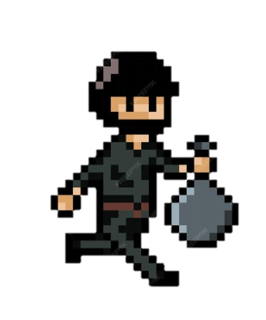

Thief Left

Thief Right

The Thief will change to one of these two sprites when the user moves left or right to give the illusion of movement.

* Thief Left will be shown when the user moves left (using the Left Arrow Key or A Key).
* Thief Right will be shown when the user moves right (Using the Right Arrow Key or D Key).

**Security Guard:**

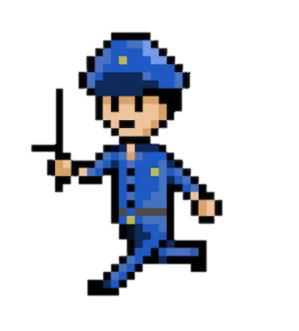

Security Guard Left

Security Guard Right

Similarly, to give the illusion of movement, the Security Guards will change to one of these two sprites when algorithm indicates to move left or right depending on the position of the Thief.

* Security Guard Left will be shown when the algorithm indicates to move left:

(guard_x -= 1)

* Security Guard Right will be shown when the algorithm indicates to move right:

(guard_x += 1).

Item Design:

The item sprite that is displayed in the Maze depends on what character is present at the given index within the 2D array.

**Coin Sprite:**



The Coin Sprite is displayed when Maze[x][y] == “C”

**Dynamite:**

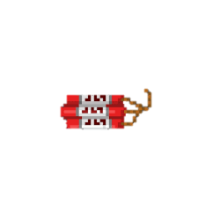

The Dynamite Sprite is displayed when Maze[x][y] == “B”

**Diamond:**



The Diamond Sprite is displayed when Maze[x][y] == “A”

# Usability Features

Level Design (Example):

Below is an example level with a simple interface designed to avoid confusing players. The layout shows the Maze followed by a black UI with the user's time at the bottom of the screen.

The design of this layout has been inspired by Bomberman, which also has a straightforward interface with a similar UI at the top.

The Maze in each level will consists of:

* A Thief
* A Diamond Power-up
* A Dynamite Power-up
* A specific number of guards and coins that vary depending on the level.

The Maze's light and dark grey theme is minimalist, keeping the interface simple. I have used abstraction when designing the walls and floor because they are not as important as the other features in the maze. Furthermore, they do not need to be designed in detail to be recognised by

the user.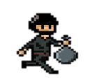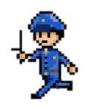

Walls

000.0

Black UI with users time

Dynamite Power-up

Door

Diamond Power-up

Coins

Security Guard

Thief

|  |  |  |
| --- | --- | --- |
| Feature Name: | Character Representation in Array: | Feature Image: |
| Thief | “T” |  |
| Security Guard | “S” |  |
| Coin | “C” |  |
| Diamond Power-up | “A” | Diamond | Pixel Worlds Wiki | Fandom |
| Dynamite Power-up | “B” | Premium Vector | Dynamite bomb in pixel style |
| Wall | “W” |  |
| Door | “D” |  |
| Floor | “ “ |  |

**Maze Index:**

I have created an index for the Maze that shows each maze feature, their image and the character representation in the 2D array.

Client Review:

I think the shapes and colours of the objects to be featured in the game are very clear and distinct, meaning that when I play the game, I won’t be confused which objects I’m interacting with.

Menu:

**Description:**

When the user runs the program, the Menu screen will be displayed. The Menu screen consists of the game title and two buttons (Play and How to Play). The menu screen enables the user to navigate through the menu options using a mouse.

* If the user clicks the Play Button will forward the user to Level 1 to play the game.
* If the user clicks the How to Play Button will display the How to Play Screen.

**Design:**

I have chosen the black background to accentuate the other features of the Menu. The game title “Great Escape” has a pink-to-turquoise gradient with the colour of two buttons matching the game title.

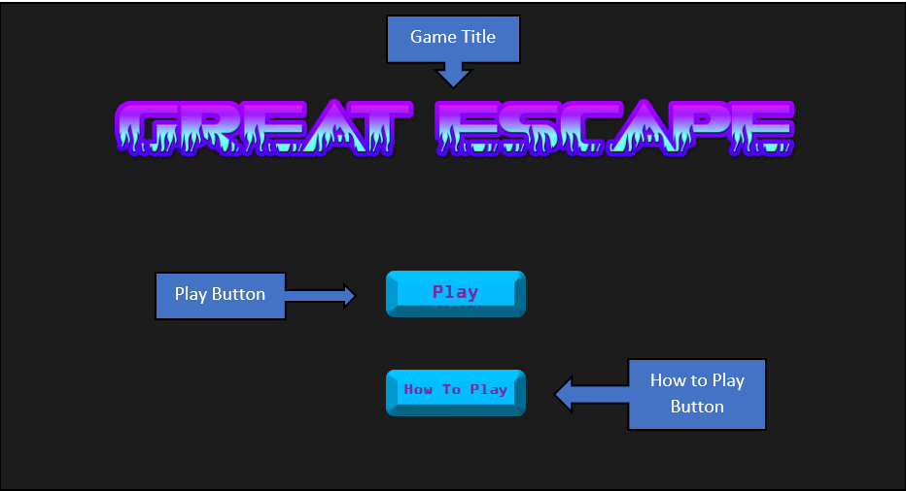

**Links to Success Criteria:** Success Criteria 1 emphasises that there should be “a menu with clear and distinct icons must be presented at the start of the game.” The buttons on the screen are clear and distinct as turquoise stands out on the black background.

How to Play Screen:

**Description:**

If the user clicks on the How to Play Button the How to play Screen will be displayed. At the top of the screen there will be information on aim of the game, below will be information about the controls and different Powerups.

The user will be notified that they can return to the Menu screen by pressing the spacebar once they have finished reading the information.

**Design:**

The black background with the white text is intended to make the text easier to read. The blue text adds variety to ensure the information is kept clear.

Information about the aim of the game

Move the thief around the maze and collect all the coins to unlock the door to the next level.

BE CAREFUL!

There are Security Guards scattered around the maze who will be chasing you.

If you are caught, the game is over…

Are You Ready?

Press “SPACE” To Return

Controls:

WASD or ARROW KEYS

Power-Ups (Once Per Game):

Dynamite – Destroys walls around the maze allowing you to move through places you couldn’t.

Diamond – Grants you a temporary speed boost.

Spacebar Prompt

Information on how to control the Thief

Power-up information

Power-up information

**Links to Criteria:** Success criteria 2 states that “at the start of the game, the user must be informed on how to play”. The screen above provides both information about the aim of the game, how to move the Thief and the different types of Power-ups.

Game Over Screen:

**Description:**

This screen will be displayed if the user has failed to beat the level. The condition for failing to beat a level is if the user has been caught by the Security Guard meaning the user and security Guard are on the same coordinate.

The screen will inform the user that they have been caught and that they can restart the level by pressing the spacebar.

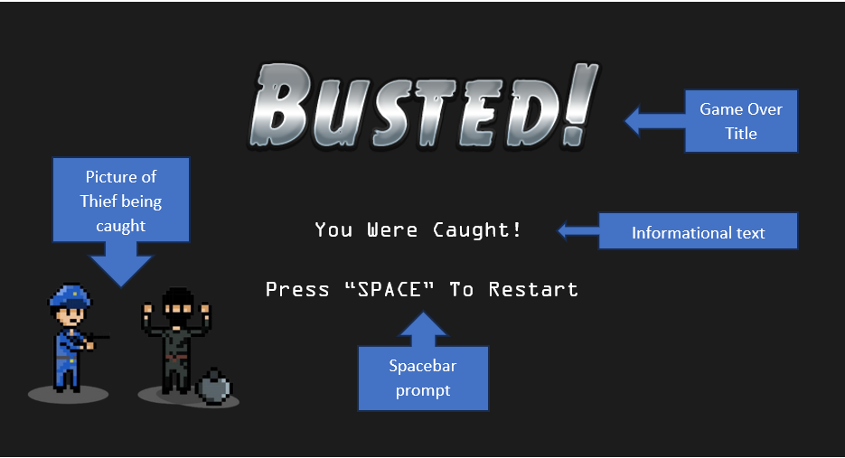

Press “SPACE” To Restart

You Were Caught!

**Links to Success Criteria:** As required by Success Criteria 11, “If the user comes in contact with a security guard there should be a display informing the user that they have lost and will have to restart the level”. In the screen above, the title and the text below notify the user in such a scenario.

Game Won Screen:

**Description:**

When the user has completed the level, this screen will be displayed. The condition for completing a level is when the user has collected all the coins in the level and reached the door without being caught the Security Guards.

The user will be notified on the screen that they have completed the level and shown the time taken to complete it. The time taken to complete the level will be retrieved from the Clock Function.

At the bottom of the screen, the user will be informed that they can progress to the next level by pressing the spacebar.

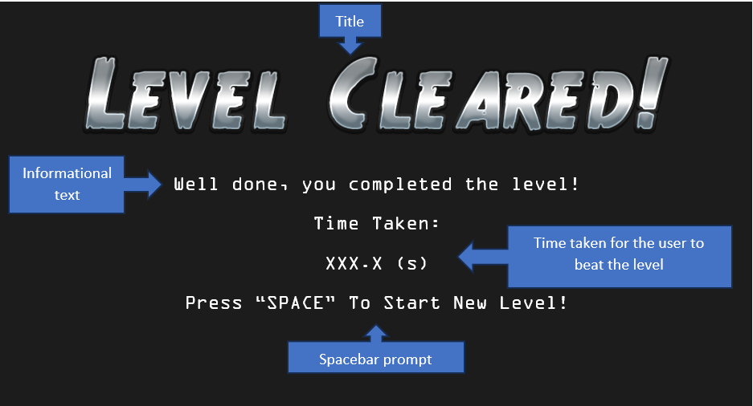

**Links to Success Criteria:** Success Criteria 10 states that “after the player has reached the exit after collecting all the coins, there should be a display informing the player that they have won and that they can progress to the next level”.

In the screen above, the title, the text, and the recorded time are provided so the user receives the relevant information to advance to the next level.

Game Completed Screen:

**Description:**

When the user has completed the final level, this screen will be displayed informing the user that they have beaten all the levels. Underneath, there will be a prompt advising them to press the spacebar to return to the Menu screen. The prompt also suggest that they should play again and attempt to beat their scores they set previously.

**Design:**

The large title in the middle of the screen and the picture of treasure have been added to provide the user with a sense of achievement, encouraging the user to play again.

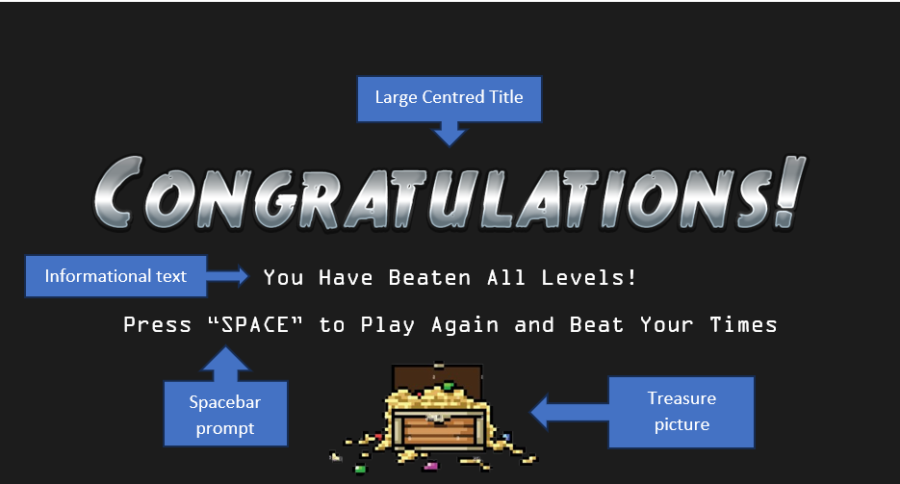

**Links to Success Criteria:** This screen meets Success Criteria 12 which states that “once the player has completed all available levels available, there should be a display informing the player that they have completed all levels.”

# Algorithms

Levels:

**Purpose: To create a level in the game**

FUNCTION level_1():

MAZE_HEIGHT = 7

Defines measurements of the MAZE

MAZE_WIDTH = 12

MAZE_SIZE = 50

Uses measurements of the MAZE to create the screen window. Special variables HEIGHT and WIDTH are used to create a window.

HEIGHT = MAZE_HEIGHT x MAZE_SIZE

WIDTH = MAZE_WIDTH x MAZE_SIZE

MAZE =[["W", "W", "W", "W", "W", "W", "W", "W", "W", "W", "W", "W",],

["W", "T", " ", " ", " ", " ", " ", " ", " ", " ", "C", "W",],

["W", " ", " ", " ", " ", " ", " ", " ", "A", " ", " ", "W",],

["W", " ", "W", "W", "W", "C", "W", "W", "W", "W", " ", "W",],

["W", " ", " ", "C", " ", " ", " ", " ", " ", " ", " ", "D",],

["W", " ", " ", " ", " ", "S", " ", " ", " ", "B", " ", "W",],

["W", "W", "W", "W", "W", "W", "W", "W", "W", "W", "W", "W",],]

2D Array that represents the Maze

This Function is an example of a level being created in the game. It is important and contributes to the overall solution as it defines global variables such as MAZE_HEIGHT that will be used throughout the level in different Subroutines. It also defines key variables that Pygame uses to create the game window.

Additionally, The Function uses a 2D array to represent the maze. Each array represents a row, and the length of the array determines the size of the maze, which can vary based on the level.

Each item within an array represents a coordinate and different characters are used to represent various features within the maze.

**Links to Success Criteria:**

* Criteria 3: Success Criteria 3 states that “the solution should have 10 levels which the player can progress through”. This function serves as a blueprint for the creation of the other levels to be added to the game.
* Criteria 4: As required by Criteria 4, the solution must include a unique Two-Dimensional maze layout for each level. Using a 2D Array will enable a 2D layout of the maze as each character represents a coordinate.

Thief:

**Purpose: To move Thief Character**

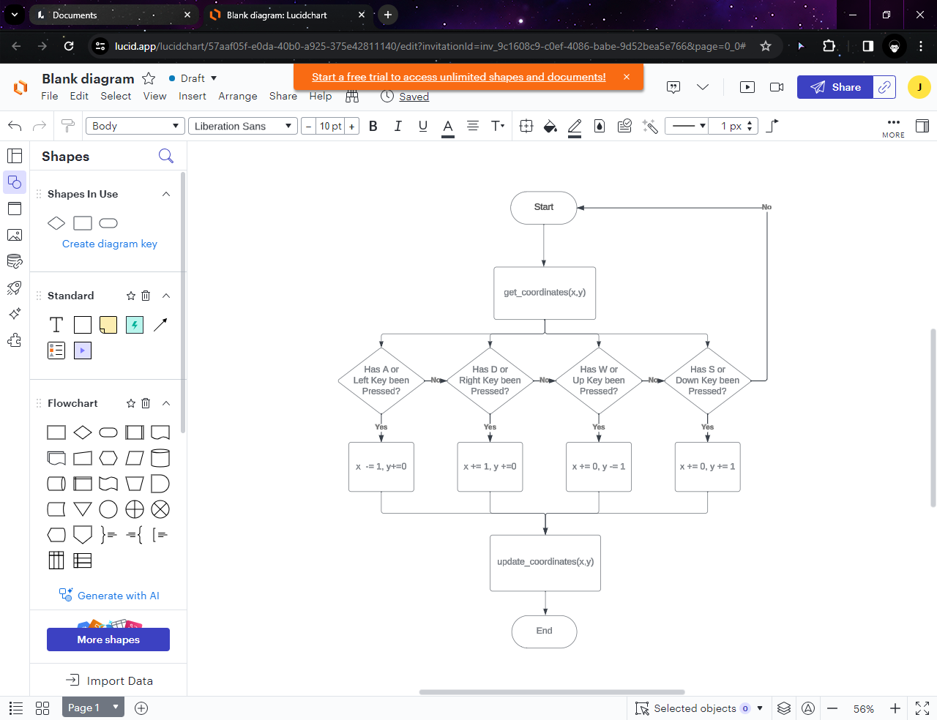

FUNCTION move_thief(key):

Gets current coordinates of Thief

  (x,y) = get_coordinates(thief)

IF key == keys.LEFT or key == keys.A:

x -= 1

y += 0

updates_coordinates(x,y)

endif

Uses IF conditions to check if that key has been pressed.

IF key == keys.RIGHT or key == keys.D:

x += 1

y + = 0

update_coordinates(x,y)

endif

IF key == keys.UP or key == keys.W:

x += 0

y += -1

update_coordinates(x,y)

endif

IF key == keys.DOWN or key == key.S:

y += 0

x += 1

update_coordinates(x,y)

endif

This function is a method in the Class Thief. The purpose of this algorithm is to receive an input of either the ARROW or WASD keys and make the appropriate change to the Thief’s position. At the end of every IF condition, the update_coordinates() function is called with the changed coordinates.

**Links To Criteria:** As required by Criteria 5, The user should move the Thief around the map using either WASD or Arrow keys. The Thief must move to the desired location as intended by the user. This algorithm allows the user to direct the thief whilst ensuring that it is interacting with the other items accordingly.

Diamond Power Up:

**Purpose:** To apply Diamond Powerup effect the Thief

PROCEDURE apply_diamond_powerup():

(x,y) = get_coordinates(thief)

seconds = 5

IF maze[x][y] == “1”:

WHILE seconds > 0:

thief_Speed = 1

time.sleep(1)

seconds -= 1

endwhile

endif

This function is a method in the Class Diamond. This algorithm is suitable for applying the diamond powerup effect as it checks the coordinates of the Thief and uses an IF condition to check if they are on the same coordinate as the Diamond Powerup. If the Thief and Diamond are on the same coordinate, the user will be granted a temporary increase in speed.

To do this a variable called seconds indicates the duration of the powerups effect. A WHILE loop checks that the seconds variable is greater than 0. Inside the WHILE loop, the thief’s speed is increased then time.sleep().

amount to increase the speed by and the duration of this effect are yet to be confirmed.

**Links To Criteria:** Success Criteria 9 states that the Diamond Powerupshould provide a boost to the character's speed for a short duration when interacted with by the player.

Security Guards:

**Purpose**: To move the Security Guard closer towards the Thief and check if the security Guard has collided with Thief.

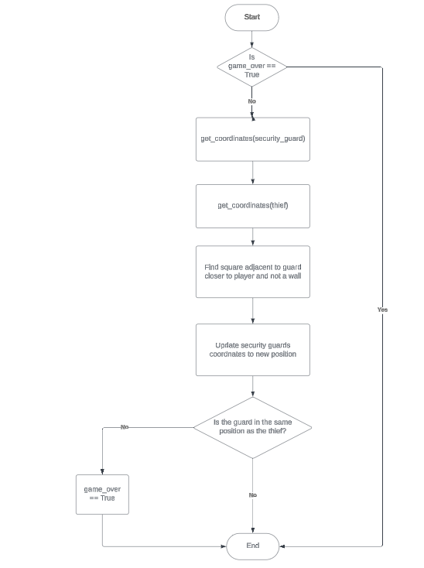

FUNCTION move_guard(guard):

global game_over

IF game_over == True:

return

(thief_x, thief_y) = get_coordinates(thief)

(guard_x, guard_y) = get_coordiantes(guard)

IF thief_x > guard_x and MAZE[guard_y][guard_x + 1] != "W":

guard_x += 1

ELIF thief_x < guard_x and MAZE[guard_y][guard_x - 1] != "W":

guard_x -= 1

ELIF thief > guard_y and MAZE[guard_y + 1][guard_x] != "W":

guard_y += 1

ELIF thief_y < guard_y and MAZE[guard_y - 1][guard_x] != "W":

guard_y -= 1

animate(guard, pos = screen_coords(guard_x, guard_y), duration = GUARD_MOVE_INTERVAL)

IF guard_x == thief_x and guard_y == thief_y:

game_over = True

This algorithm retrieves the coordinates of both the Thief and Security Guards, and updates the security guards' position to move one coordinate closer towards the player. It takes into account the walls around the maze and ensures that the guards do not pass through them. The algorithm also checks if the player and security guard are on the same coordinate. If they are, the game ends.

**Links to Success Criteria:** This algorithm satisfies Criteria 7 which states that the security guard character should move towards the player and signal the end of the game upon contact.

# Variable Table

|  |  |  |
| --- | --- | --- |
| Variable: | Data Type: | Justification: |
| HEIGHT, WIDTH | Integer | These are special variables in Pygame zero that sets the height and width of the screen window.  As the height and width of a window is a measurement, the variable’s data type will be integer. Real will not be used to prevent rounding errors. |
| game_over, game_won | Boolean | game_over and game_won are both set to False each time a level is started.  If the Thief reaches the Door with all the coins game_won will be set to True. This will then trigger the  If the Thief is on the same coordinate the Security Guard is on, game_over will be set to True. |
| game_completed | Boolean | game_completed will be set to False when the program is run.  As Boolean has two states, game-completed will be set to True to indicate that all the levels have been completed. |
| level | Integer | level will indicate what level is being currently played so that the correct MAZE is drawn on screen.  As the user progresses through levels, the level variable will be incremented. |
| thief_x, guard_x | Integer | thief_x stores the column the Thief is in and guard_x stores the column the Security Guard is in. A whole number is used to represent the column which is why Integer is the appropriate data type. |
| thief_y, guard_y | Integer | thief_y stores the row the Thief is in and guard_y stores the row the Security Guard is in. A whole number is used to represent the row which is why Integer is the appropriate data type. |

# Files

|  |  |
| --- | --- |
| “Level1.txt” | |
| 50  35  68  43  70 | Each file will store how much time users took to complete the level which each line being a different ‘score’.  When the user wants to view the high scores for the current level. The file associated with the level will be opened and read line by line.  The values will be added to an array where a sort algorithm will be applied so the user sees the scores in ascending order. |

# Validation

The two main inputs for the game are the buttons on the main menu interface and the keyboard inputs to move the Thief.

**Buttons:**

The buttons need to be validated as it is important that any mouse click does not lead to the button being pressed; the button must only be pressed if the mouse is hovering over the button.

To check this, the mouse click will be checked to ensure it is within the boundaries of the button.

**Keyboard Inputs:**

The keyboard inputs for player movement need to be validated to ensure an input doesn’t result in the Thief moving off the screen.

To prevent this the maze is surrounded by walls and the keyboard inputs will be validated by ensuring that the new coordinates are not ones where a wall is located. If the coordinates contain a wall, then the Thief’s position will not be updated.

# Testing Milestones

Here are milestones that will be referred to when coding the solution to ensure it has met the standards of the success criteria. Each milestone has its own testing conditions which will be checked and evidenced during the iterative development.

Milestones:

1. Main Menu Interface
2. How To Play Interface
3. Levels
4. Move Thief
5. Move Security Guards
6. Coins
7. Game Over Interface
8. Game Won Interface
9. Diamond Powerup & Dynamite Powerup
10. Clock
11. Game Completed Interface

|  |  |  |
| --- | --- | --- |
| **Milestone 1 – Main Menu Interface:** | | |
| Test Number: | What is being tested: | Expected Output: |
| 1 | The game title is shown on the screen. | The game title is displayed in the centre at the top of the screen. |
| 2 | The play button is shown on the screen. | The play button is displayed in the middle of the screen. |
| 3 | The how-to-play button is shown on the screen. | The how-to-play button is displayed in the middle of the screen below the play button. |
| 4 | The how-to-play button triggers the how-to-play screen to be displayed. | The how-to-play button opens the how-to-play window. |
| 5 | The play button triggers the first level to begin. | The play button opens the level 1 game window. |
| **Milestone 2 – How to Play Interface:** | | |
| Test Number: | What is being tested: | Expected Output: |
| 1 | Text informing the user on how to play is shown on the screen. | Text informing the user on how to play is displayed in the centre at the top of the screen. |
| 2 | The user can press the spacebar to return to the main menu interface. | The spacebar opens the main menu window. |

|  |  |  |
| --- | --- | --- |
| **Milestone 3 – Levels:** | | |
| Test Number: | What is being tested: | Expected Output: |
| 1 | The maze is displayed on screen. | The maze is drawn on screen with all the features in the correct place. It should also allow space for the clock (Black UI). |

|  |  |  |
| --- | --- | --- |
| **Milestone 4 – Move Thief:** | | |
| Test Number: | What is being tested: | Expected Output: |
| 1 | The thief spawns on screen. | The Thief actor appears on the screen in concordance with its position in the 2D array (This will vary depending on the level). |
| 2 | The user can move the thief:   * Left with A or Left arrow key * Right with D or Right arrow key * Up with W or Up arrow key * Down with S or Down arrow key | The thief image can move left, right, and down at a fair speed, but cannot leave the screen. |
| 3 | The thief actor changes appearance when it moves left or right. | The thief actor changes appearance when the user inputs left or right. |

|  |  |  |
| --- | --- | --- |
| **Milestone 5 – Move Security Guards:** | | |
| Test Number: | What is being tested: | Expected Output: |
| 1 | The security guards spawn on screen. | All the security guards spawn on the screen in concordance with their position in the 2D (This will vary depending on the level). |
| 2 | The security guards move one step closer towards the thief each time the thief moves. | All the security guards move one coordinate closer towards the thief each time the thief moves. The security guards will not go off-screen. |
| 3 | The game ends when the security guard touches the thief. | The user can no longer move the thief when a security guard is on the same coordinate as the thief. |
| 4 | The security guard actors change appearance when they move left or right. | The security guard actors change their appearance when they move left or right towards the thief. |

|  |  |  |
| --- | --- | --- |
| **Milestone 6 – Coins:** | | |
| Test Number: | What is being tested: | Expected Output: |
| 1 | The coins spawn on screen. | All the coins spawn on the screen in concordance with their position in the 2D (This will vary depending on the level). |
| 2 | The coins disappear when the thief touches them. | A coin is removed from the screen when the thief is on the same coordinate. |
| 3 | The door disappears and the user can leave the level when the user has collected all the coins. | The door is removed from the screen and the user can progress to the next level when all the coins are in the array. |

|  |  |  |
| --- | --- | --- |
| **Milestone 7 – Game Over Interface:** | | |
| Test Number: | What is being tested: | Expected Output: |
| 1 | The game over title is shown | The game over title is displayed in the centre at the top of the screen. |
| 2 | Text informing the user that the game is over is shown on the screen. | Text informing the user that the game is over is displayed in the centre of the screen. |
| 3 | The user can press the spacebar to play again. | The spacebar triggers the level to be reset and displayed again. |
| 4 | The picture of the thief being caught is shown | The picture of the thief being caught is displayed to the left of the screen. |

|  |  |  |
| --- | --- | --- |
| **Milestone 8 – Game Won Interface:** | | |
| Test Number: | What is being tested: | Expected Output: |
| 1 | The game won title is displayed | The game won title is displayed in the centre at the top of the screen. |
| 2 | Text informing the user that they have beaten the level is shown on the screen. | Text informing the user that they have beaten the level is displayed in the centre of the screen. |
| 3 | Text displaying the time it took for the user to complete the level is shown on the screen. | Text displaying the time it took for the user to complete the level (rounded to 1 decimal place) is displayed in the centre of the screen. |
| 4 | The user can press the spacebar to advance to the next level again. | The spacebar triggers the new level to be displayed. |

|  |  |  |
| --- | --- | --- |
| **Milestone 9 – Diamond & Dynamite Powerup:** | | |
| Test Number: | What is being tested: | Expected Output: |
| 1 | The diamond powerup spawns on the screen. | The diamond powerup is displayed on the screen in concordance with its position in the 2D (This will vary depending on the level). |
| 2 | The dynamite powerup spawns on the screen. | The dynamite powerup is displayed on the screen in concordance with its position in the 2D (This will vary depending on the level). |
| 3 | The diamond powerup increases the speed of the thief temporarily. | The diamond powerup increases the speed of the thief for 5 seconds (yet to be confirmed). |
| 4 | The dynamite powerup destroys a number of walls within the level. | The dynamite powerup randomly removes 25% of the walls in the maze (yet to be confirmed).  Ensuring that no walls that prevent the thief from going off the screen are removed. |
| 5 | The diamond powerup disappears when the thief touches it. | The diamond powerup is removed from the screen when the thief is on the same coordinate. |
| 6 | The dynamite powerup disappears when the thief touches it. | The dynamite powerup is removed from the screen when the thief is on the same coordinate. |

|  |  |  |
| --- | --- | --- |
| **Milestone 10 – Clock:** | | |
| Test Number: | What is being tested: | Expected Output: |
| 1 | The black UI is shown with the user's time. | The black UI with a clock at the centre is displayed at the top of the screen. The clock starts as soon as the user starts the level. |
| 2 | The clock starts as soon as the user starts the level. | The clock begins counting up in seconds when the user starts the level. |
| 3 | The user's time is recorded as soon as they finish the level. | When the user finishes a level, the clock stops, and the user's time is saved to the file associated with the level. |

|  |  |  |
| --- | --- | --- |
| **Milestone 11 – Game Completed Interface:** | | |
| Test Number: | What is being tested: | Expected Output: |
| 1 | The game completed title is shown | The game completed title is displayed in the centre at the top of the screen. |
| 2 | Text informing the user that they have beaten all the levels is shown on the screen. | Text informing the user that they have beaten all the levels in the centre of the screen. |
| 3 | The user can press the spacebar to return to the main menu. | The spacebar triggers the main menu to be displayed again. |
| 4 | The picture of treasure is shown | The picture of treasure is displayed at the bottom of the screen. |

# Testing Milestones

In the post-development stage, beta testing will be used. This is where the solution will be available to a small sample that represents the target audience, here they will be able to uncover any bugs and provide feedback on the game.

Beta testing is necessary as during the development of the game, manual testing will be conducted. There is a risk that I will become too familiar with the game and therefore cannot spot bugs easily and test things such as game difficulty.

# Developing The Coded Solution:

# Milestone 1 – Main Menu Interface

**Code written to achieve milestone:**

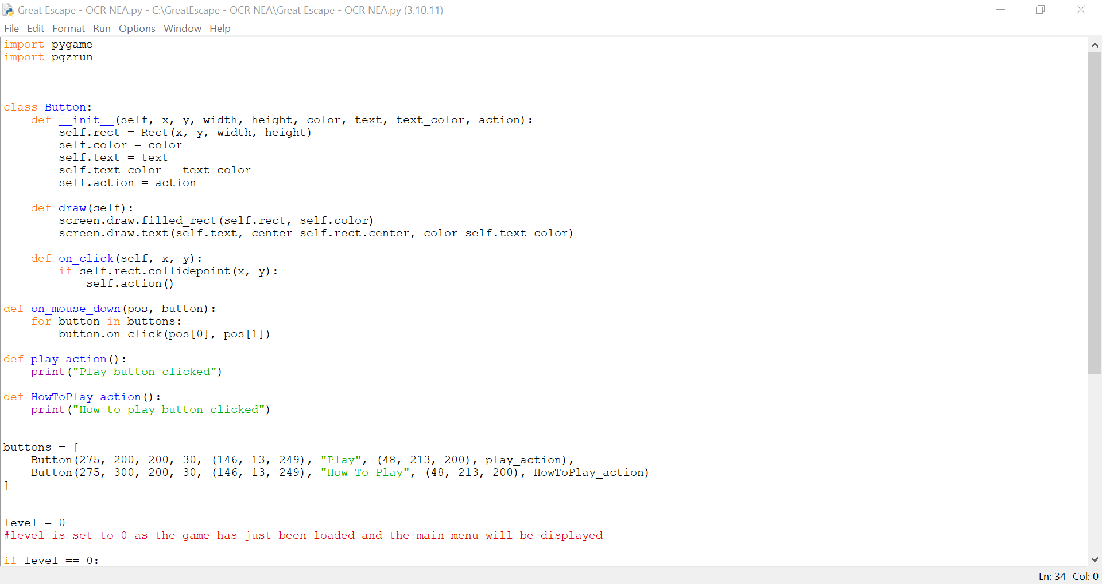

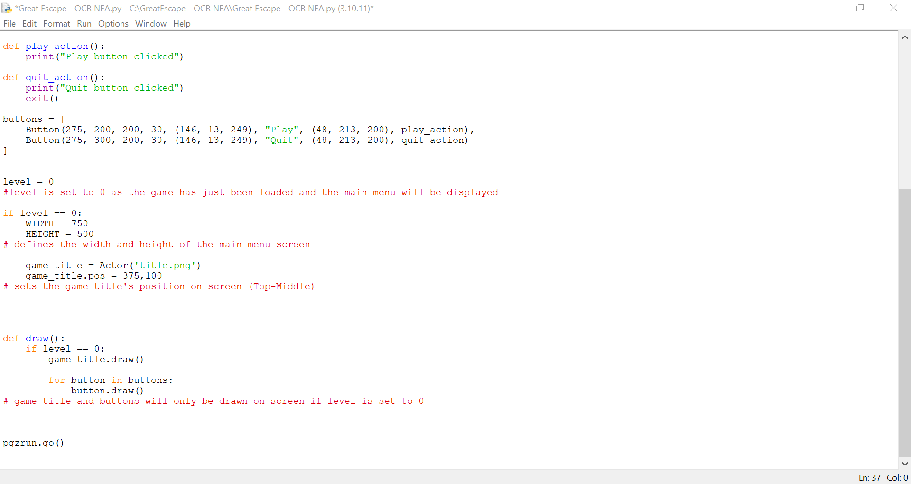

**Explanation of the code:**

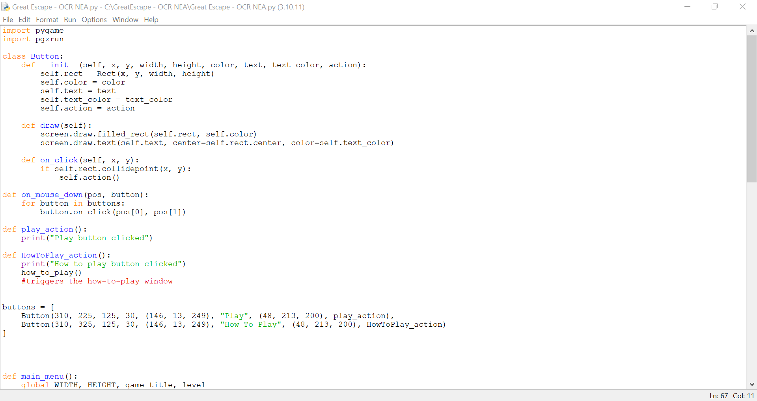

‘Pgzrun’ and ‘Pygame’ are imported as these are external libraries that will be used throughout the code, more libraries such as ‘random’ and ‘time’ will be used later in development.



To create the buttons, I used a class. By using a class, the two buttons can be created without having to create their variables such as height and width each time. Within the class ‘Button’ I initialised all the button's key properties such as their position on the screen (x,y) and their measurements (width and height) using a constructor class (def __init__).

The draw method (def draw (self)) was created to draw the buttons on the screen with their intended colour and the text that would go inside.

The ‘on_click’ method was created to check if the buttons are clicked by comparing the mouse coordinates (x, y) with the button's rectangle (self.rect). If the click is within the button's rectangle, it executes the button's action. This could either be the play button to execute the ‘play_action()’ or the how to play button that executes the ‘HowToPlay_action()’

I also created two methods, one for each button, that will complete the action associated with the button. As the rest of the game has not been created, for now, the method only prints a statement to test that the button is responsive to the mouse click. When the first level and the how-to-play function are created the methods will be updated to perform different actions such as triggering to opening of the first level or the how-to-play interface.



The individual buttons are stored in a list, each button has its own values that will be passed through the class as parameters to initialise them.



The ‘level’ variable indicates what level is currently being played, when the variable changes a new window will be created. IF statements are used to check which level the game is at before setting up a new window and drawing all the contents on the screen. Initially, the ‘level’ variable is set to 0 to trigger the creation of the main menu game window.

The game title is initialised as an Actor which is a class in Pygame Zero. I have chosen to make it an Actor as it is straightforward to set their position and draw them on screen, in comparison to defining it as an image.



The ‘draw’ function is used to draw all objects on screen. ‘IF level == 0’ ensures that the objects needed for the main menu are draw only when the main menu screen is displayed. ‘.draw() is a method in both the Actor and Button class. As the there are two button objects that are stored in a list, the For loop (‘for button in buttons:’) iterates through the Button class and draws each one.

At the end of the code, ‘pgzrun.go()’ is used to start the game.

**Module Testing:**

I tested that the game window opened, and the game title appeared on the screen. The window opened and the game title was positioned at the top in the centre. However, it was a bit too low, therefore I changed the y position from 150 to 100.

I also tested that the buttons appeared on the screen with the position of the how-to-play button being below the play button. Finally, I tested that the buttons responded to my mouse click by printing a statement when clicked.

**Evidence:**

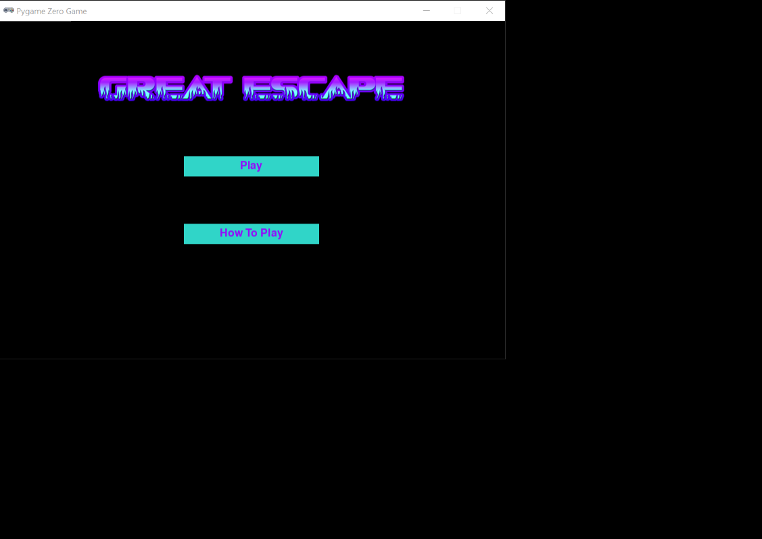

**User Feedback:**

My user likes the title of the game, she thinks it is enticing and intriguing. However, she believes there is work needed to be done on the buttons.

Firstly, she thought the colour of the buttons was unappealing and suggested inverting the colouring of the buttons to purple and the writing blue to make the buttons blend better with the title colour.

She also thought that the buttons needed to be moved down because she felt that they were too close to the title which slightly took the attention away from it. Finally, she would like the width of the buttons to be shorter.

**Reflections:**

To make the changes suggested by my user, I could modify some of the values in the button list for each of the buttons.

To invert the colours of the button’s colour and text, I simply need to swap their respective RGB values. For example, the text colour which was (146, 13, 249) now becomes (48, 213, 200) which was the colour of the buttons.

To move the buttons down, the y values of the buttons can be increased. For example, the y value for the play button was 200 it can be changed to 225.

Making the width shorter can be completed by decreasing the width value of the buttons. Consequently, the x value of the buttons will have to be increased as the buttons are now smaller and will have to be centred again.

**Evidence 2:**

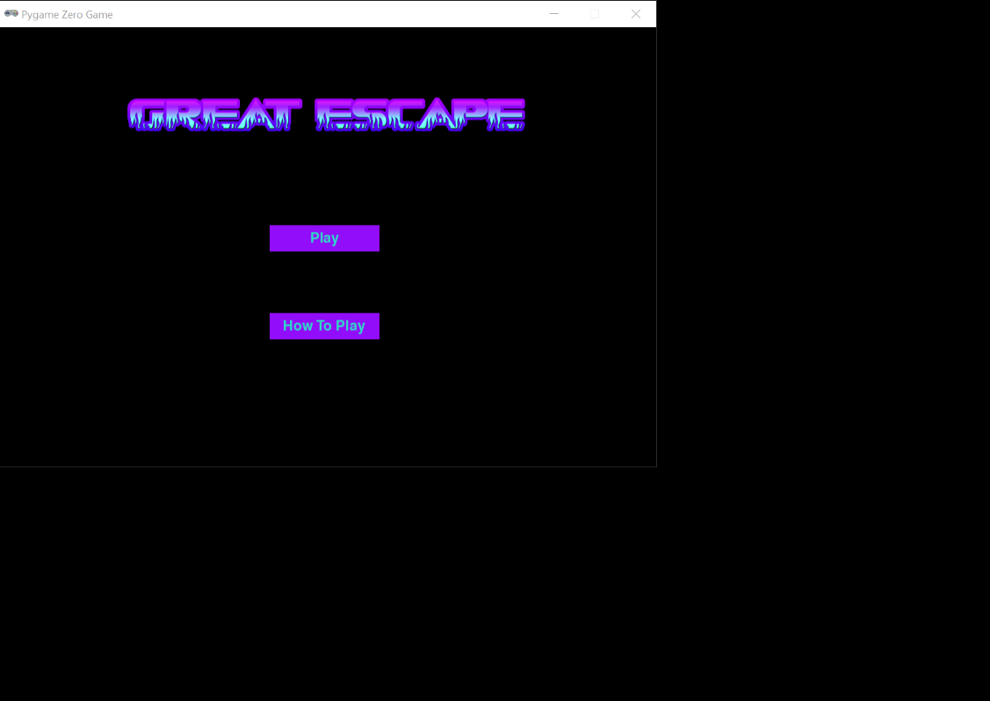

# Milestone 2 – How To Play Interface

**Code written to achieve milestone:**

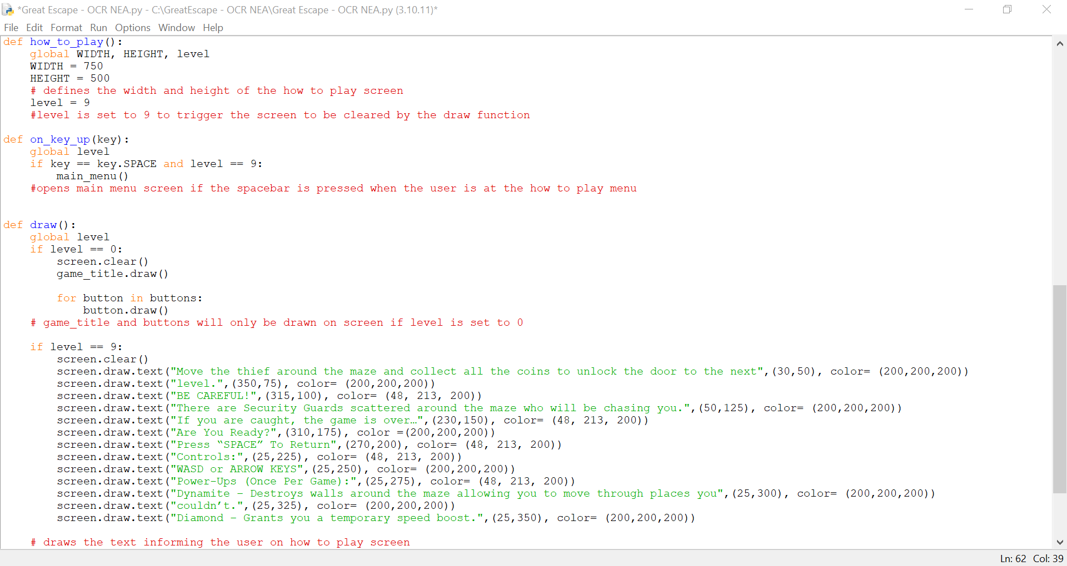

**Explanation of the code:**

I came across an issue where the window measurements of the how-to-play interface wouldn’t change when the how-to-play button was clicked, which would be a problem later on when a levels window measurements are set as those are adjusted with each level. I realised it was because of the IF statements.

Changing the ‘level’ variable value would have no effect on the IF statements as in procedural programming IF statements are only checked once and the program moves on to the next line. This meant that the IF statement had already been checked and evaluated as false hence why when the value of the ‘level’ variable changed, it didn’t alter the measurements of the screen.

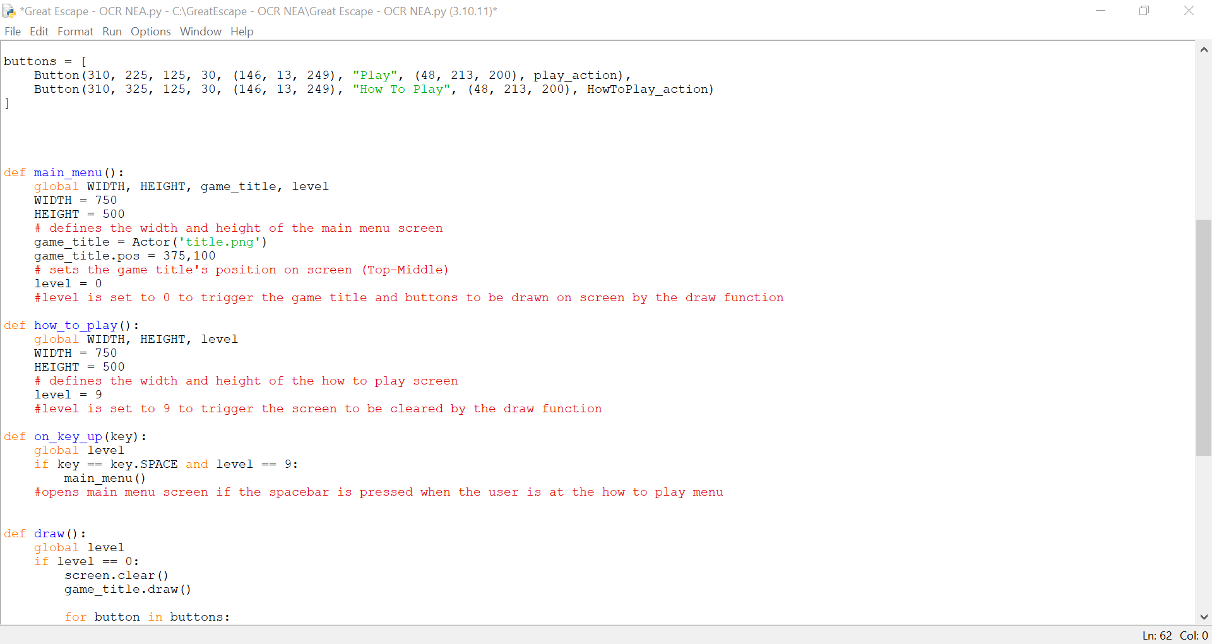

To fix this I adopted the function for setting up each of the levels, which is mentioned in the design stage, and applied it to both the main menu interface and the how-to-play interface. The code for this is shown above.

Within each of the functions, the width of the screen was defined as 750 by using ‘WIDTH = 750’ and the height the screen was defined as 500 by using ‘HEIGHT = 500’. This is because I wanted to keep the measurement of both screens the same.

The objects that needed to be displayed on screen such as ‘game_title’ were also initialised in the function ‘main_menu()’. In both functions, the ‘level’ variable is set to different values; this is so the functions can trigger the objects/text associated with the screen to be drawn.

Now when the program is started the ‘main_menu()’ function is called, and it displays the main menu screen. When the how to play button is clicked the ‘how_to_play()’ function is called and displays the how to play screen. This will be the new way I trigger the different types of variables going forward.

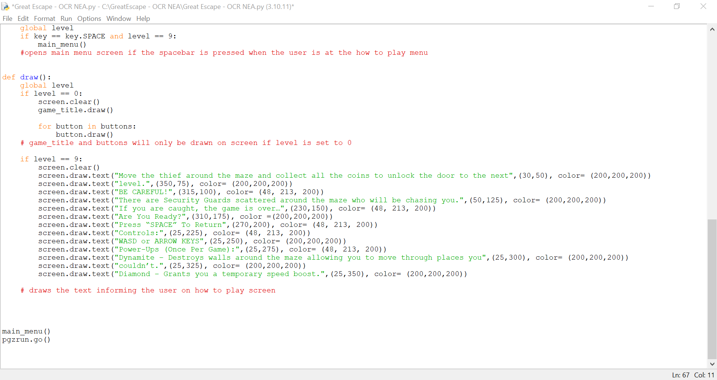

In the draw function, If the ‘level’ variable is set to 9, the screen is cleared to remove all existing objects and the text for the how-to-play screen is drawn. Each row of text has a spacing of 25 pixels and the colours of the text vary line by line.

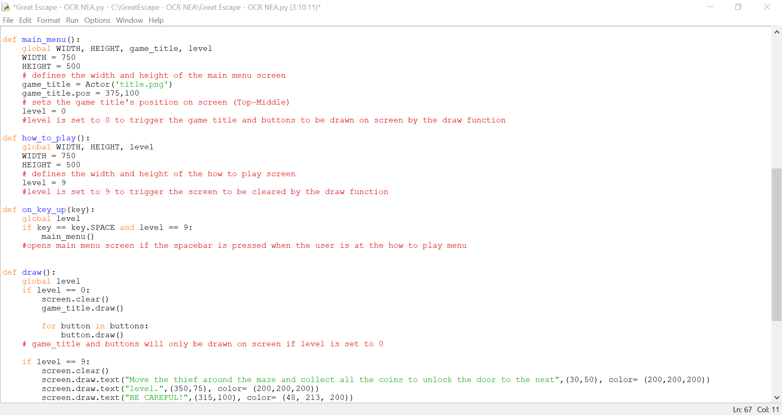

Finally, a new function was created to handle if the spacebar is pressed. The spacebar must be only functional in the interfaces where it is needed. Therefore, an IF statement checks if the spacebar has been pressed and if it has been pressed at the right screen using the level ‘variable’.

At the how to play screen the user can press the space bar to return to the main menu. To implement this, the IF statement ‘IF key == key.SPACE and level == 9’ checks if the spacebar has been pressed and if the level variable is set to 9. If the condition is met the main menu function will be called to display the main menu screen again.

**Module Testing:**

I tested that the how-to-play screen appeared when the how-to-play button was pressed and that text informing the user was displayed. However, some lines of text went off the screen as it was too long. To fix this I created a new line using ‘screen.draw.text()’ and added the words. that went off the screen. Then I adjusted the y value, so the words were below the text it was originally part of.

I also tested that when the space bar is pressed when the user is on the how to play screen the main menu is displayed again.

**Evidence 1:**

**Evidence 2 (Revised):**

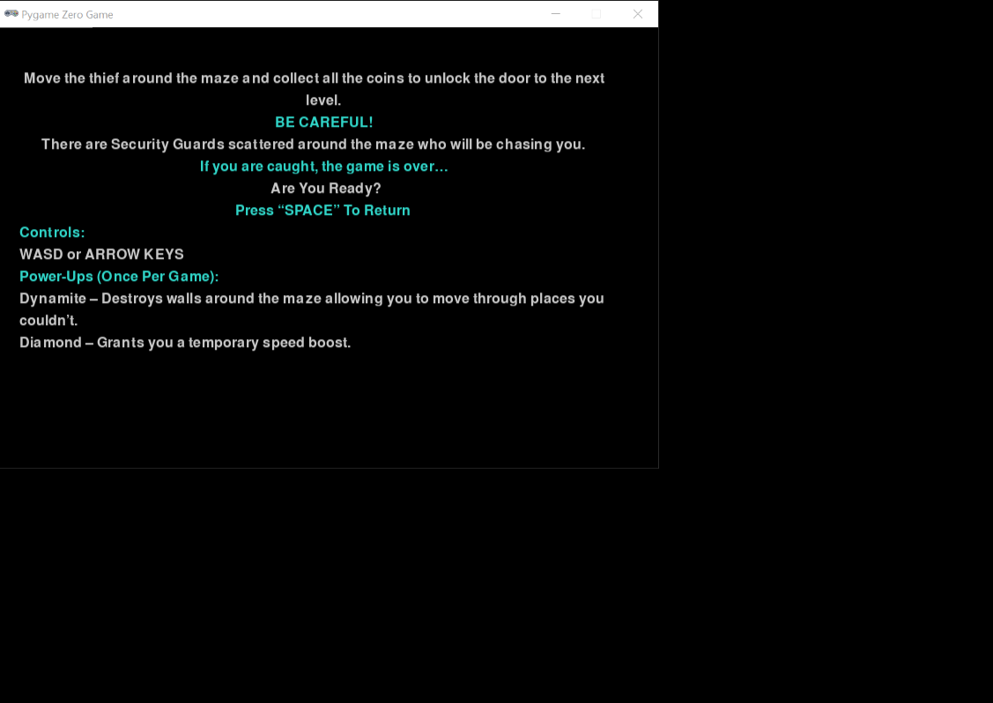

**User Feedback:**

My user thought that the ‘Space Bar’ Prompt needed to be easier to distinguish from the rest of information on the screen.

**Reflections:**

To make the ‘Space Bar’ Prompt easier to see I moved it to the bottom of the screen by adjusting the y value of the text. I also created a variable called box which initialised a rectangles' position on the screen and colour. I wanted the rectangle to surround the ‘Space Bar’ prompt to highlight the text. Therefore, I made the rectangle's position on the screen align with the position of the text.

# Milestone 3 – Level

**Code written to achieve milestone:**

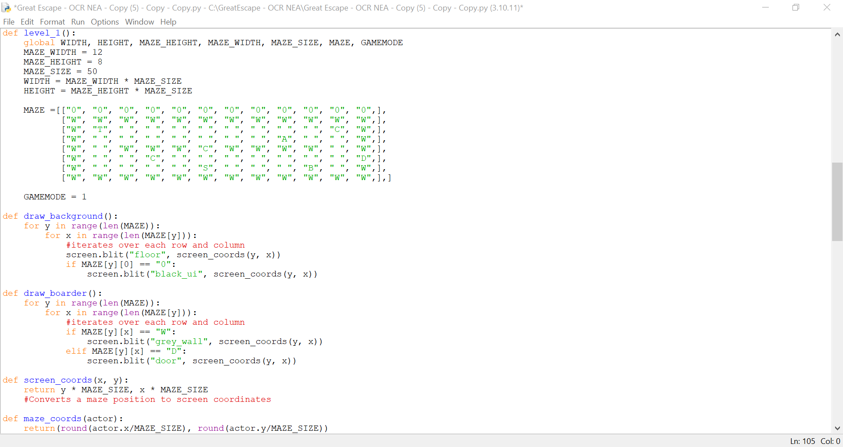

**Explanation of the code:**

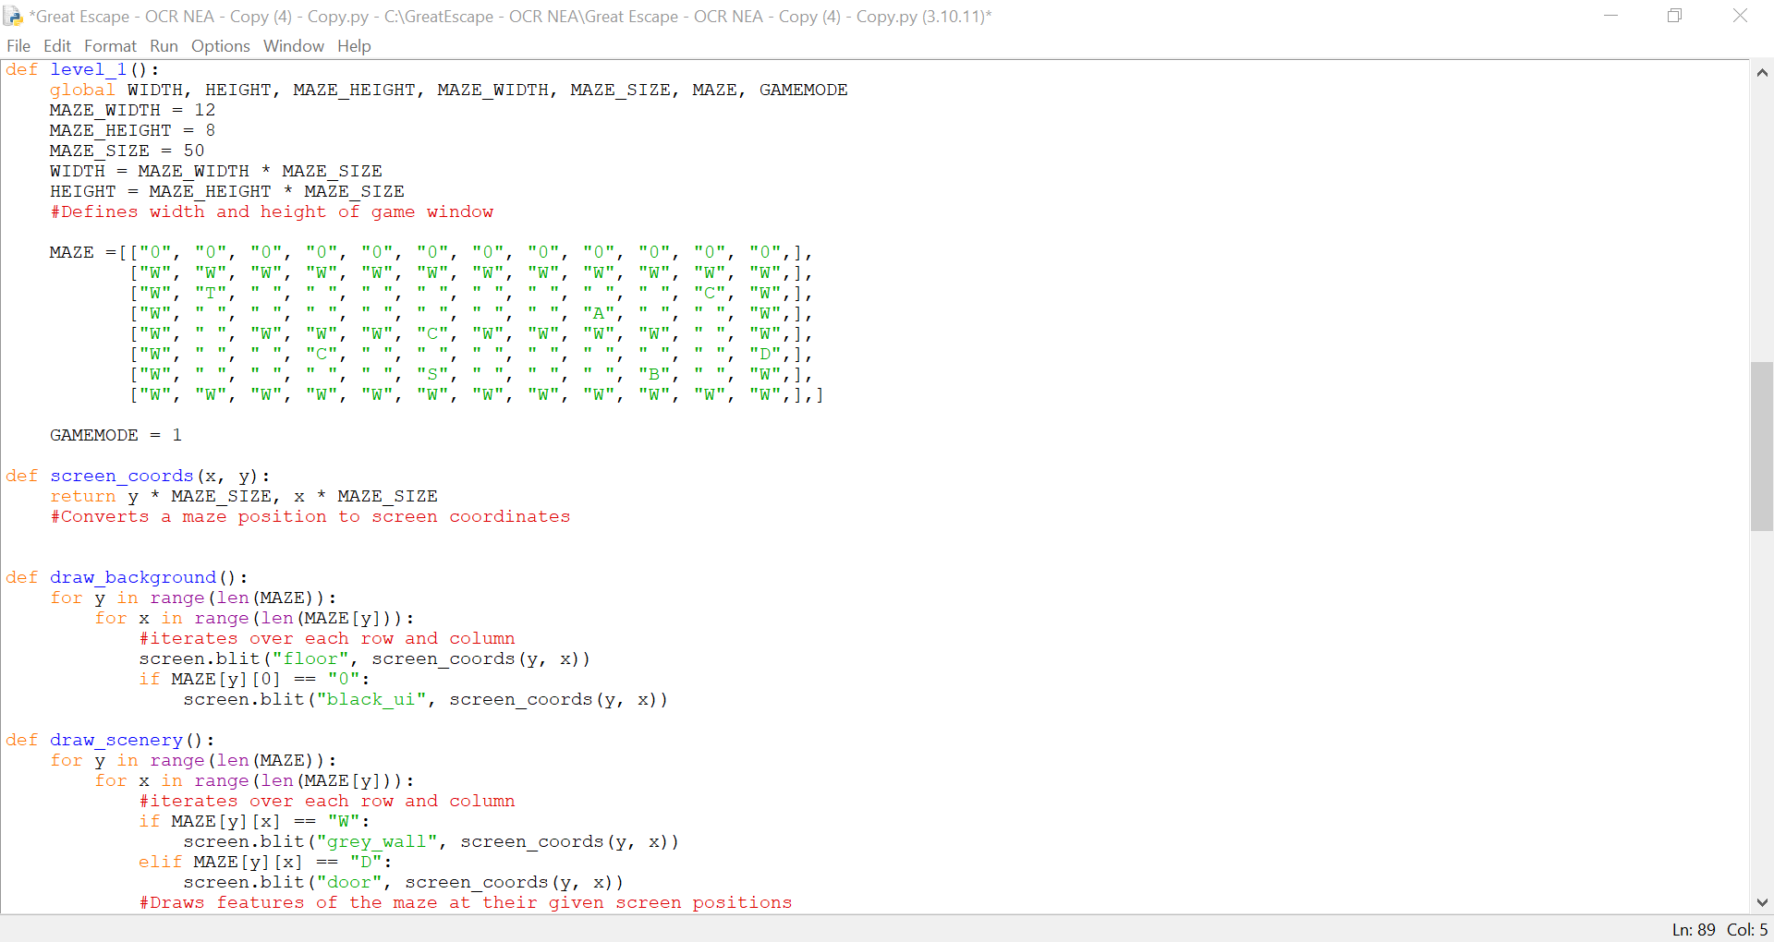

To create the levels, I have taken inspiration from Kate Russell (2020) guide. However, there is more than one level in my game therefore there has been adjustments made.

To create the first level, it is defined using a function. The function defines the Mazes’ width, height and size. The variable ‘MAZE_SIZE’ is a constant which is set to 50 as each coordinate in the maze will store an image that is 50x50. To set the screen measurements, the width and height of the maze (WIDTH, HEIGHT) are multiplied by the size of the Maze (MAZE_SIZE). This ensures every coordinate is 50x50 to ensure that the images fit inside.

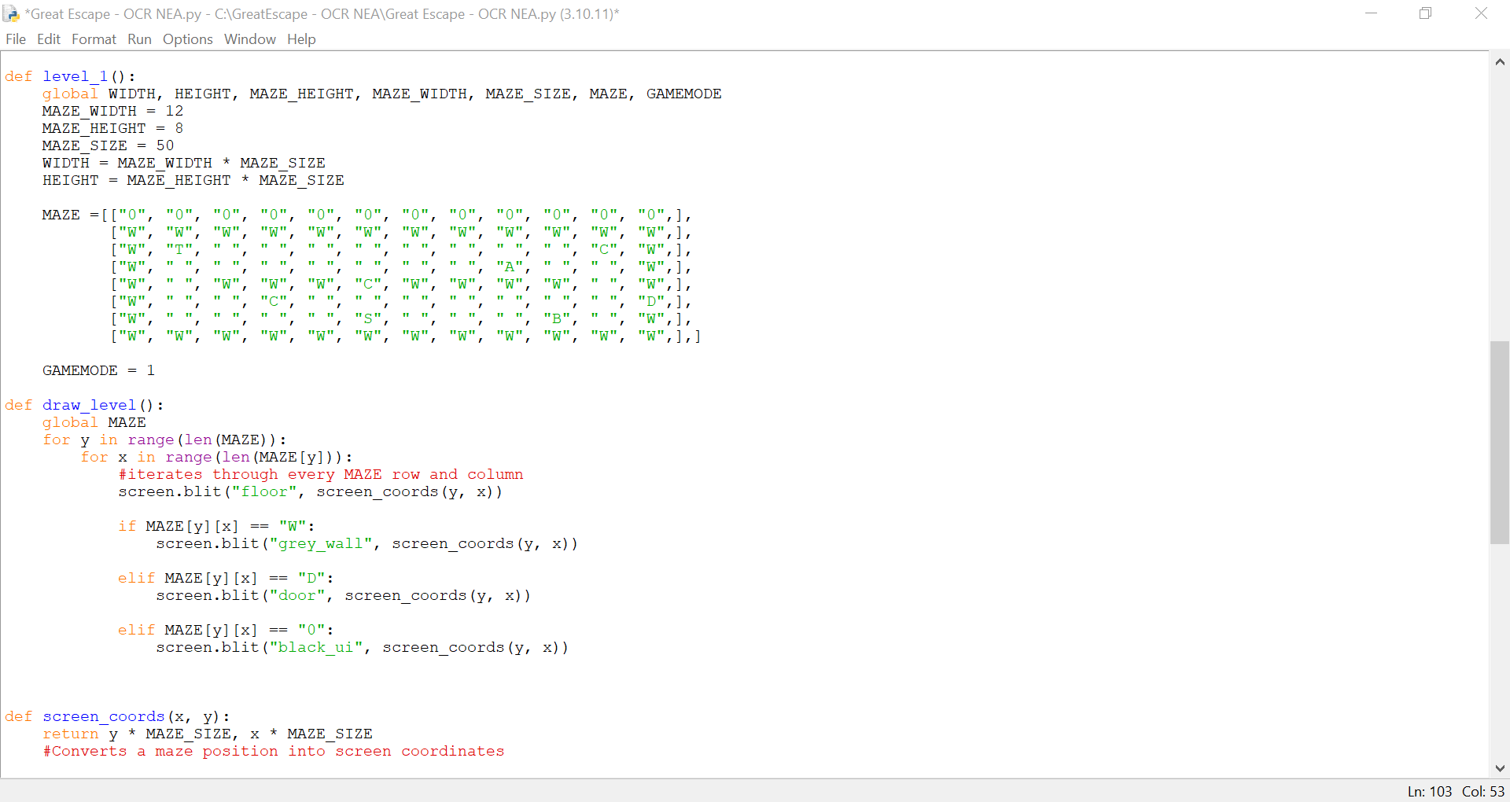

The MAZE is set as a 2D array which is different for every level. Although I came across a problem as my initial solution for adding the Black UI was to iterate through each row and column of the 2D array and add 1 to the y value of the current index which would leave row for the UI.

However, that did not work, therefore I added another row to the top of the 2D array. All items in that row are called “0” and assigned to display a 50x50 black square, this will be used to create the black UI.

I have changed the name of the variable ‘level’ to ‘GAMEMODE’, this is because, with the introduction of the ‘level_1’ function, the names would have been too similar, and it would be easy to get confused whilst debugging.



The Maze for levels is drawn on screen when the variable GAMEMODE is not equal to 0 or 9, multiple functions are called to draw certain features of the maze on screen.

These functions include:

* ‘draw_background()’ which sets the position of all non-interactable features in the maze.
* ‘draw_boarder()’ which sets the position of features of the maze which will be used in validation e.g the wall to prevent the thief from leaving the screen.

I have taken these functions from Kate Russle (2020) and adjusted to accommodate a 2D array. These functions when called, use nested FOR loops that iterate through each row and column of the 2D array (MAZE) and checks the contents of each index. A series of IF statements checks if the item stored at the index matches with a given character. If the statement is evaluated as true, an image will be drawn on the screen that is associated with the given character using ‘screen.blit()’ a class in Pygame Zero that displays an image on given coordinates. The coordinates are then passed through ‘screen_coords()’ which is a function that multiplies the coordinates by the MAZE_SIZE (50) to ensure that they follow the same diameters as the screen.

However, the only image that does not require an IF statement to be drawn is the floor as the floor is drawn everywhere with other features being drawn on top.

**Module Testing:**

I tested that the maze is displayed on screen with all the features in the correct place. I also tested that the Black UI appeared at the top of the screen.

**Evidence:**

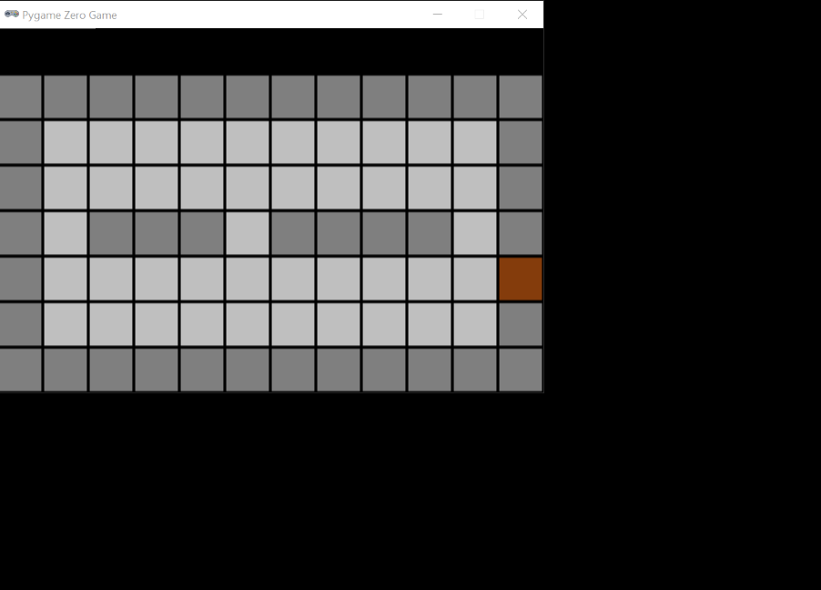

**User Feedback:**

My user thought that the maze looked as an introductory level to the game as it is simplistic but not too easy.

**Reflections:**

N/A

# Milestone 4 – Move Thief

**Code written to achieve milestone:**

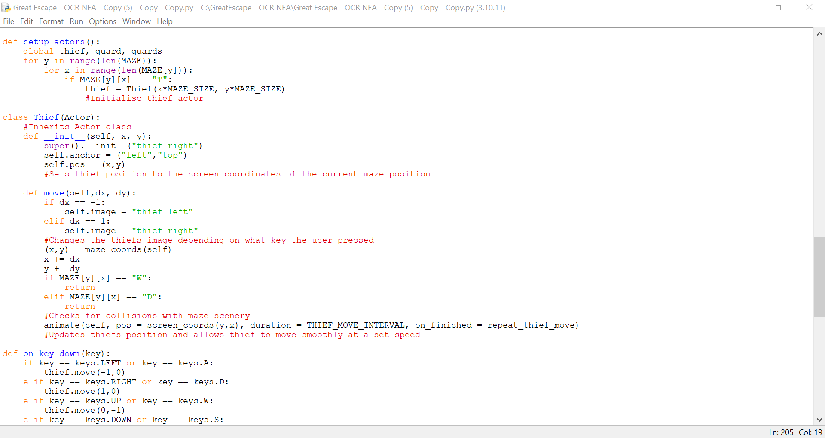

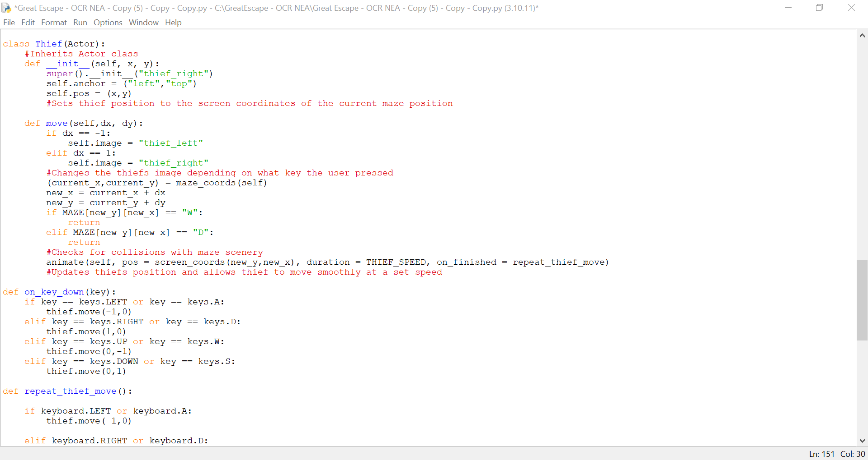

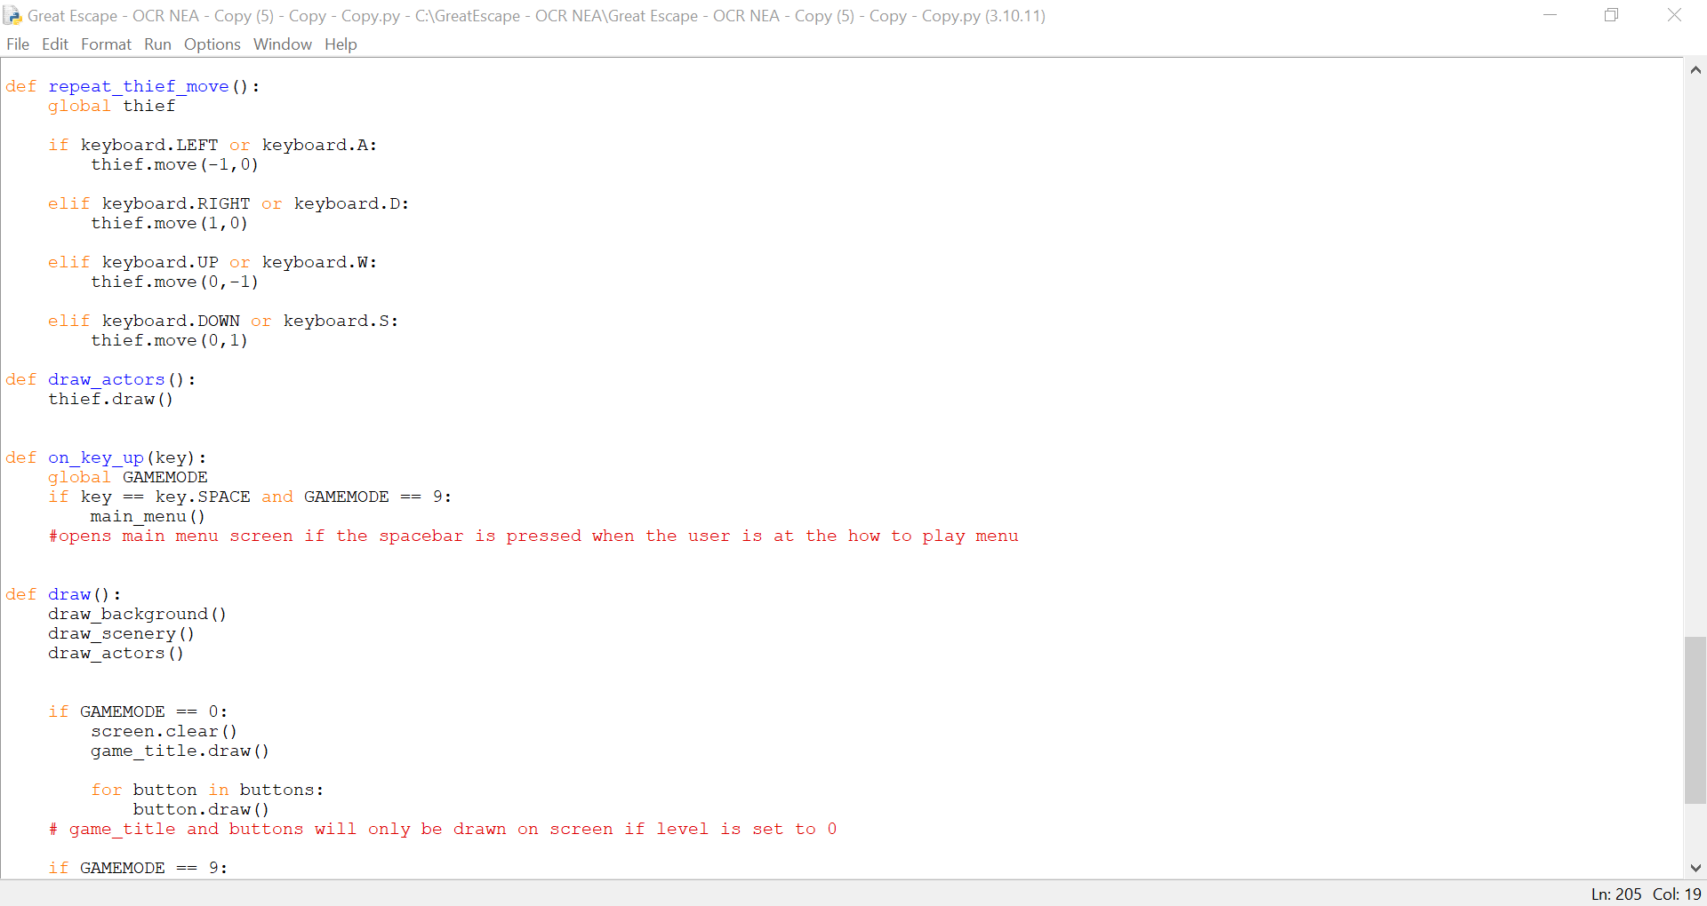

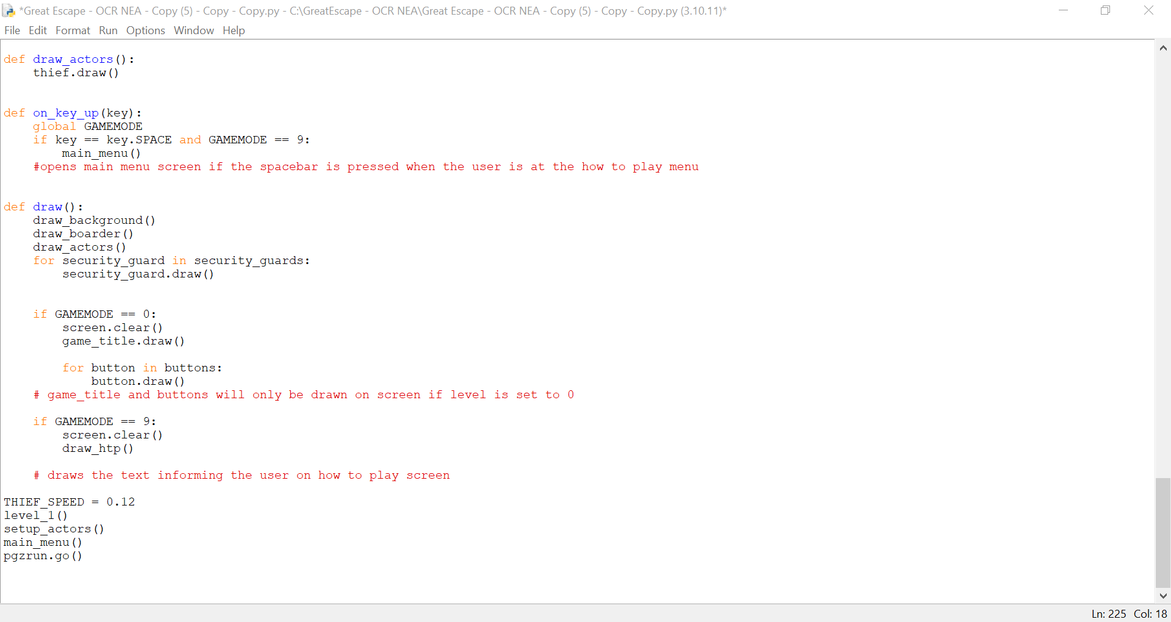

**Explanation of the code:**



The function ‘setup_actors()’ is used to initialise the thief and will be used for all other actors in the game. To setup the thief, a nested FOR loop iterates through each row and column in the MAZE 2D array and uses IF statements to check if the character represents the thief (“T”).

The thief is then initialised passing its position in the array through the parameters of the Thief class. These are multiplied by the MAZE_SIZE to ensure that the thief is positioned inside a cell.

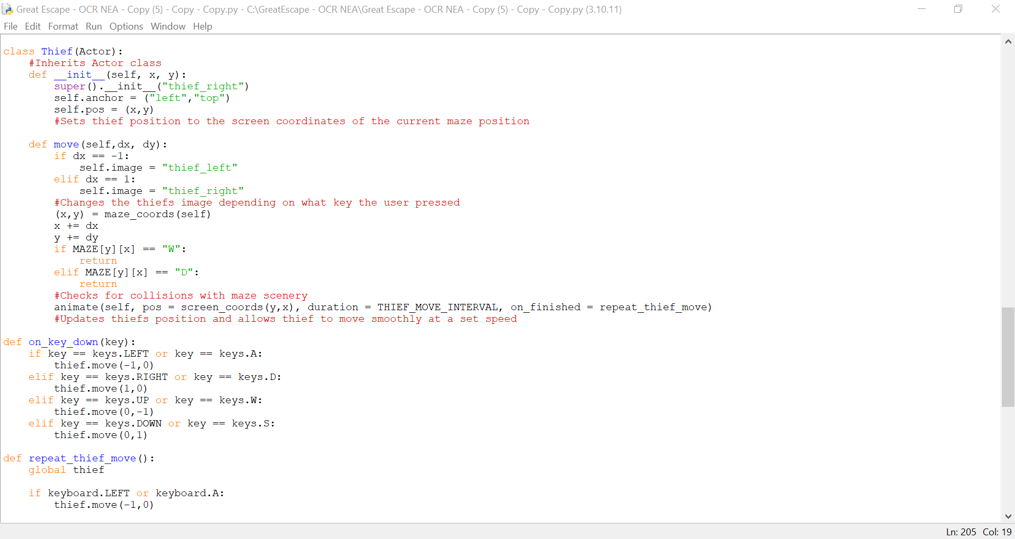

The Class Thief inherits methods from the Class Actor which is a class in Pygame Zero’s library. It inherits methods to define the image that the thief uses, set the anchor point at the top left corner and set its initial position in the array.



The function ‘on_key_down()’ is an event handler that reacts to when the user presses an arrow key or WASD by using IF statements. If one of the conditions is met, the move method is called with the intended changes to its position as parameters this can either add or subtract 1 from the y or x value of the thief to ensure it moves in the right direction.



To check and apply these changes to the thief’s position, the function ‘move()’ is called passing the intended changes through its parameters.

First, I wrote two IF statements that are used to check if the user has moved left or right by comparing dx either -1 to check if its moved left and 1 to check if its moved right, this changes the way the thief actor is facing.

After the thief’s current maze position is retrieved using ‘maze_coords()’ and is held in the variables ‘current_x’ and ‘current_y’. The intended changes to the thief’s position held in ‘dx’ and ‘dy’ are added to the currents thief’s position to create the thief’s new position (new_x)(new_y).

As a form of input validation, I wrote two if statements that’s that check if the new position in the maze array has a wall or door. If one of them is evaluated as TRUE then return is used to stop the execution of the function, this is to ensure the thief doesn’t move off the screen.

If it has cleared all the checks, then thief’s position will change.

Using the animate function in Pygame Zero I pass the thief’s new position as arguments and set the duration as THIEF_SPEED which is specified as 0.12 this will update the thiefs position after 0.12 seconds. When finished it then checks if the user has repeated the move by calling ‘repeat_thief_move’. This is to ensure that the user can move the thief smoothly.

**Module Testing:**

I tested that the thief spawned on screen in the place that it needed to be. However, when I tested if the thief image would move in the intended direction the user wanted, the image wouldn’t move to the new direction. After using print statements to debug my code, I realised that the thief’s new coordinate would be updated using the function ‘move()’, but the thief’s image would not update.

I figured that this was due to the IF statements in the draw function as they are only checked once and therefore the thief is only drawn once. To solve this, I needed to make sure that the draw functions for creating the level were called continuously, so I removed ‘IF GAMEMODE == 1’ and called the ‘level_1()’ function at the start of the game. This means that all the objects in the maze are already defined and drawn for level 1 without using IF statements. I now know that the only parts that need IF statements in the draw function are for the User Interfaces that do not require updating.

I also separated the objects that need to be drawn for the levels into their own functions to make it easier to debug in the future.

After fixing that issue, I checked if the thief’s actor changes appearance when it moves left or right.

**Evidence:**

<https://youtu.be/GGWyFaWjpGA>

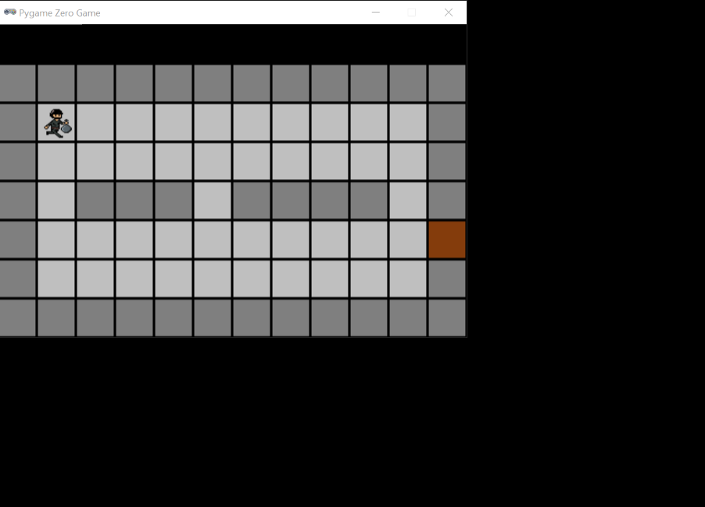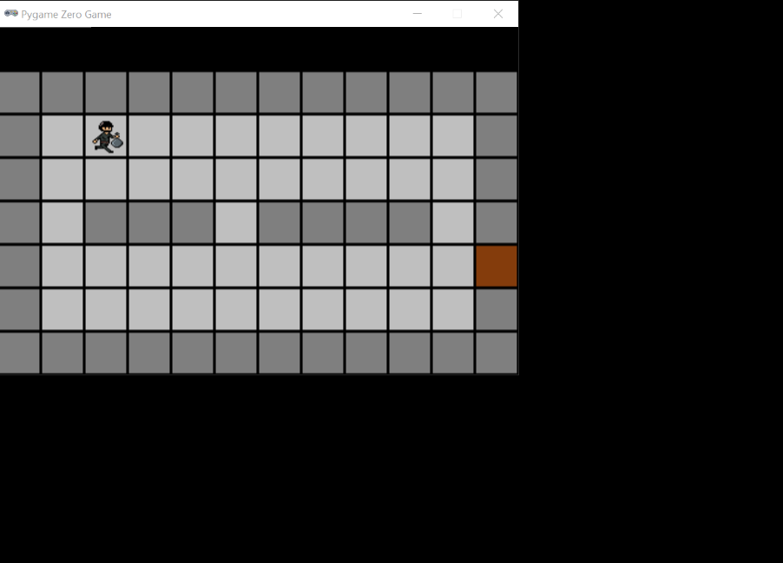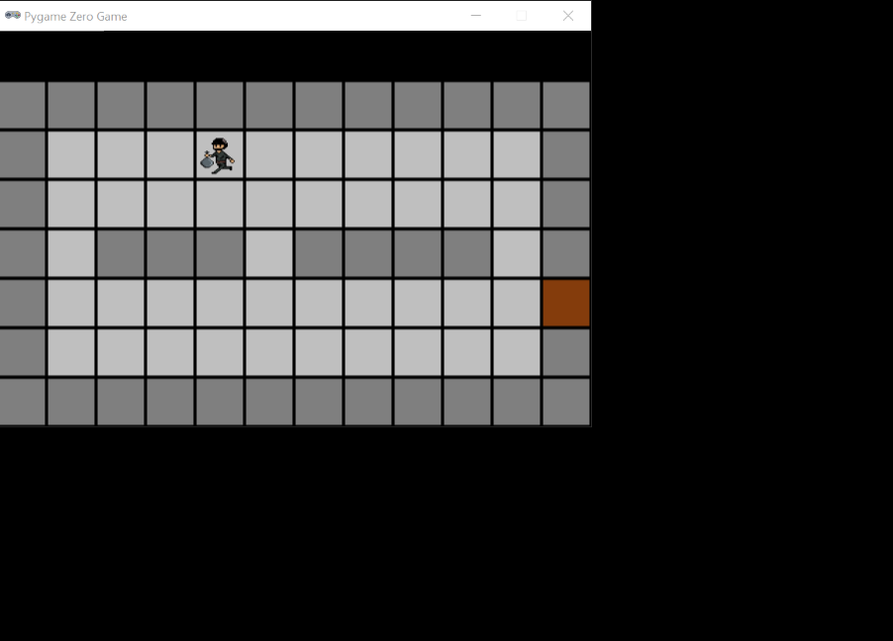

**User Feedback:**

My user thought that the thief moved too fast for the level and would make gameplay far too easy.

**Reflections:**

I decreased the thief’s speed by changing the value of the variable THIEF_SPEED from 0.12 to 0.15.

# Milestone 5 – Move Security Guard

**Explanation of the code:**

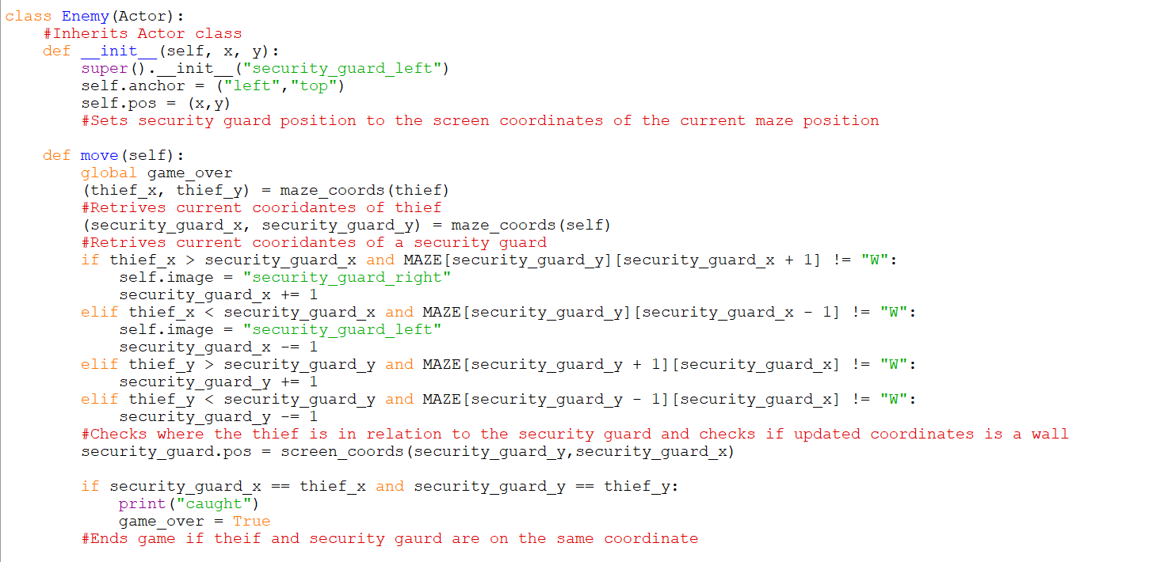

I created a class for the security guards called Enemy which has similar properties to the thief class. The class inherits both attributes and methods from the Actor class. Additionally, it has a move method which moves all security guards in the maze.

To move the security guards, the move function is created inside the Enemy class. Both coordinates of the thief and the security guard are retrieved using ‘maze_coords()’. These are then stored in x and y values associated with the character (thief_x, thief_y) or (security_guard_x, security_guard_y).

To move toward the thief, I created IF statements that would check all possible directions the thief could be (left, right, up or down). The IF statements compare the thief x position (thief_x) to the security guards x position (security_guard_x) to check if the thief is left or right of the security guard. For example, If thief_x is greater than security guard_x then the security guard’s x position is incremented by one to move right.

To ensure that the security guard does not hit a wall, the new position is checked to see if it's not a wall using for example MAZE[security_guard_y][security_guard_x + 1]. To change the security guard’s position both conditions have to be met using AND.

To update the security guard’s coordinates on screen, the security guard’s position is updated with its new coordinates.

After I needed a way to ensure that the game ends when the thief and security guard are on the same coordinate. To do this, I wrote an IF statement that compared the thief’s coordinates with the security guard’s if this condition is met game_over is changed to True.

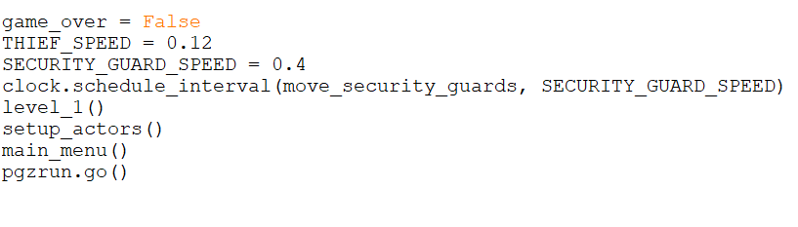

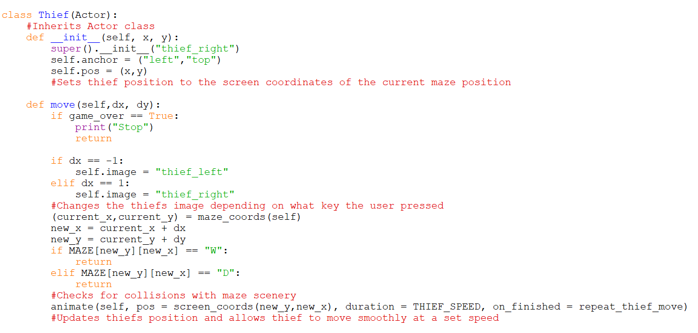

I set the variable ‘game_over’ to False at the beginning of the program. I also used Pygame Zero's library class, Clock.schedule_interval, to move the security guards at regular intervals. I created a constant called SECURITY_GUARD_SPEED which sets the interval at which to move all the security guards.

added an IF statement to the thief’s move method, which uses return to stop the thief from moving.

To move all the security guards, a function outside the Enemy Class iterates through the ‘security guards’ list and calls the move method for each security guard. I used Pygame Zero's library class, Clock.schedule_interval, to move the security guards at regular intervals. I created a constant called SECURITY_GUARD_SPEED which sets the interval at which to move all the security guards.

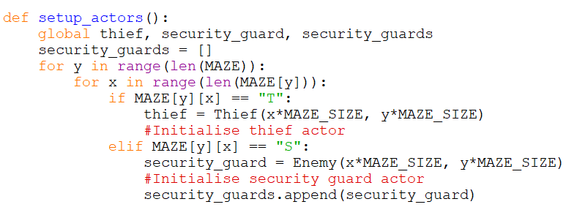

To create the security guards, I first had to create a new list in the ‘setup_actors()’ function which will be responsible for holding all the security guards of a level and drawing them. Inside the nested FOR loop, I added another IF condition: ‘elif MAZE[y][x] == “S”:’ which initialises a security guard to the Enemy class and passes its position on the screen as arguments. Then, the security guard object is added to the ‘security_guards’ list and appends their position.

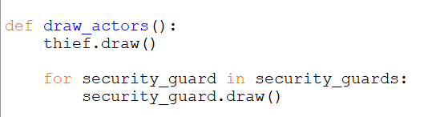

To draw the security guard on the screen, I added a FOR loop that iterates through the ‘security guards’ list and draws each security guard.

**Module Testing:**

I tested that the security guards spawn on the screen and that the security guards moved towards the thief.

However, the security guard started moving towards the thief even when I was at the main menu or how to play the screen. This was because the level had already been defined and drawn when the program had started. To fix this I added an IF statement that only allows a security guard to move if GAMEMODE == 1. Although, this worked I believe it is unsustainable when I add more levels the GAMEMODE variable will be updated and therefore not be equal to 1. So, I may have to create a new variable that starts and stops security guard movement in the future.

I also had difficulty when testing that the game ends when the security guard touches the thief. The expected outcome was that the user could no longer move however, I could still move even after the security guard had been on the same coordinate. After debugging my code with print statements, I found that I had to make ‘game_over’ a global variable so it could be accessed anywhere in the program. As previously in the Enemy class, it was only a local variable and the intended changes to the rest of the code would not be implemented.

**Evidence:**

<https://youtu.be/0SB0AOMon0c>

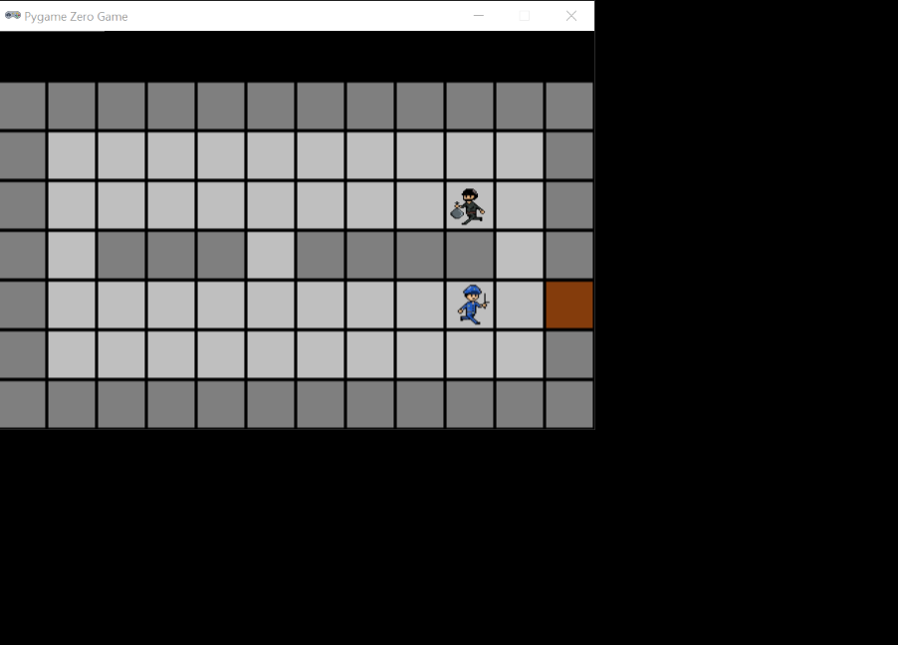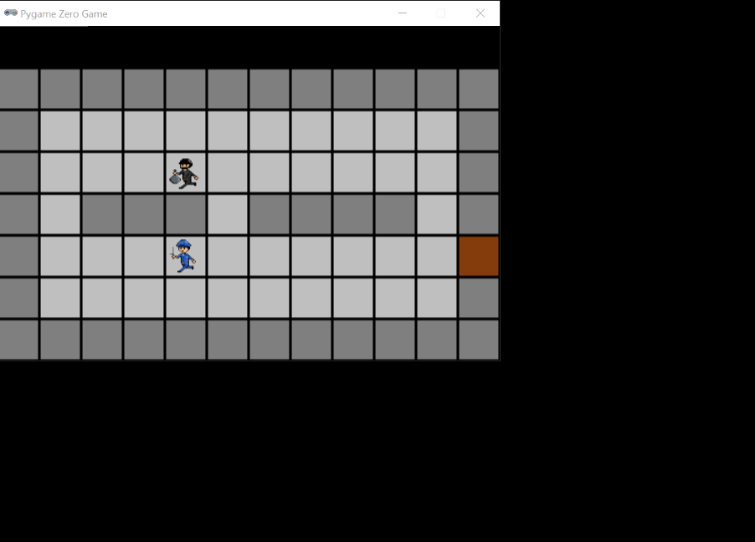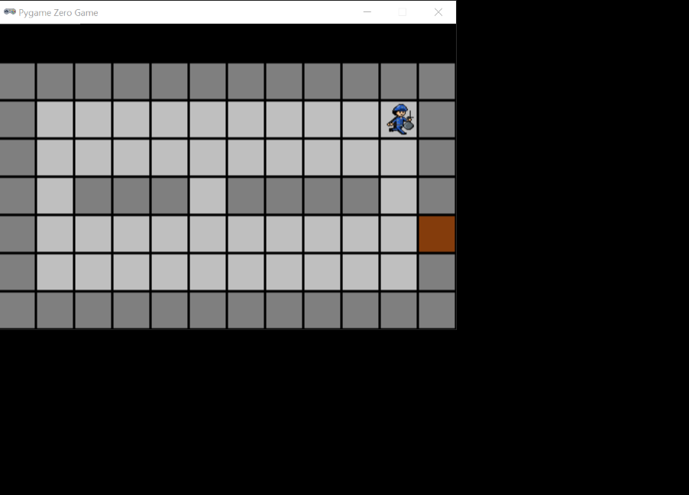

**User Feedback:**

My user thought that the security guard was too slow and that players would find it too easy.

**Reflections:**

I increased the security guard speed by changing the value of the constant SECURITY_GUARD_SPEED from 0.4 to 0.3. This means that the thief is now x2 faster than the security guard which I believe is balanced.

# Milestone 6 – Coins

**Explanation of the code:**

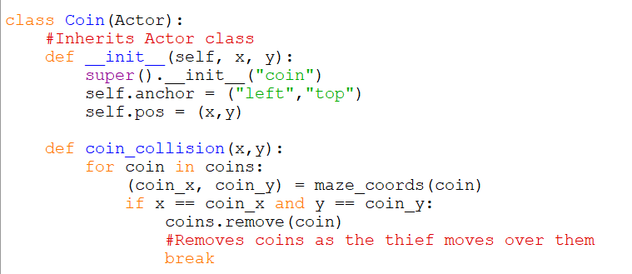

I created a class for the coins called Coin which has similar properties to the thief and security guard class. The class inherits both attributes and methods from the Actor class. Additionally, it has a method which removes the coins.

The function ‘coin_collision(x,y)’ takes the thief’s new x and y position as parameters. I used kate russle (2020) to understand how to remove coins once the thief is on the same coordinate.

The function uses a FOR loop to iterate through all the coins in a list, retrieves their position on the screen and assigns it to ‘coin_x’ and ‘coin_y’. Then ‘if x == coin_x and y == coin_y:’ checks if the coins cooridnates are the same as the thiefs, if this is evaluated as TRUE to coin is removed using an Actor method ‘remove()’. This is followed by a break to exit the FOR loop as only one coin can be on the same coordinate as the thief.

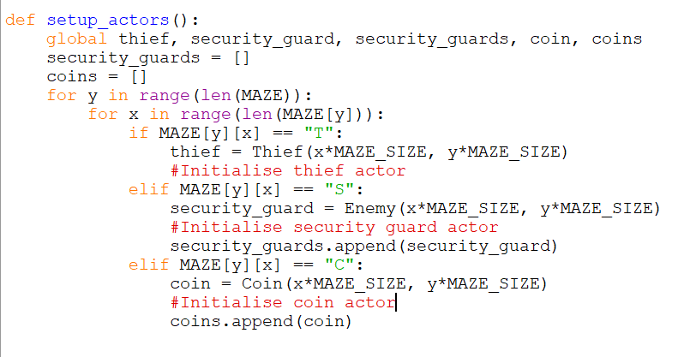

In the ‘setup_actors()’ function, I created another list called ‘coins’ that will store all the coin actors in a level. I also added lines of code that initialised a coin to the Coin class and appended their position to the Coin class.

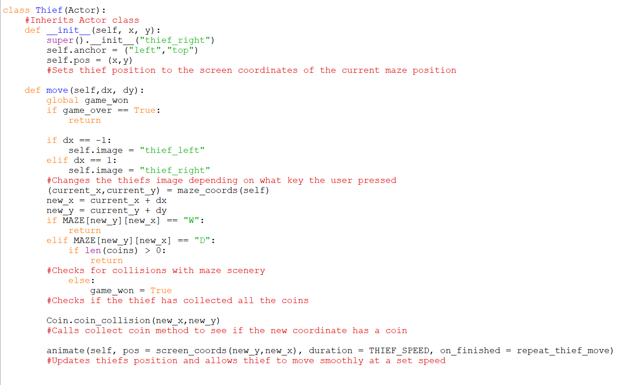

In the Thief class, the method ‘move()’ the IF statements that checks if the thief has collided with the door has been updated. If the number of coins in the list is greater than 0 then the user has not completed the level and will not be allowed to proceed to the door coordinated and therefore return is used. However, if it the number of coins in the list is 0, then the user has won and game_won is set to TRUE.

Below, I called the ‘coin_collision()’ method from the Coin class and passed the thiefs new coordinates (new_x, new_y) as arguments to check if the thief is on the same coordinates as a coin.

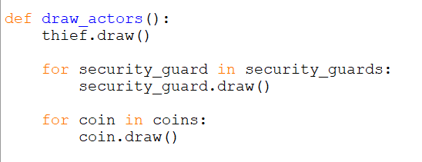

Finally, to draw the coins on the screen, I added a FOR loop In the ‘draw_actor()’ function that iterates through the ‘coins’ list and draws each coin.

**Module Testing:**

I tested that the coin spawned on the screen. I also tested that the coins disappeared when the thief is on the same coordinate. I also tested that the door disappeared when the user had collected all the coins.

**Evidence:**

<https://youtu.be/uB-abHCrXTs>

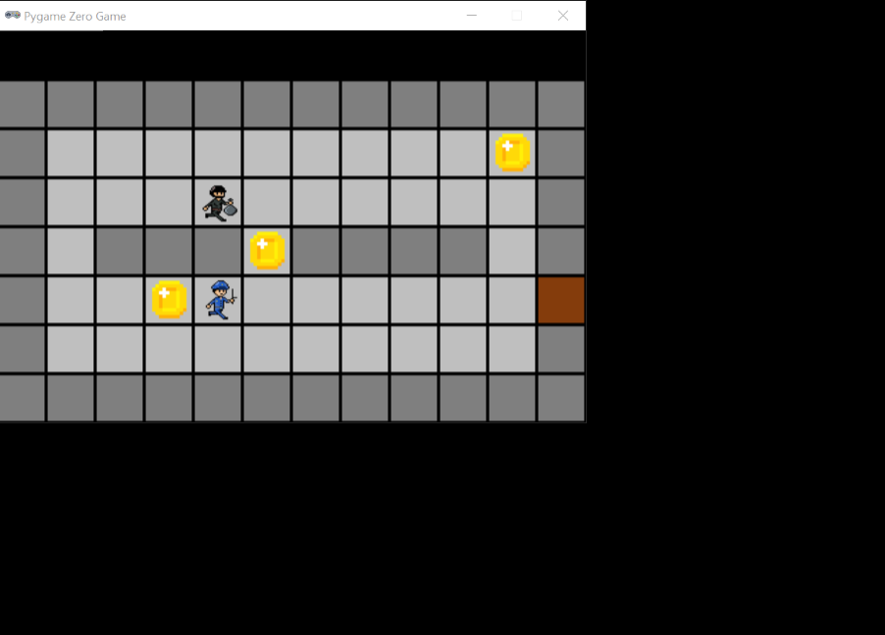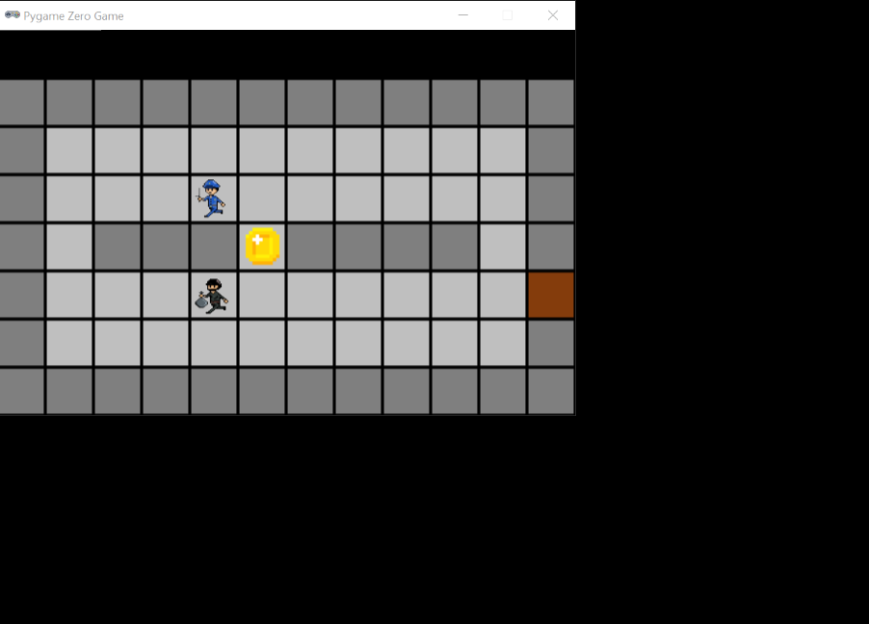

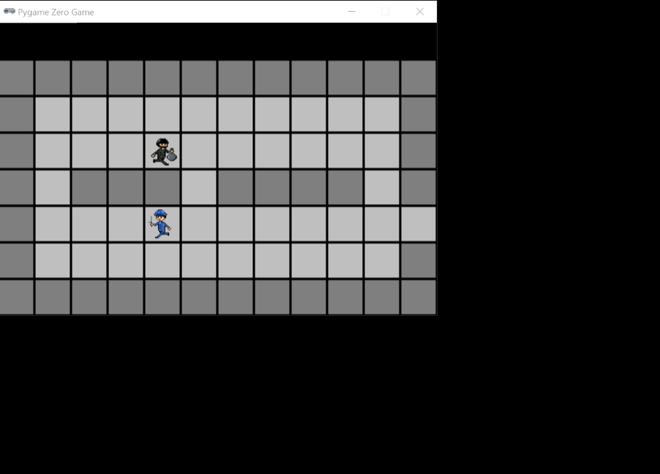

The door has been removed

# Milestone 7 – Game Over Interface

**Explanation of the code:**

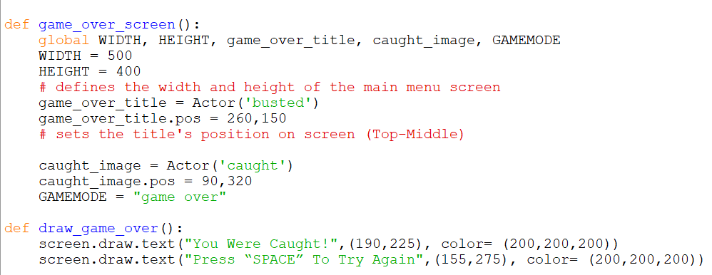

There were a lot of changes made to the program during this milestone, firstly to create the game over interface I used a function which follows the features of other interface functions. I defined the width and height of the screen. Then I added the different images that will be used and set their position on screen.

I have made some more changes to the variable GAMEMODE as it will no longer be storing the number of the level currently being played. That role is now given to LEVEL which is a variable I have decide to add back to the program. Instead, the variable GAMEMODE now stores the current interface being displayed as a string.

For example, the ‘level_1()’ function below now defines what interface is currently being used (GAMEMODE = “play”) and what the current level is (LEVEL = 1). This is useful when drawing objects that need to go on screen.

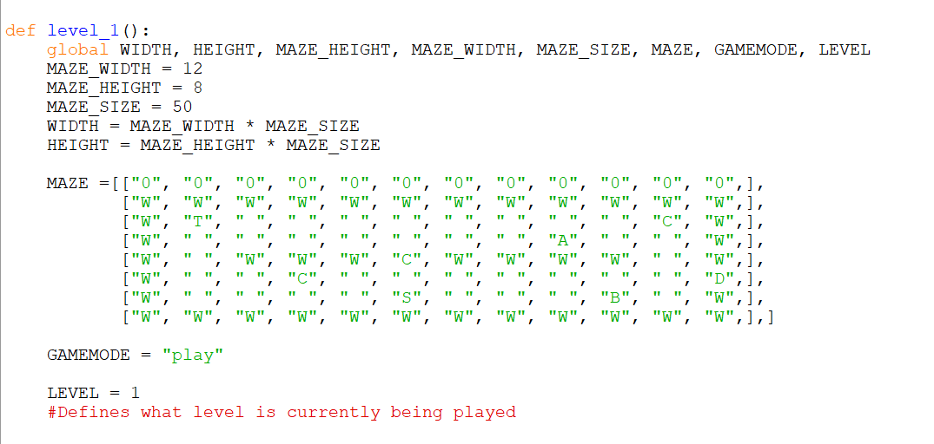

Currently, the different values the GAMEMODE variable can hold are:

* “game over”
* “play”
* “main menu” – which was previously set as 0
* “how to play” – which was previously set as 9

I will add more values when new interfaces are created in future milestones.

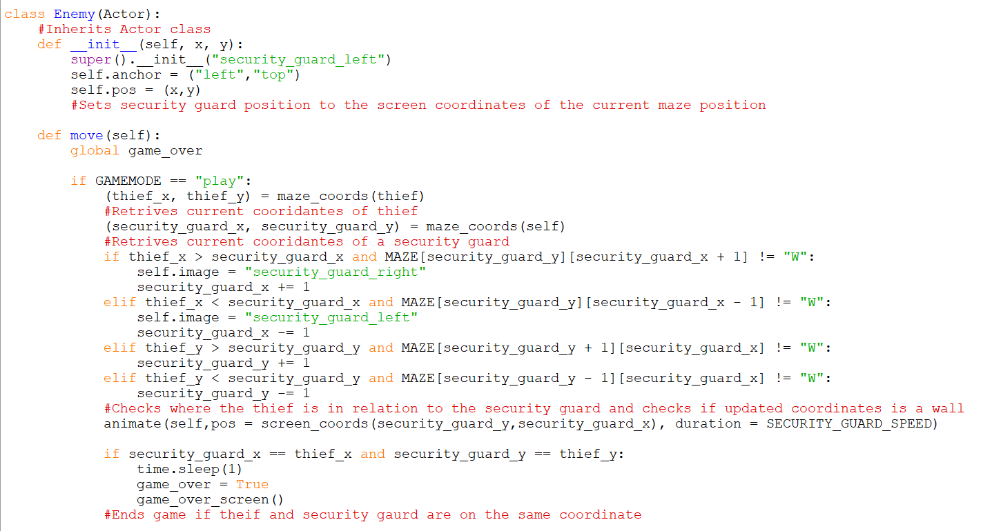

I updated the ‘move()’ method in the Enemy class so when the security guard and thief are on the same coordinate, the program waits one second so that the user can see that the thief has been caught rather than ending the game abruptly. To implement this, I imported time which is a library in Python. After the 1 second has passed, game_over is then changed to TRUE and the ‘game_over_screen()’ function is called to display the game over interface.

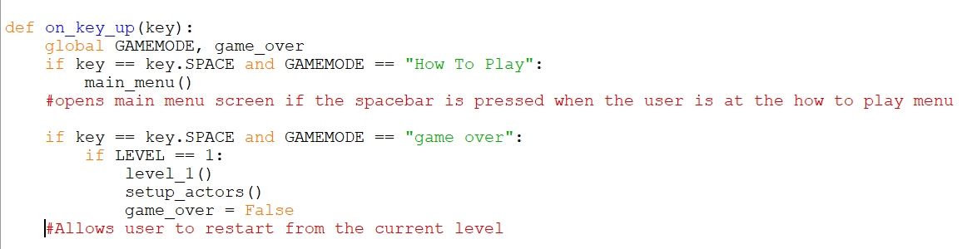

I have added a new condition to the spacebar event handler ‘on_key_up()’. The IF statement checks that the spacebar has been pressed and that the current display is the game over interface held by GAMEMODE. Then an IF statement checks what current level is being played, and calls the function associated with the level, calls the function ‘setup_actors()’ to reset the actors in the level.

This is the reason why GAMEMODE changed as it could not be used in both IF statements to check the interface and check the level that is currently being played.

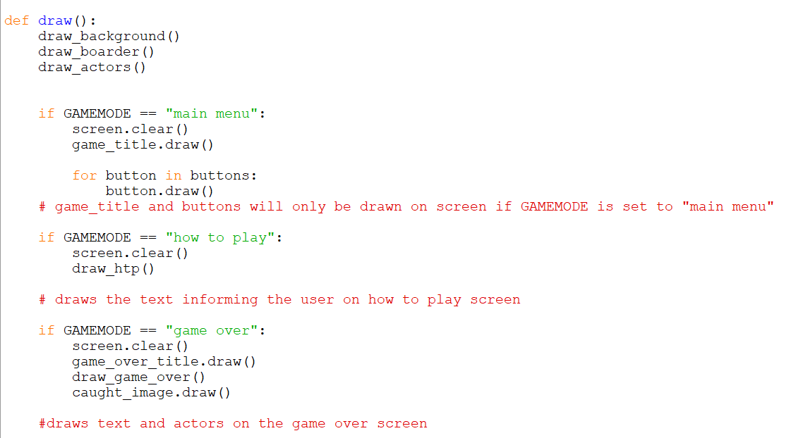

Finally, I added a new IF statement to the ‘draw()’ function that would clear the screen and draw the text and actors for the game over interface.

**Module Testing:**

I tested that the game over title, text informing the user, and picture the of the thief being caught was shown on screen. However, there was a lot of trial and error in getting the right positions on screen.

I also tested that when the spacebar is pressed the level is reset and displayed again. Although, there was a problem as when I pressed space bar the level would appear for a brief moment then the game over interface would be displayed again. This was because the game_over variable was still True. Therefore, I changed the variable to False.

**Evidence:**

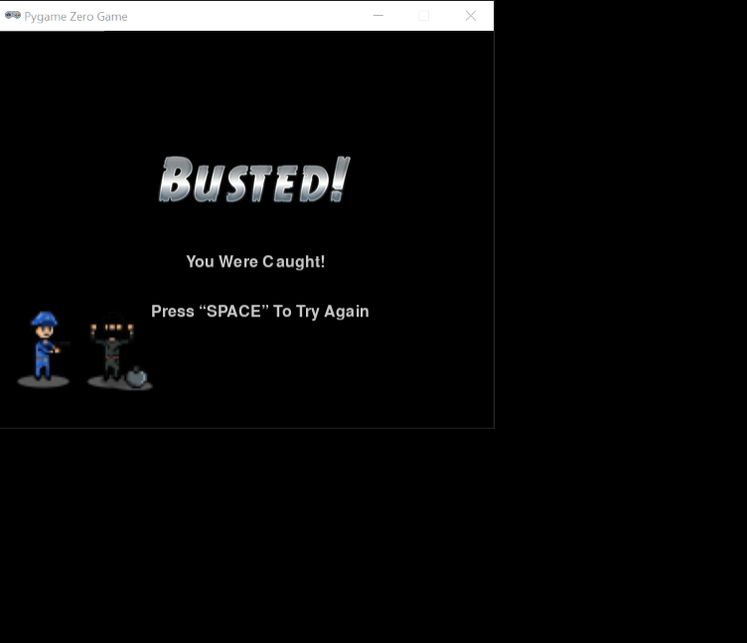

**User Feedback:**

The user thought this was a comprehensive way to inform the user that they were caught.

**Reflections:**

N/A

# Milestone 8 – Game Won Interface

**Explanation of the code:**

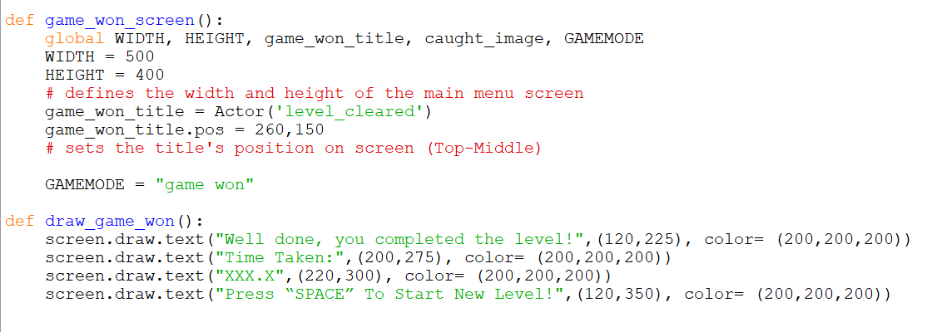

Similar to the game over interface, another function was created to define the game won interface. There is only one image in the game won screen, which is the title, this is defined using the Actor class. The variable GAMEMODE is then set to “game won”.

To draw the text on the game won screen, the function ‘draw_game_won()’ draws the text line by line. The line that displays the time taken temporarily has a string, however when the milestone clock is completed this will display the contents stored in a variable have the time it took for the use to complete the level.

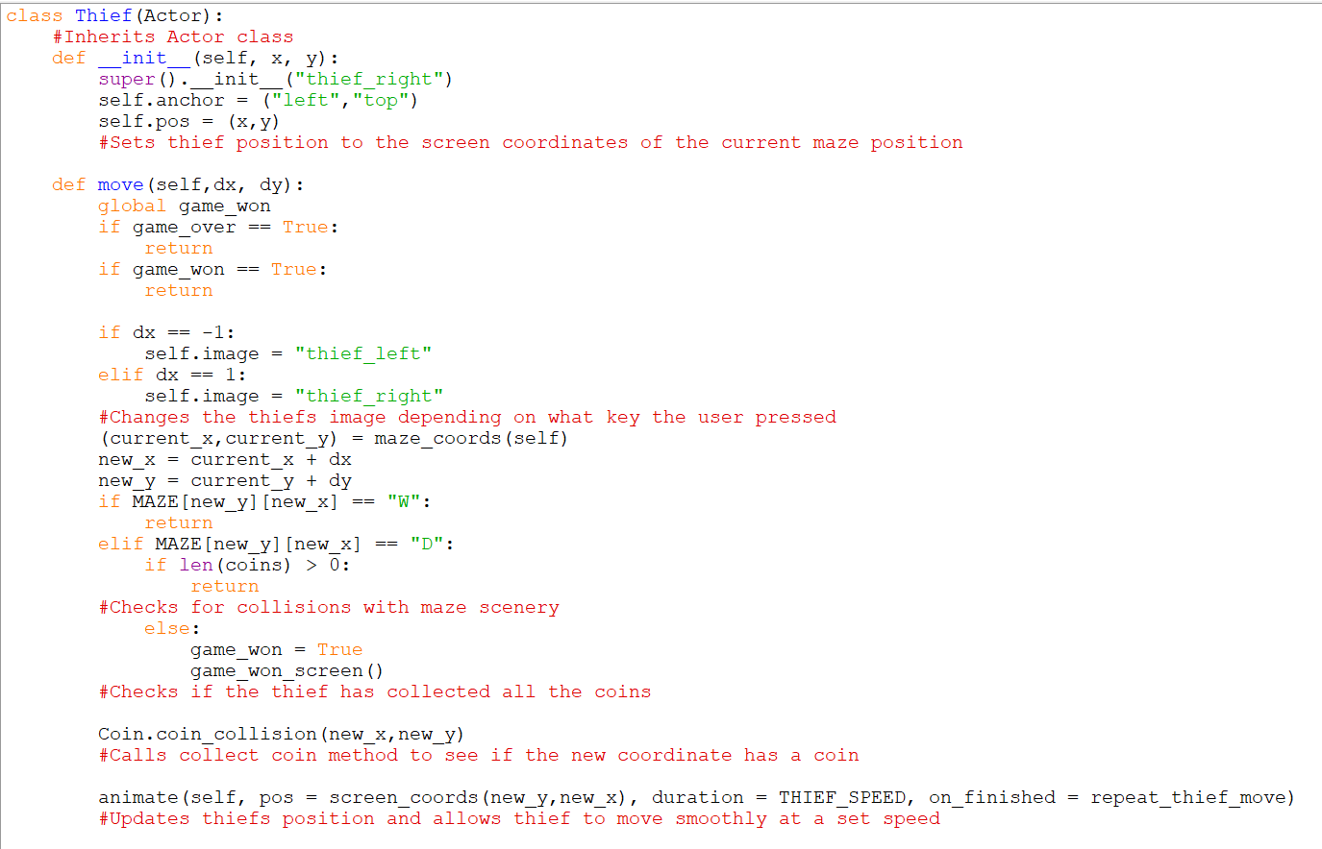

The method ‘move()’ in the Thief class is now updated to stop executing ‘if game_won == TRUE’. This is because the user could now potentially move outside the maze as when the user has collected all the coins, the door is removed. The door in a form of input validation put it place to ensure the thief doesn’t move off the screen.

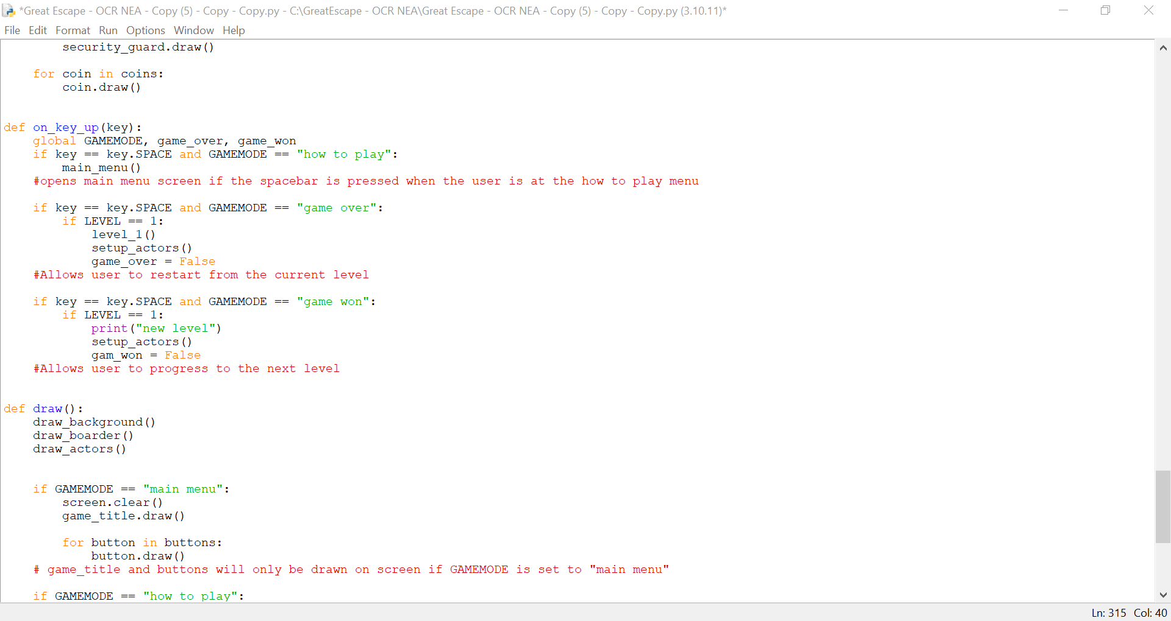

To allow the user to progress to the next level, the ‘on_key_up()’ event handler is updated to accept a spacebar input when the user is on the game won screen by using IF statement that checks if the user has pressed the spacebar and the GAMEMODE is set to “game won”. As there are no other levels at the moment the IF condition only prints the statement “new level”. When there are new levels the next level function will be called.

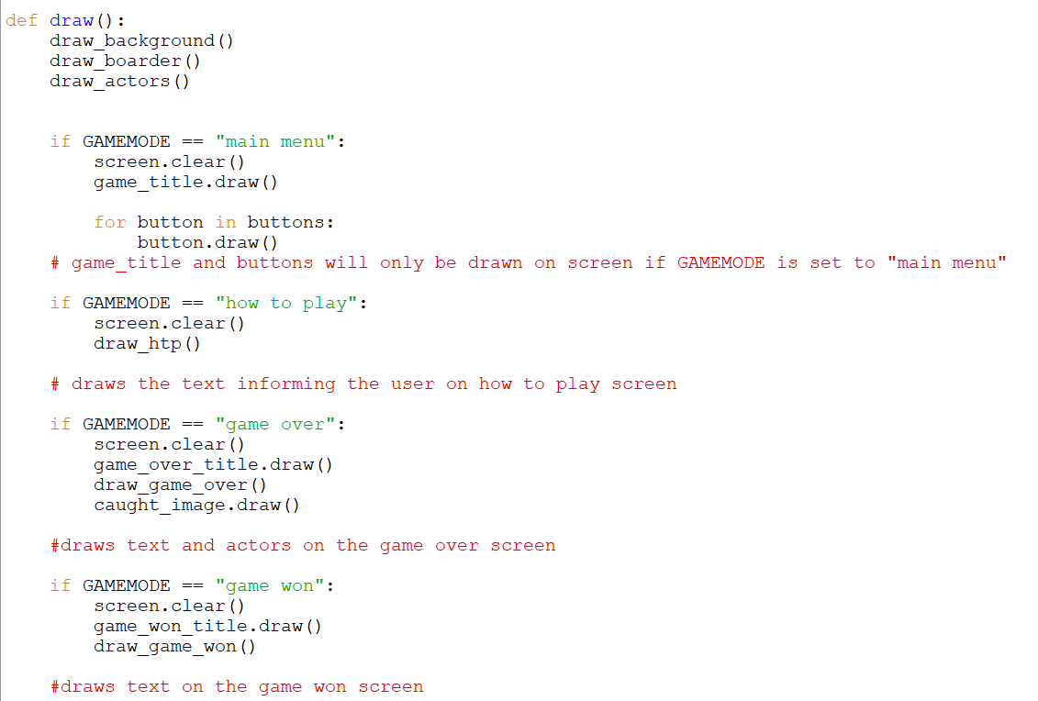

Finally, I added a new IF statement to the ‘draw()’ function that would clear the screen and draw the text and title for the game won interface.

**Module Testing:**

I tested that the game over title, text informing the user, and picture the of the thief being caught was shown on screen. However, there was a lot of trial and error in getting the right positions on screen.

As I can’t check that the space bar progresses the user to the next level, I will come back to test this once new levels are added.

**Evidence:**

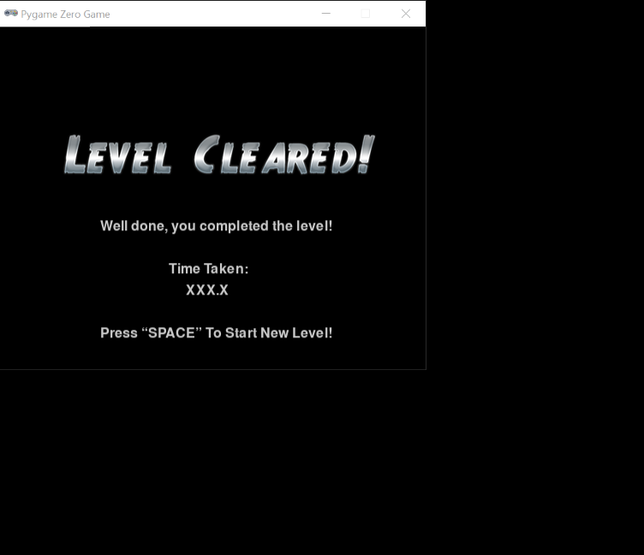

**User Feedback:**

The user thought that the design of this usability feature displayed the information well.

**Reflections:**

N/A

# Milestone 9 – Diamond & Dynamite Powerup

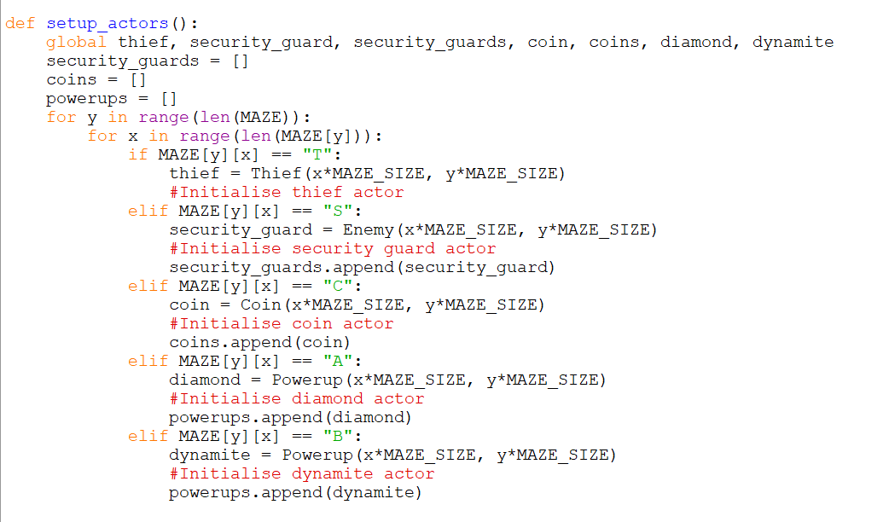

In the ‘setup_actors()’ function, I added lines of code that initialised both the dynamite and diamond to the Powerup class and appended their position to the Powerup class.

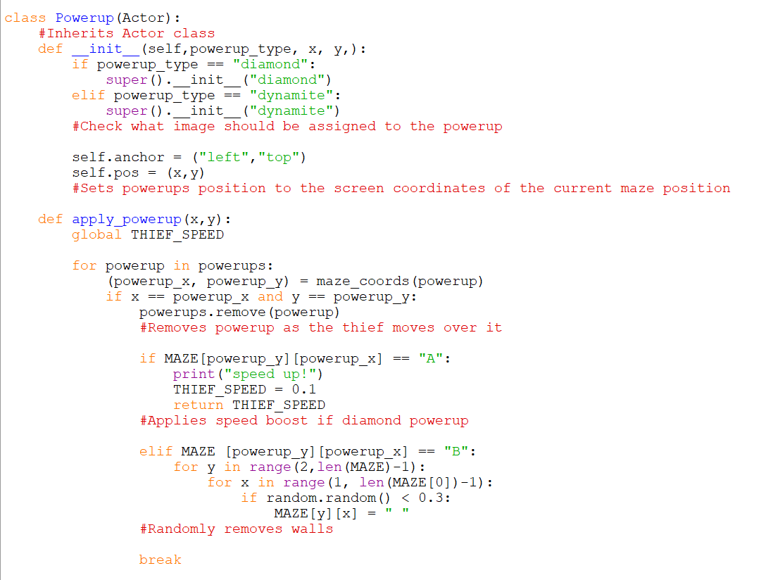

In the design stage both powerups had separate classes, however I have decided to use one class and have the different powerups as objects as it saves space as there is fewer lines. Within the constructor super().init__ is used to inherit attributes and methods from the Actor class. IF statements are used to check what image should be assigned to the powerup using a new variable called ‘powerup_type’ which holds the name of the powerup.

The function ‘apply_powerup()’ takes the thiefs coordinates as parameters (x,y). I then used a FOR loop to iterate through all the powerups in the powerups list. For each powerup their coor=dinate is obtained by using the function ‘maze_coords()’. Then using an IF statement it checks that the thief and powerup are on the same coordinate. If so the powerup is removed from the screen using ‘.remove()’ which is a method in the Actor class.

To apply the relevant effect, an IF statement uses the position of the powerup and checks if that position in the maze array holds the item “A” or “B”.

If the item is “A” then the diamond powerup is applied. However, I had some difficulty in making the effect temporary. The pseudocode used in the design stage does not work as the WHILE loop made the game crash. I then tried a for loop which used ‘in range(0-4)’. However, the new problem was that ‘time.sleep(1)’ made the whole game pause for a second which prevented the user from moving. Therefore, I have decided to let the effect last until the user completes the level or loses which is the variable THIEF SPEED increased to 0.15.

If the item is “B” then the dynamite powerup is applied. A nested FOR loop iterates through the 2D array MAZE. I adjusted where the iteration starts to account for the black UI added to the array, it now starts from 2 instead of 1. Using the Python library import, a number is randomly generated if the number is less than 0.3 then a set number of walls are removed from the maze.

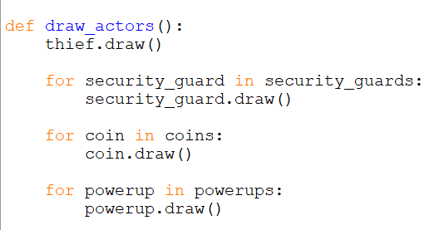

Finally, to draw the powerup on the screen, I added a FOR loop In the ‘draw_actors()’ function that iterates through the ‘powerups’ list and draws each powerup.

**Module Testing:**

I tested that both the diamond and dynamite powerup spawns on screen.

However, the diamond powerup did not temporarily increase the speed, once the powerup was applied it remained.

The dynamite destroyed walls that acted as validation which wasn’t intended to happen. I fixed this by changing where the iteration of the maze started from.

Both powerups disappeared when the thief was on the same coordinate.

**Evidence:**

[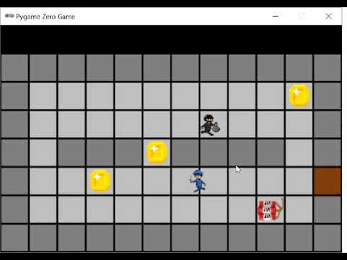](https://www.youtube.com/embed/DKrm-MToizs?feature=oembed)

**User Feedback:**

The user was a little disappointed with the outcome of diamond powerup, however they though that the dynamite powerup followed the criteria exactly and was a good implementation to the game.

**Reflections:**

N/A

# Milestone 10 – Clock

**Explanation of the code:**

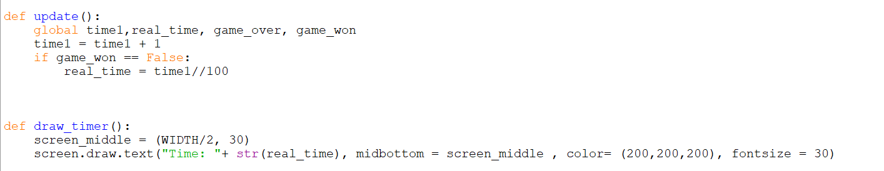

To complete the clock milestone, I use a youtube video by LovJak(2020). To increment the timer, the function ‘update()’ is used. Each time the game updates, the variable time1 is incremented by one, this is intended to represent the seconds increasing. To ensure the time stops counting when the game is won, an IF statement checks if the user has not won the game. The function then takes the number on the time1 clock and divides it by 100. This gives a rough estimate of how many seconds have passed since the user has started playing. Then it writes this number on another variable called ‘real_time’.

‘real_time’ is then used in a function called ‘draw_timer()’. This function will draw the contents stored in ‘real_time’ as the game updates and the time is incremented. As the clock is supposed to be drawn in the centre of the black UI. The screen_middle variable divides the width by 2 to find the centre and sets its y value as 20. This is then used to set the position of the clock.

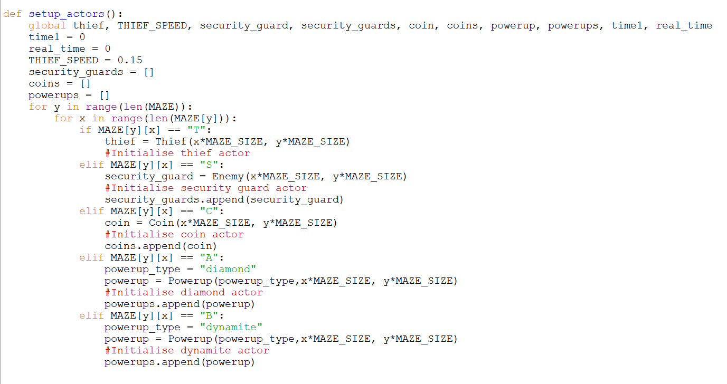

In the ‘setup_actors()’ function, the variables ‘time’ and ‘real time’ are set to 0. I have decided to define them in this function as this is the function that is called to reset all the actors when the user loses. Therefore, the timer will be reset alongside the actors.

I am having difficulty creating the high score feature as I am not sure where to start.

**Module Testing:**

I tested that the black UI is shown with the user’s time and that it starts as soon as the user starts the level. I tested that the users time is recorded and shown on the game won screen, however I cannot save this time to a file as it hasn’t been created.

**Evidence:**

**[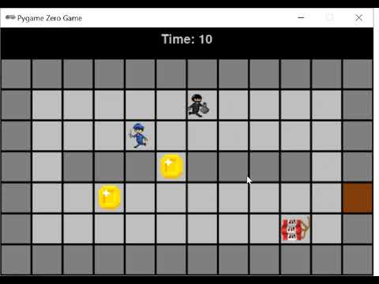](https://www.youtube.com/embed/HwXJVDHzfZI?feature=oembed)**

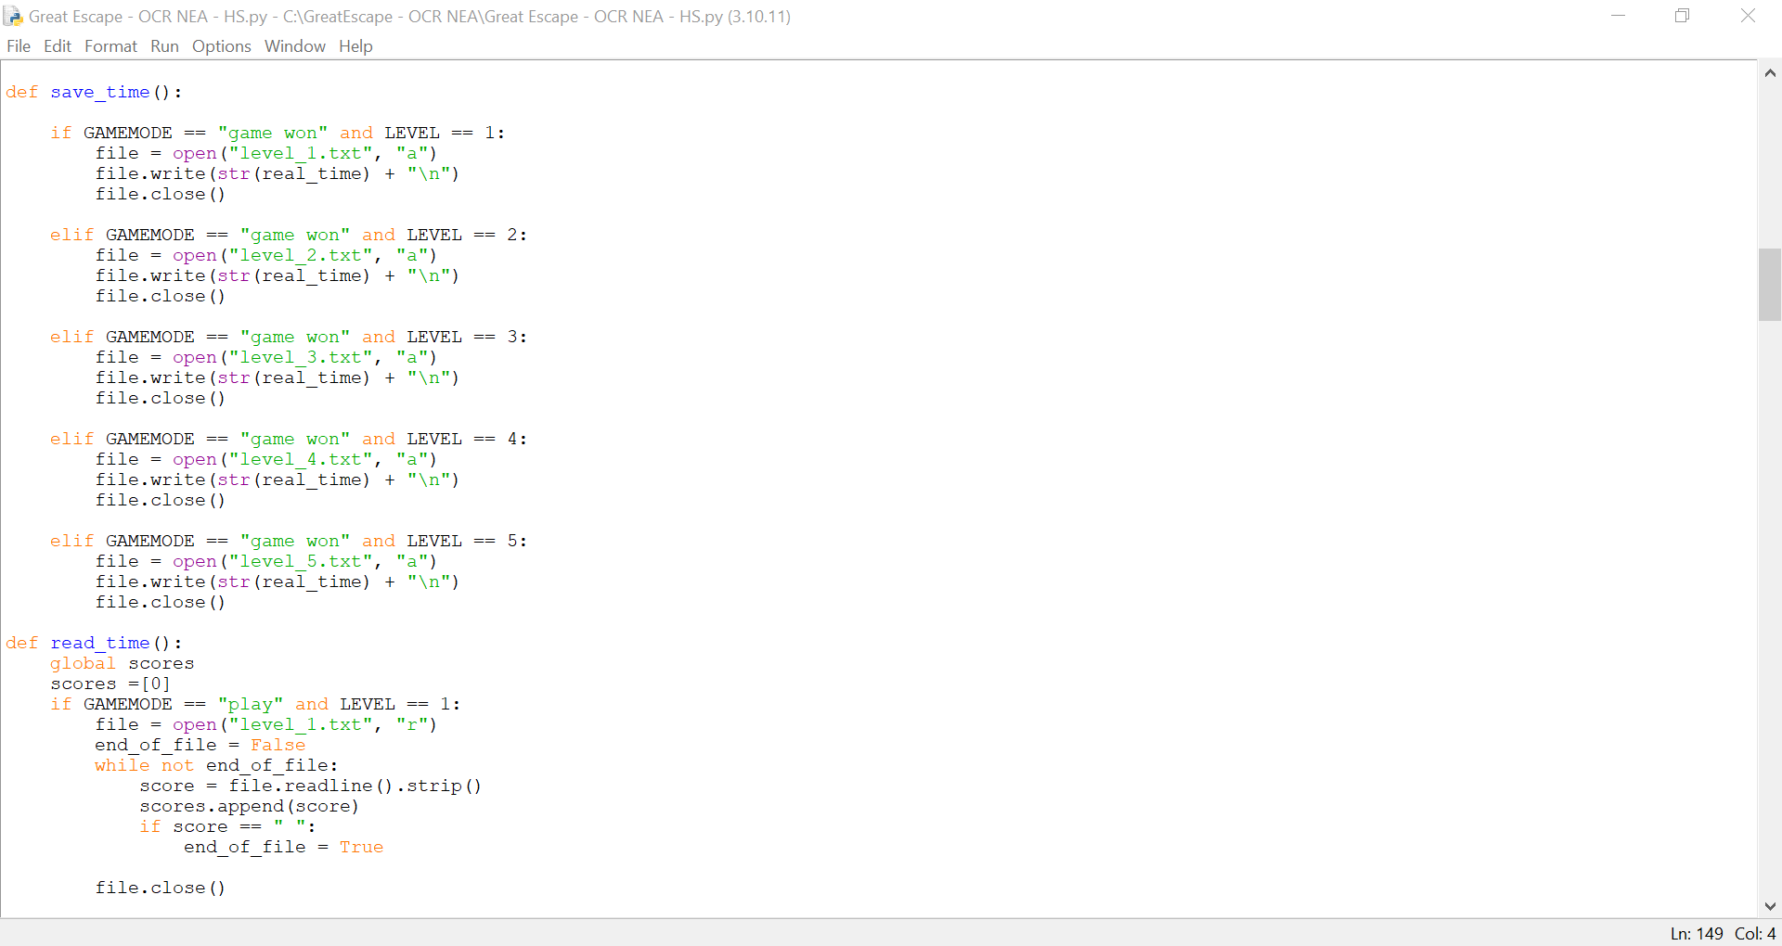

I used a YouTube Video by Craig'n'Dave (2020) to understand how to manipulate files.

To save the users time, a new function is created called ‘save_time()’. To save the users time to the relevant level, I had to take a different approach to my design. I now have 5 different txt files (one for each level) that will store the users time.

IF statements check if the user has completed the level and what level the user is currently playing.

Each IF statement opens the relevant level file and writes the contents stored in the variable ‘real_time’ by converting it into a string using ‘str()’. To allow new times to be added “\n” creates a new line. Finally the file is closed using ‘file.close()’.

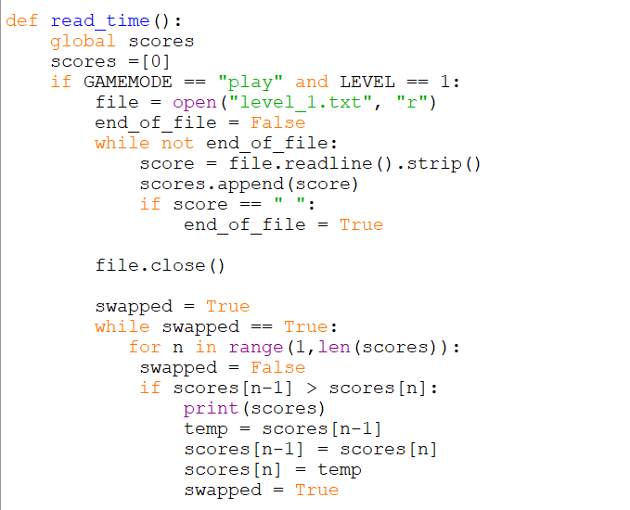

To read the times saved to a file, a new array called ‘scores’ that will hold all the times read for that specific level txt file. Initially the array holds 0 as when a new level is played hat does not have a high score, the high score will be set to set and displayed on screen.

For this section of code I watched Craig’n’Daves video for assistance. For each of the level files, end_of_file is set to False. A WHILE loop iterates through the lines of the file and appends the time to the list ‘score’. An IF statement checks that the contents stored in the variable ‘score’ is empty. When this is evaluated as True then end_of _file is set to True aswell to end the WHILE loop.

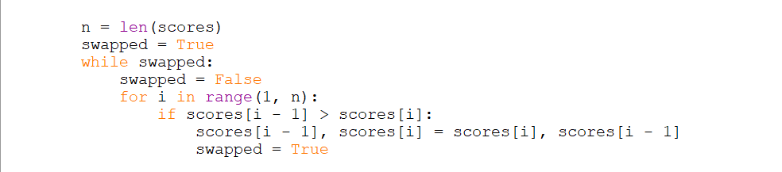

To sort the times held in the array ‘scores’ a bubble sort is implemented which I used in a previous project. ‘n’ holds the length of the array ‘scores’ and ‘swapped’ is initially set to True. A WHILE loop sorts the array until ‘swapped == False’. For a swap to happen, swapped is set to False then a FOR loop iterates through the array from the first index to the last using ‘n’. If the previous time held in scores[i – 1] is greater than the time held in scores[i] then a swap is initiated. By using this method to swap the items there is no need for the temp variable that is usually incorporated in bubble sort.

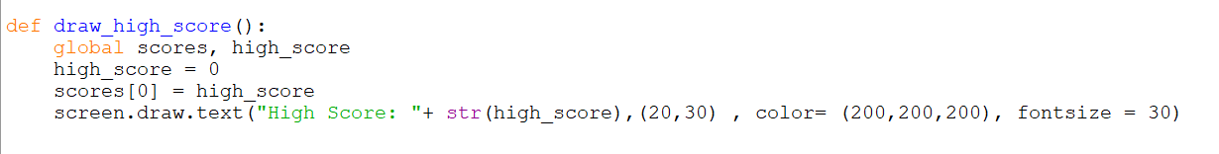

To draw the high score on screen, the variable ‘high_score’ uses the first item in the index of the sorted array ‘scores’ and displays this on screen using screen.draw.text.

**Module Testing:**

The high score appeared on screen, but it wasn’t in the correct position. In addition, when I completed the first level and ran the program again. The high score didn’t change meaning it wasn’t saved. I assumed this was due to the 0 used in the array ‘score’ as when the array is sorted it is the lowest score which means it will be used.

**Evidence 1 (Error):**

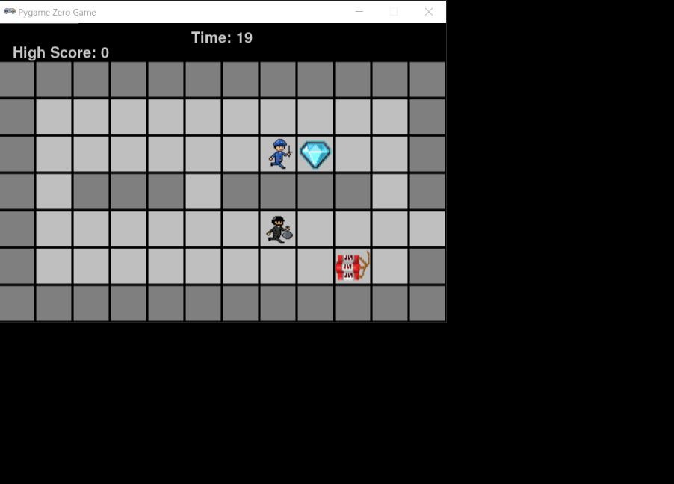

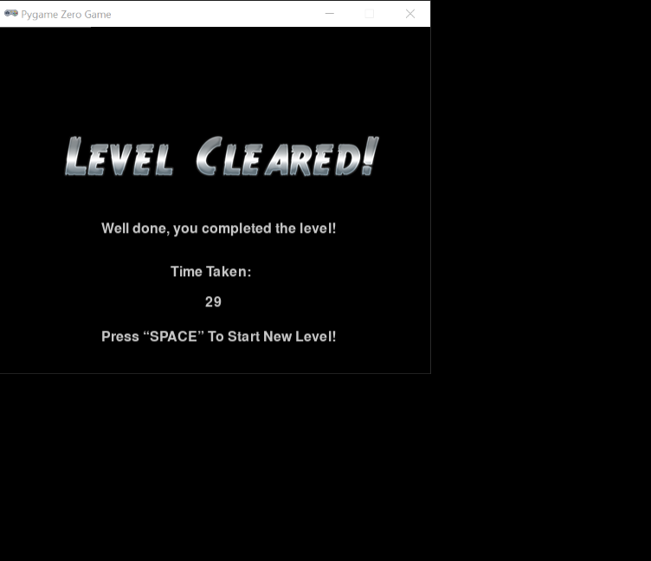

Time that should have been saved as the high score

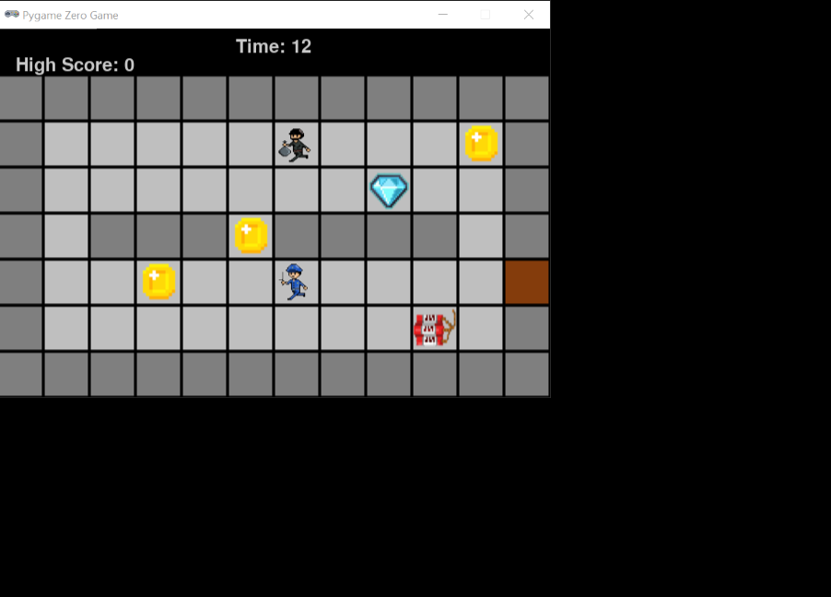

**Reflections Based on Test:**

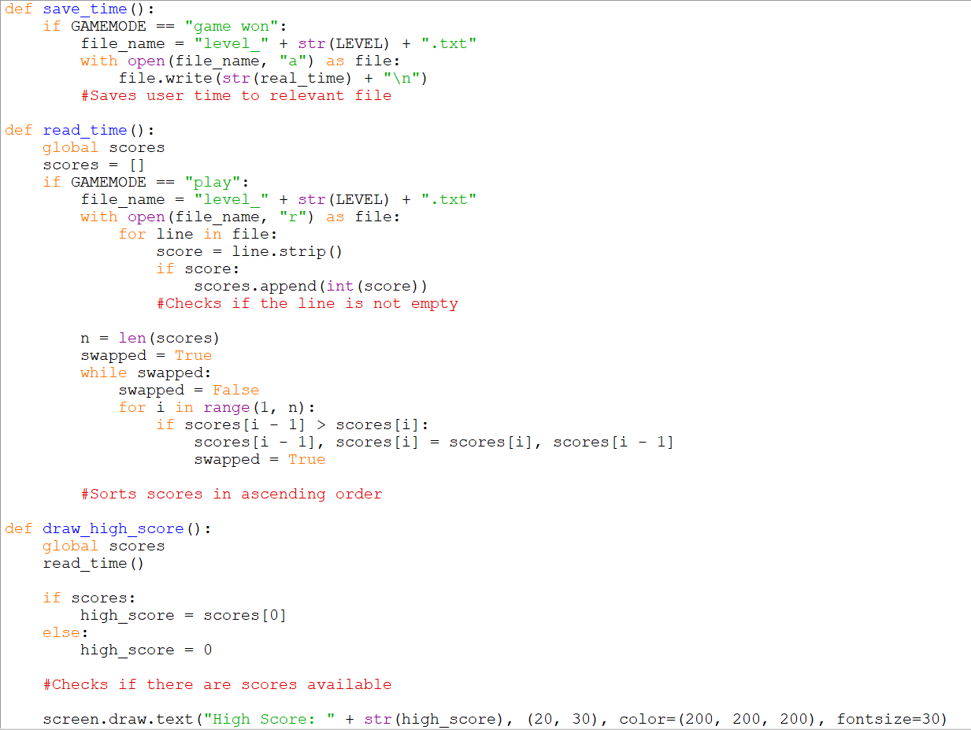

To reduce lines in the code, I concatenated “level_” with the current level the user is playing (LEVEL) to get the file name to be used.

For the next part I used… this showed me that I needed a FOR loop instead of a While loop to iterate through the lines and at the end use and IF statement to check is there is a score present to append to the array.

To fix the actual problem, I checked if the file had been written to as if there was nothing in the file the array ‘scores’ would be empty. If the array is empty then the high score is set to 0.

I also adjusted the x and y position of ‘screen.draw.text()’ so it was in the right place.

**Module Testing 2:**

The first levels high score was displayed and updated when I completed the level. However when I progressed to the next level it produced an error (below).

**Evidence 2 (Error):**

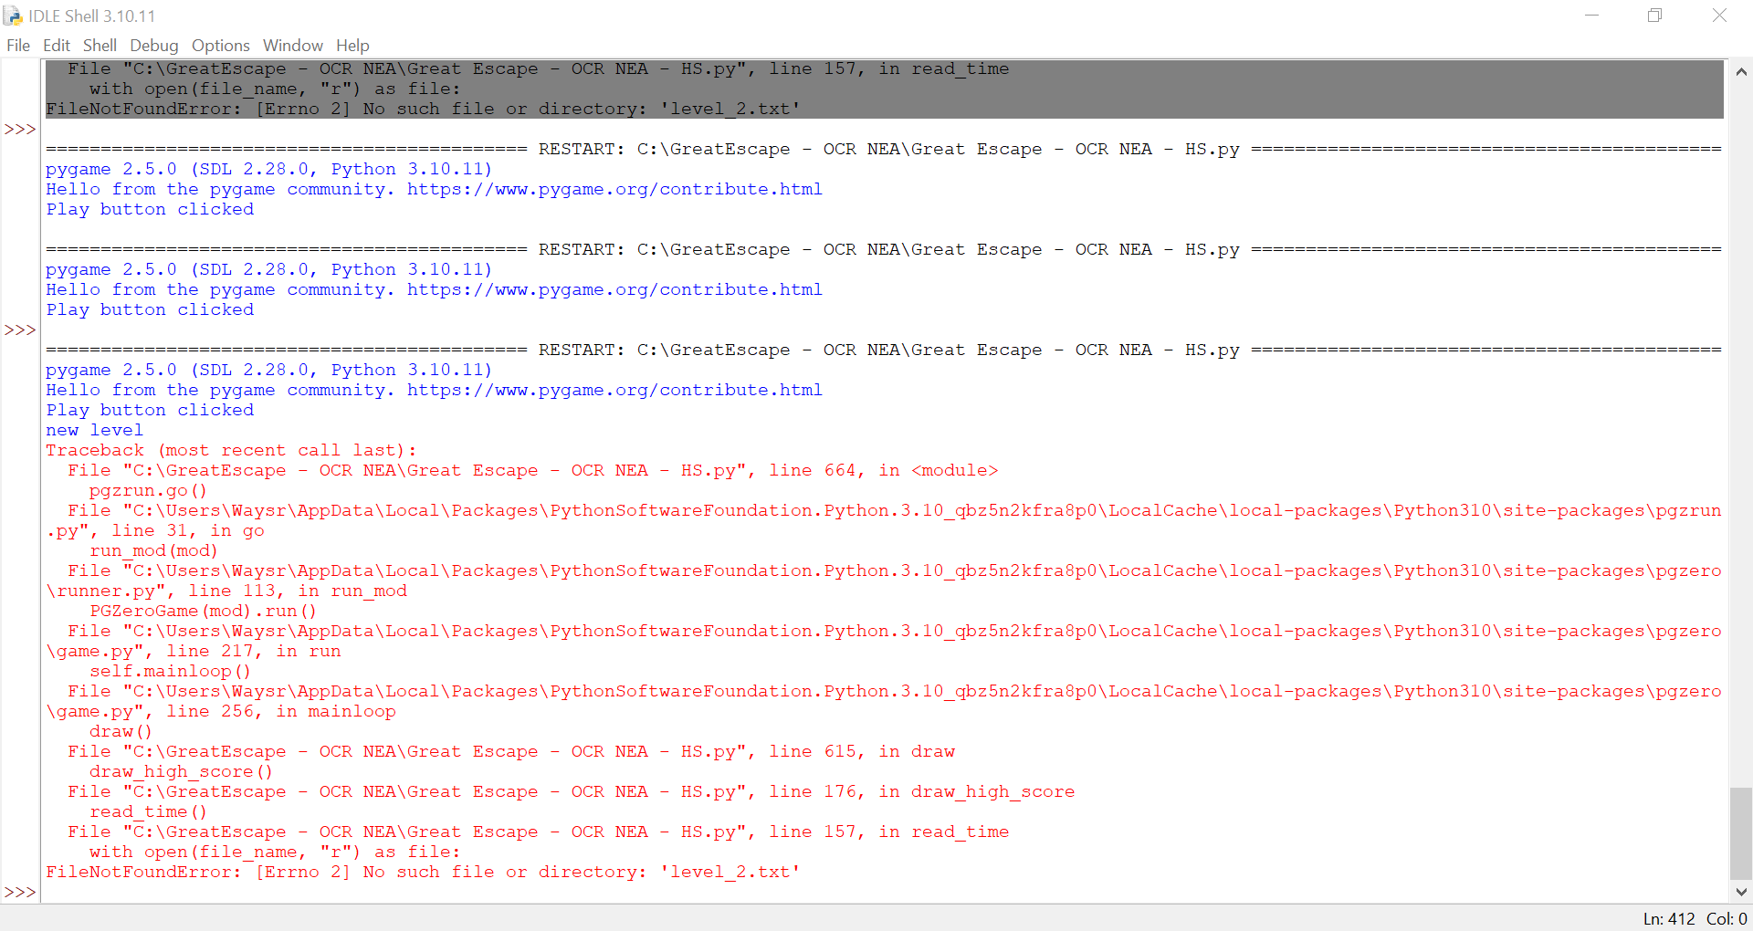

**Reflections based on Testing:**

To fix the error I created 5 extra files in my directory for each of the level. Although I assumed that when using the “a” – append feature when opening a file, it would create one if it wasn’t present already.

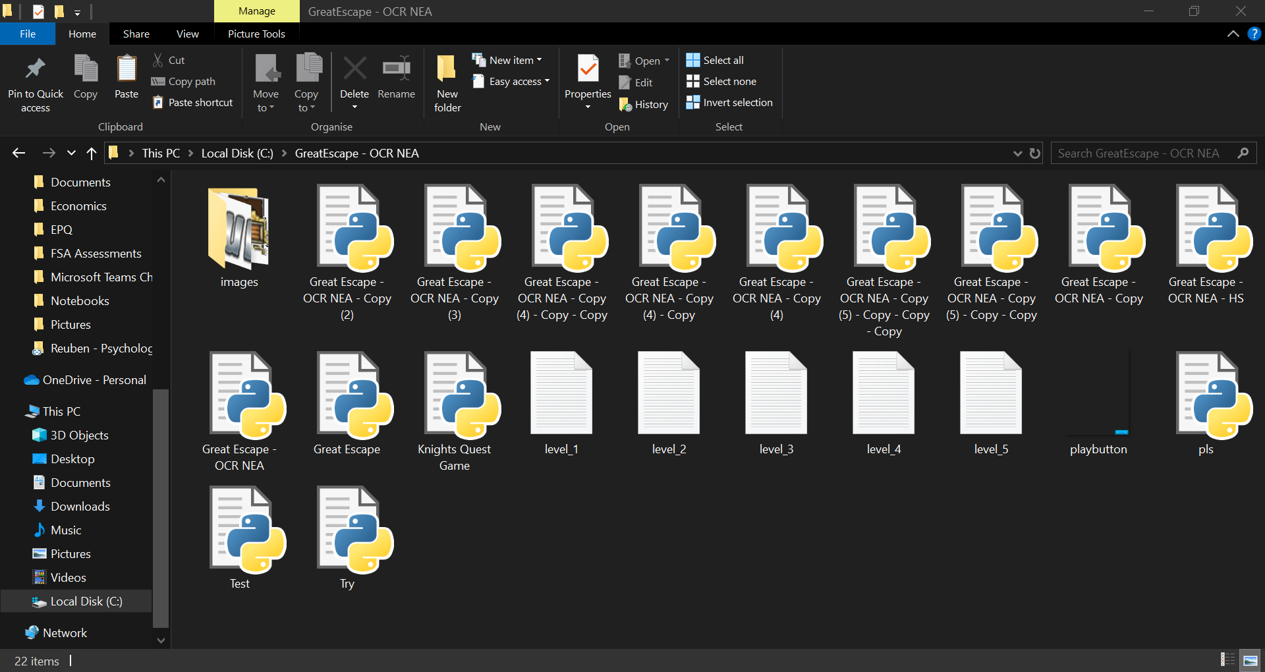

**Module Testing 3:**

I tested that the high score was displayed and updated for each of the levels successfully.

**Evidence 3:**

**[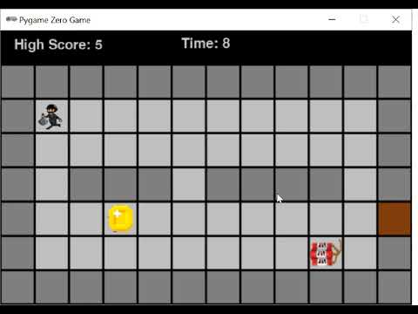](https://www.youtube.com/embed/Wx7iwYpxCkc?feature=oembed)**

**User Feedback:**

My user enjoyed setting all the high scores for the levels. However, they wanted a button that allowed them to restart the level if they had made a mistake and wanted to try again. They also wanted a button/key that would return them to the main menu screen.

**Reflections based on User Feedback:**

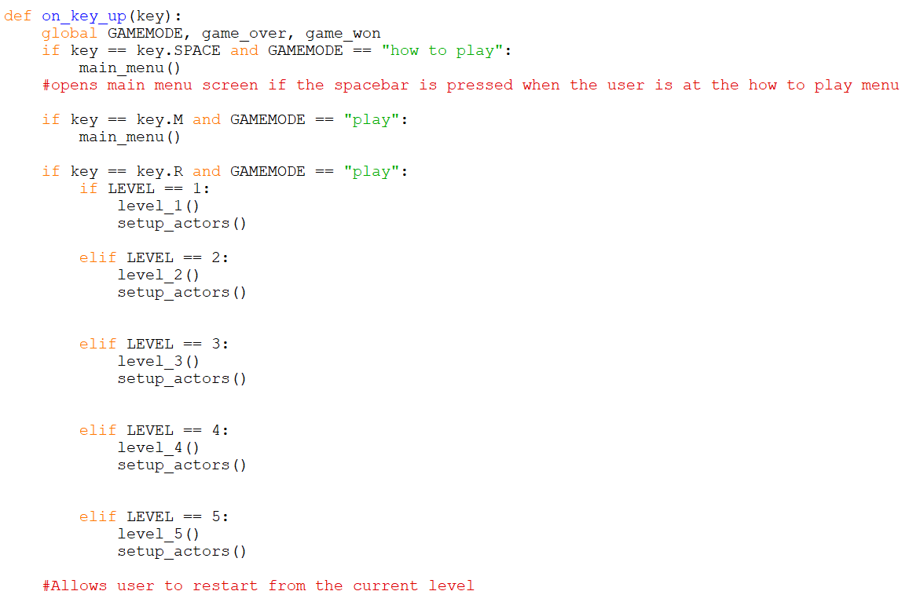

To apply the feedback, I added to the ‘on_key_down()’ function. Which checks if the user has pressed M or R when the GAMEMODE is set to “play”.

To return to the main menu the IF statement calls the ‘main_menu()’ function.

To restart the level a series of IF statements checks what level the user is at and calls the level function associated e.g ‘level_1()’ then calls the ‘setup_actors()’ function to reset the level.

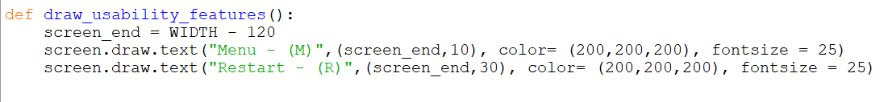

I created a variable called ‘screen_ end’ which will set the position for the text to be placed no matter how wide the screen is as it takes the WIDTH of the screen and subtracts 120.

# Milestone 11 – Game Completed Interface

**Explanation of the code:**

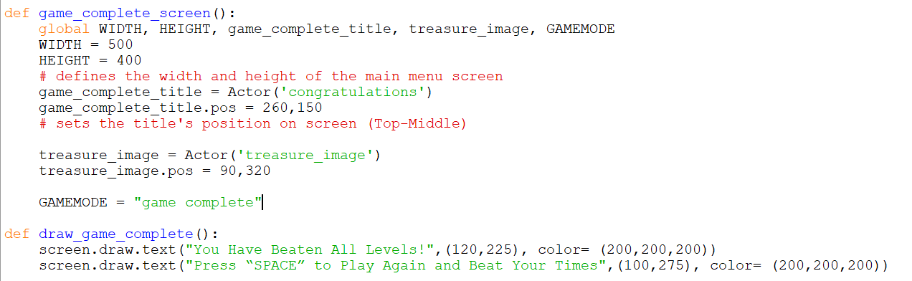

Another function was created to define the game complete interface. The screens width and height are set and images are initialised using the Actor class. The variable GAMEMODE is then set to “game complete”.

To draw the text on the game complete screen, the function ‘draw_game_complete()’ draws the text line by line.

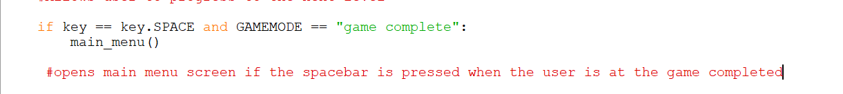

In the function, ‘on_key_down()’ I added another IF statement to return to the main menu screen by calling the ‘main_menu()’. The conditions of the IF statement are that the space key is pressed and the GAMEMODE is equal to zero.

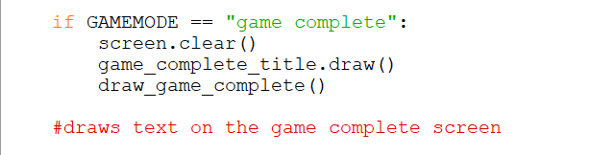

I wrote this IF statement in the function ‘draw()’, It clears the screen using screen.clear() and proceeds to draw the game_complete_title and the text that appears on the screen.

**Module Testing 1:**

The game complete screen was not shown, instead the game won screen was shown. Also, the thief was able to move off the Maze and an IndexError was shown (below).

**Evidence 1 (Error):**

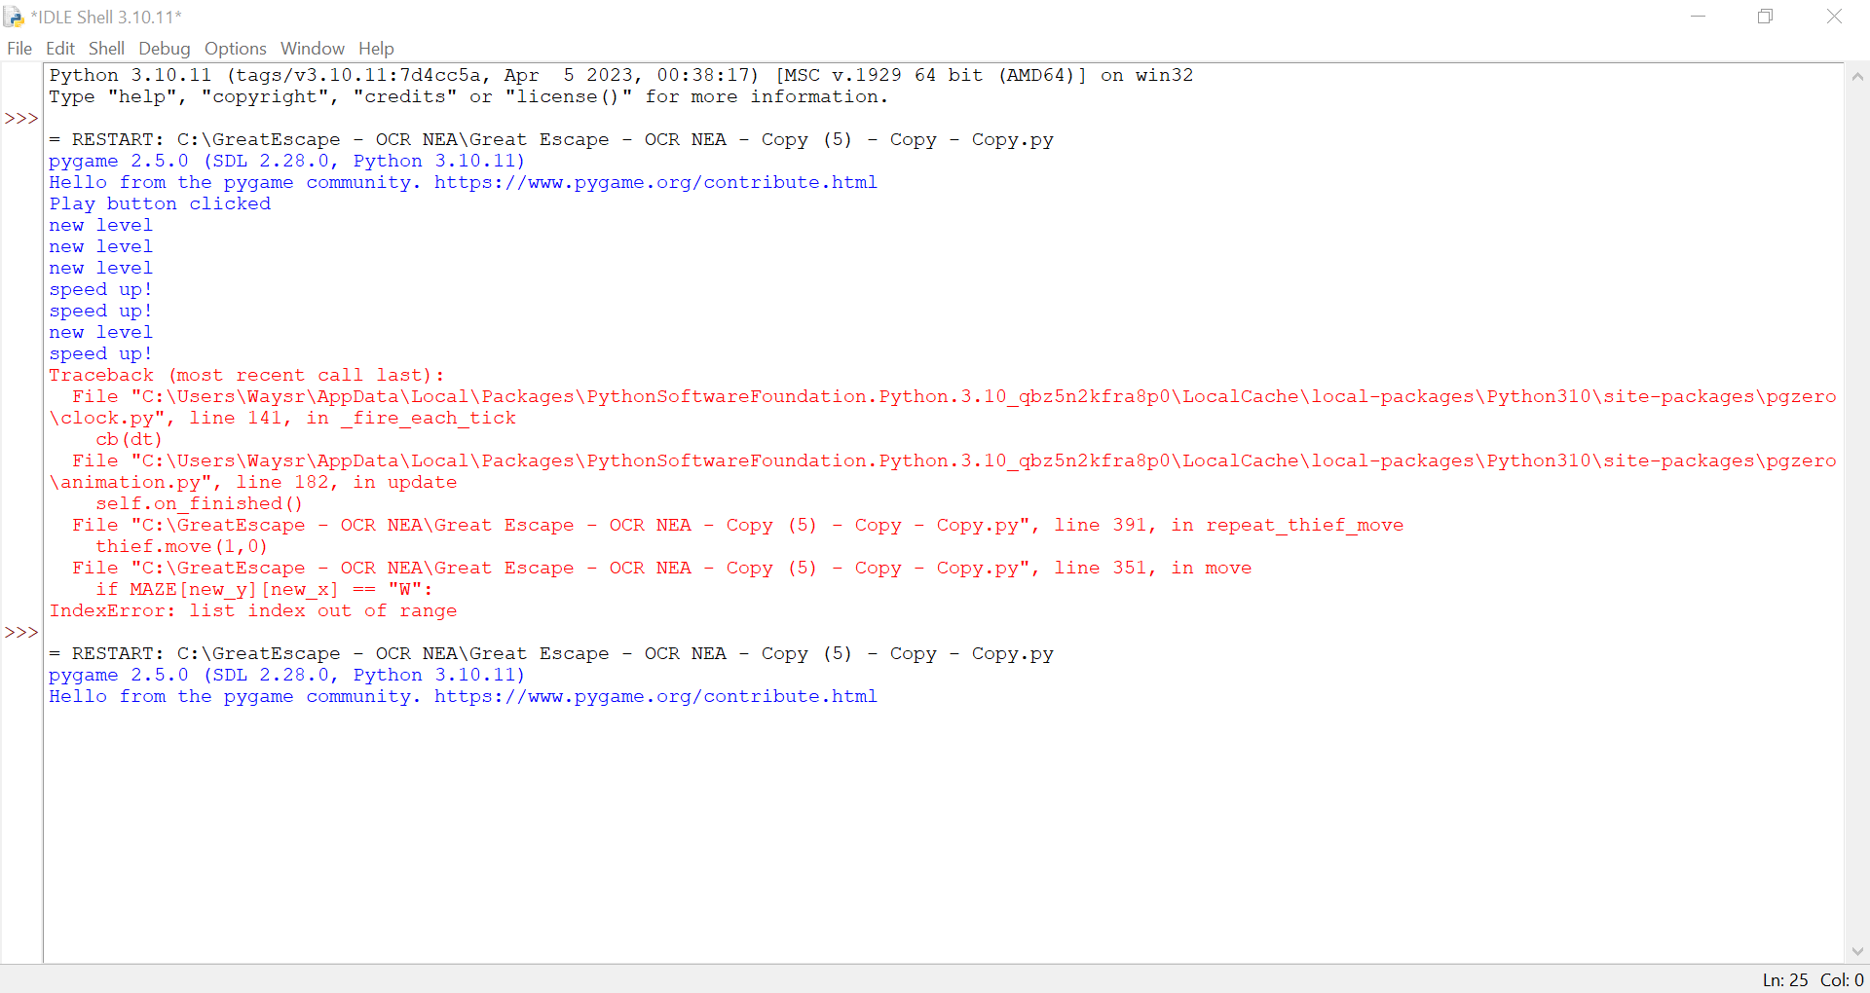

IndexError

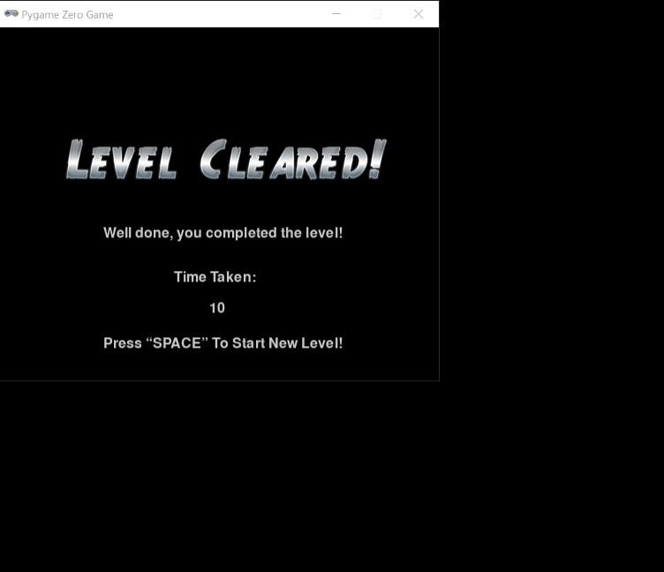

Screen that was shown

**Reflections Based on Testing:**

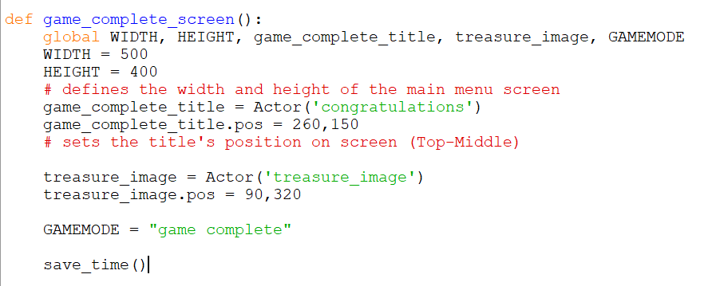

Whist debugging, I noticed that the ‘game_complete()’ function did not call the ‘save_time()’ function. This means that users times would not be saved for the final level.

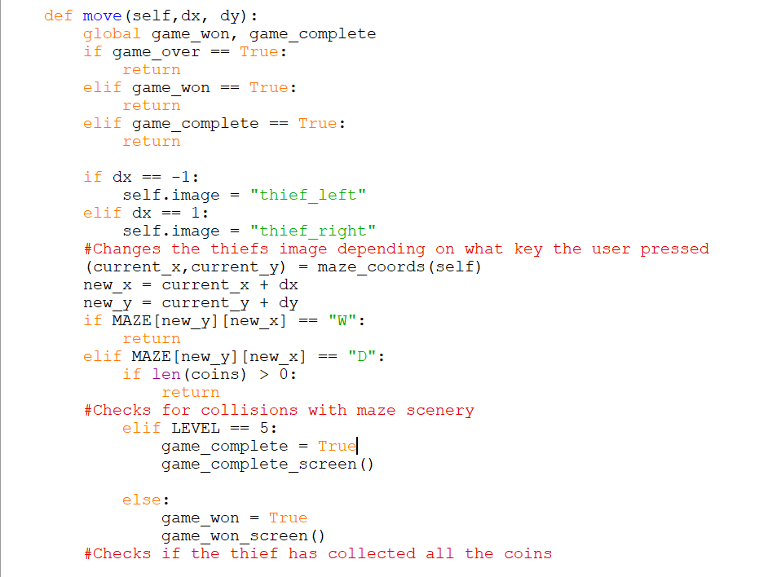

To ensure that the game complete screen appears,I added a new IF statement that checks if LEVEL == 5 which is the final level. If the condition is met, then the variable ‘game_complete’ is set to True and the ‘game_complete_screen()’ function is called.

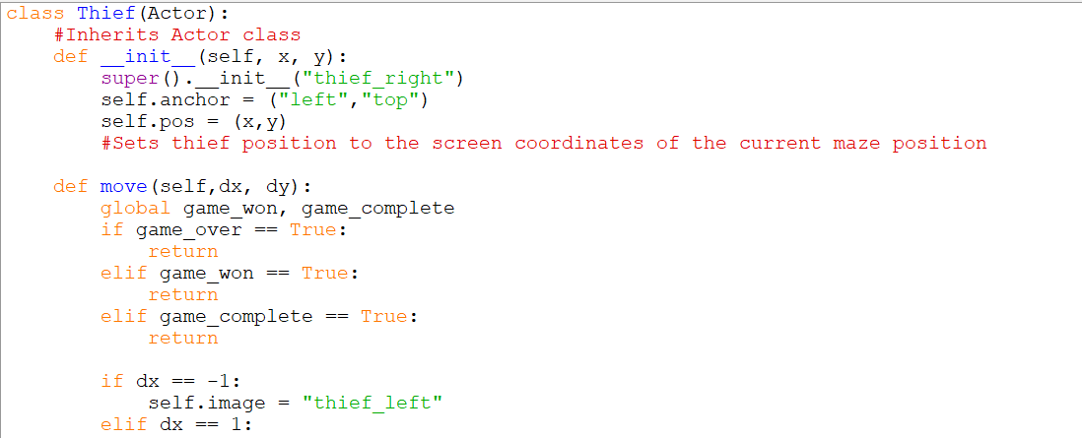To solve the IndexError, I added a new IF statement to the ‘move()’ method in the Thief Class. ‘ELIF game_complete == True’ then the function returns nothing to stop it from executing a new move.

**Module Testing 2:**

I tested that the game completed title was displayed at the centre at the top of the screen. I tested that text was displayed and that the picture of the treasure was displayed at the bottom of the screen. I also tested that the spacebar triggers the main menu to be displayed again, however there was an issue as when I pressed the play button again some actors did not appear.

**Evidence 2 (Error):**

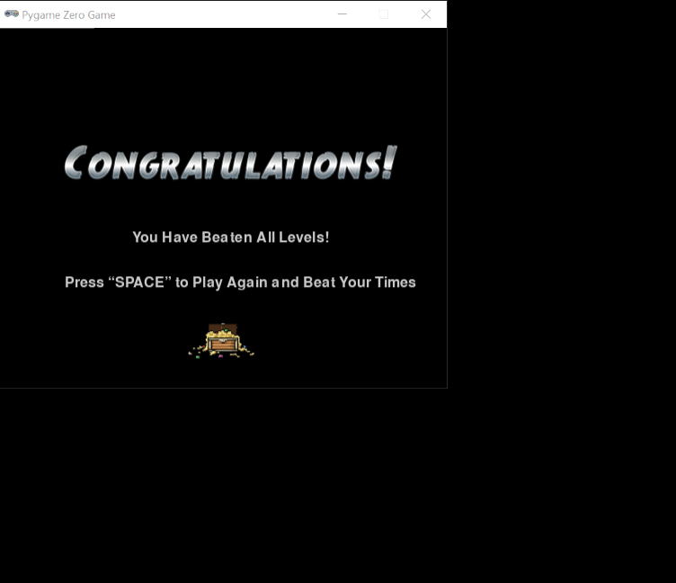[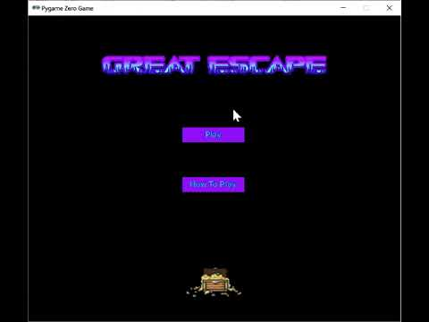](https://www.youtube.com/embed/NwSKxNCFT8Y?feature=oembed)2

**Reflections based on Testing 2:**

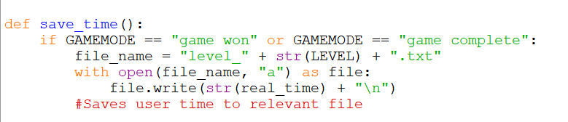

Whilst debugging, I noticed that the users time for the final level would not save. I fixed this by adding another condition to the save time function (GAMEMODE == “game completed”).

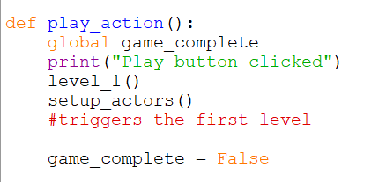

The function ‘play_action()’ for the button was updated to now call the ‘setup_actors()’ function to reset the level and the variable ‘game_complete()’ is now set to False. This is because the ‘game_over’ variable was still set to True when the final level is completed. Inside the ‘move()’ method in the Thief class, there is a IF statement that stops the thief from moving when ‘game_complete == True’. Hence why the thief couldn’t move.

**Module Testing 3:**

I tested that the game completed title was displayed at the centre at the top of the screen. I tested that text was displayed and that the picture of the treasure was displayed at the bottom of the screen. I also tested that the spacebar triggers the main menu to be displayed again.

All were successful.

**Evidence 3:**

**[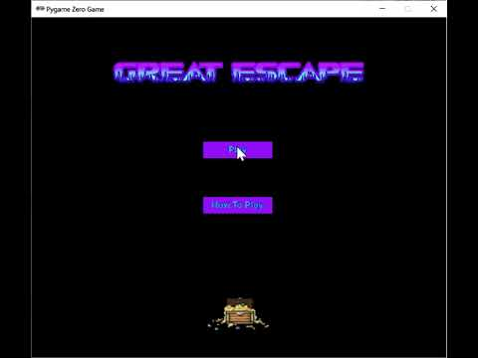](https://www.youtube.com/embed/mYGt96Iv0bM?feature=oembed)**

*\*Please note that there were some issues with screen recording.*

**User Feedback:**

The user wanted a way to see the time achieved for the final level.

**Reflections Based on User Feedback:**

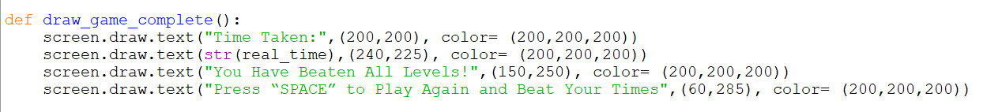

I added text that informed the user on their time, one of the lines uses the variable ‘real_time’ and converts it into a string to be displayed on screen.

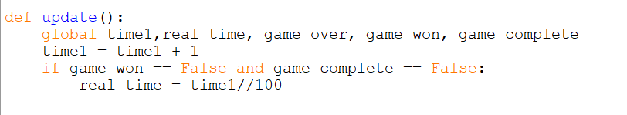

I also made the time stop when the game was completed, by adding another condition to the ‘update()’ function. Now when the variable ‘game_complete’ == True the timer will stop counting.

**Evidence 4:**

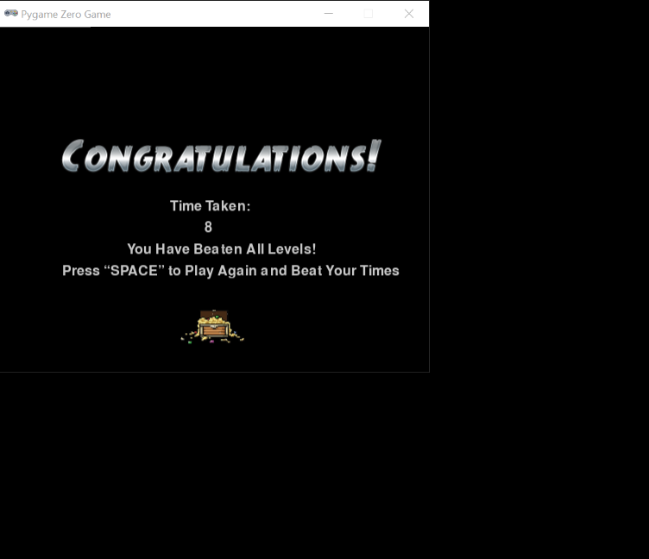

# Evaluation:

# Post Development Testing – Function & Robustness

**Full Game Evidence:**

[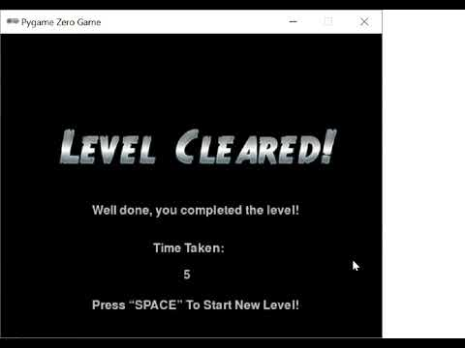](https://www.youtube.com/embed/4HWu80zWPc4?feature=oembed)

**Test For Errors and Robustness:**

I have tested the games robustness examples include. The thief going off the screen, errors when switching between the interfaces, displaying and saving times.

|  |  |
| --- | --- |
| Time Stamp | Description |
| 0:20 | To test that thief does not go off the screen, I moved the thief towards the edge of the screen. As expected, the thief could not move of the screen as the walls act as input validation preventing the user from completing the action. |
| N/A | To test that there are no errors when switching between interfaces. I completed all the levels and interact with all the interfaces. |
| N/A | To test that times where displayed and saved accordingly, I played through each level and achieved different times. The time that I completed the level in was always shown and if it was the lowest time it was displayed as the high score. |

However, there is some unpredictability withing the program as I have recorded some rare instances where the Diamond powerup did not apply the effect to the thief. This is not expected and proves a problem for users trying to complete a level.

**User Final Review:**

“I liked the menu; I think that the choice of colour was quite exciting and intriguing. I believe that the how to play screen had slightly too much writing on it and should be kept short and simple. The levels are very thrilling and although there are only 5 levels, you could spend lots of time playing this game and trying to beat the high score. This is exactly what I wanted in the game – one that would not get boring and challenges you enough to want to keep playing. The map of each level is unique based on the bomb you could get change the map each time. To improve I think it would have been nice if the time was in milliseconds, because for instance the first level, I am able to get a time of 4 seconds multiple times seeing it in milliseconds would mean I could beat it down to the second making it even more exciting and challenging.”

# Usability Features & Testing

**Menu:**

At the start of my game, the main menu appears with the game title and two buttons. The user can interact with both buttons using the mouse.



The Play button effectively takes the user to the main game (Level 1). The how to play button displays the information on how to play.

When the user is playing the main part of the game, the user can press (M) to bring them back to the main menu. Similarly, when the user is finished reading the information on the how to play screen they can press (SPACE) to return to the main menu.

These features make the start of the game navigable and easy to interact with.

**How To Play:**

The user can press the how to play button to call a function which displays the how to play screen.

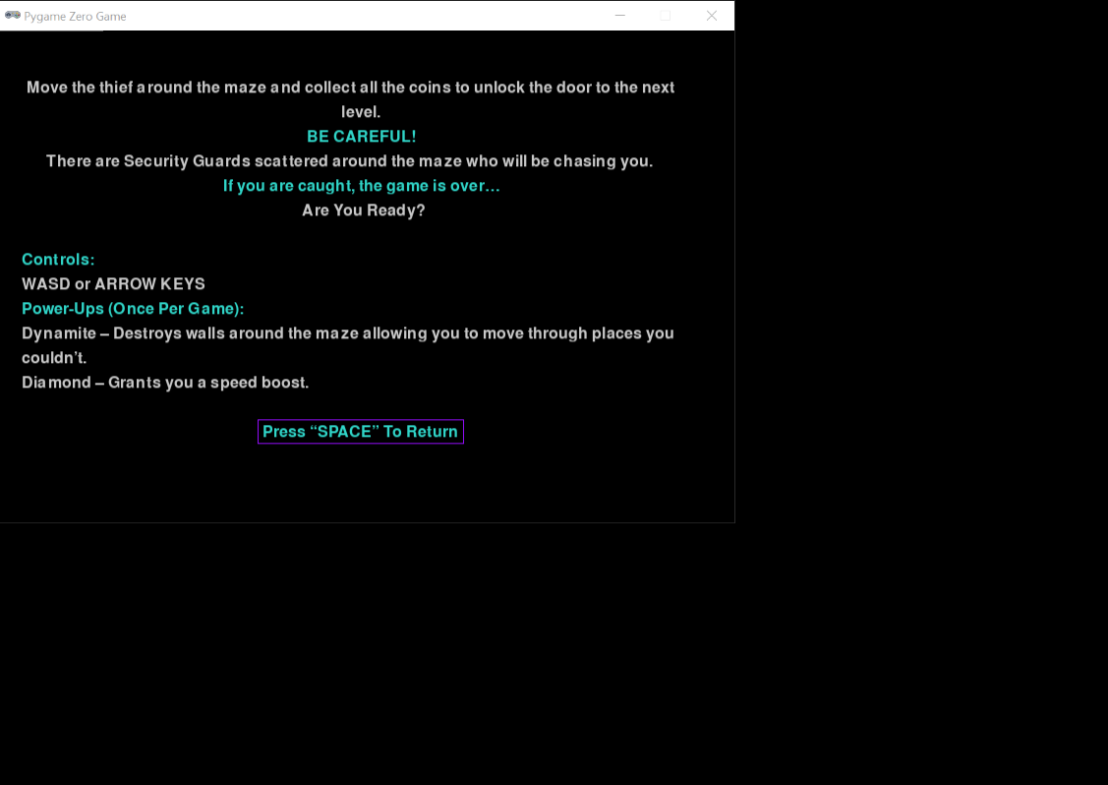

Information on powerups

Aim of the game

Information on the controls

Within this screen the user is debriefed on the aim of the game, how to move the thief character and information about the powerups.

**Usability Interface:**

**During the main game, a black Usability Interface (UI) is displayed at the top of the screen – *similar to the researched game Bomberman.*

* I tested that the high score achieved for that level is visible.
* I tested that the users current time increments in seconds.
* I tested that the buttons (R) and (M) can be pressed in order to restart the level or return to the main menu.

The UI helps the users understand and enjoy whilst they play. The positioning ensures that it doesn’t obstruct or distract the user’s gameplay.

Video evidence of UI and Pressing ‘R’ to restart (Towards End)

**Game Won/Lost/Completed:**



If the thief comes in contact with a security guard, there is a display informing the player that they have lost and have to restart the level by pressing space.

I tested that when the user presses space, the level is reset with all the features in the correct place.



After the player has reached the door after collecting all the coins a new screen is displayed informing the user that they have beaten the level, what time they achieved for the level and that they can progress to the next level by pressing the spacebar is included.

I tested that when the user presses space, the next level is displayed.

Once the user has completed all available levels, the game completed screen is displayed.



The screen informs the user…

* About their achieved time for the last level
* That they have completed all the levels but can go through all of the levels again and attain a new high score by pressing the spacebar.

I tested that when the user presses space, they will return to the main menu.

These three different screens ensure the user knows what is going on at each game event e.g loss, wining, completing the game.

# Evaluation of Success Criteria

1. **Menu – Met:**

Criterion – A menu with clear and distinct buttons must be presented at the start of the game.

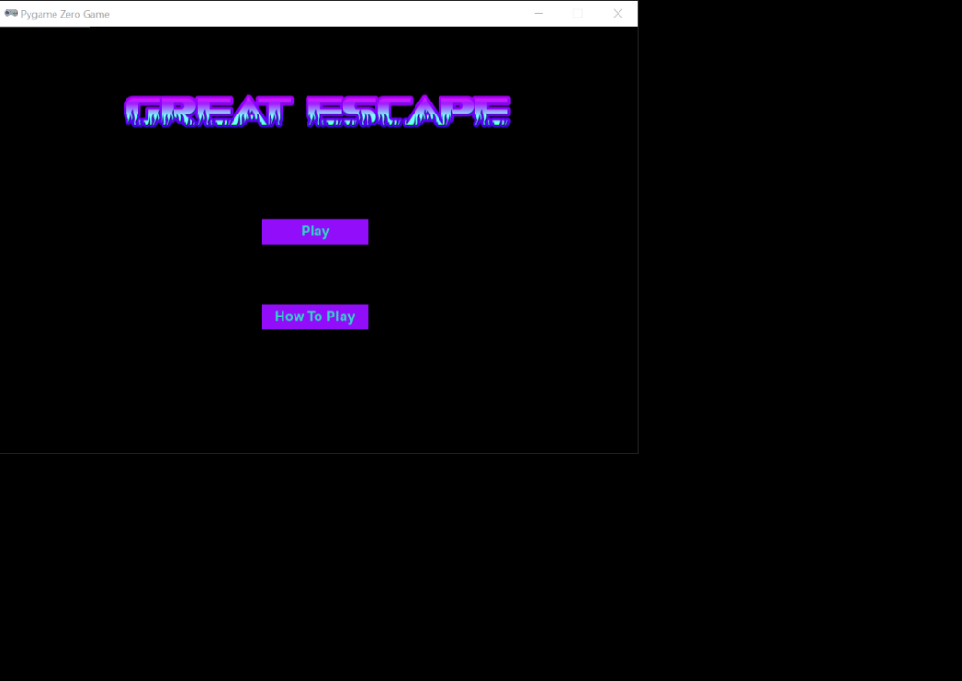

Two distinct Buttons

At the start of my game, the main menu appears with two clear and distinct buttons. The buttons were created using a class which called different functions when a button was pressed.

1. **How To Play – Met:**

Criterion – At the start of the game, the user must be informed on how to play. Information should include details about the aim of the game, how to move the thief character and power-ups.



Aim of the game

Information on the controls

Information on powerups

At the start of the game, the user can press the how to play button to call a function which displays the how to play screen. Within this screen the user is debriefed on the aim of the game, how to move the thief character and information about the powerups.

1. **Levels – Partially Met:**

Criterion – The solution should have 10 levels which the player can progress through.

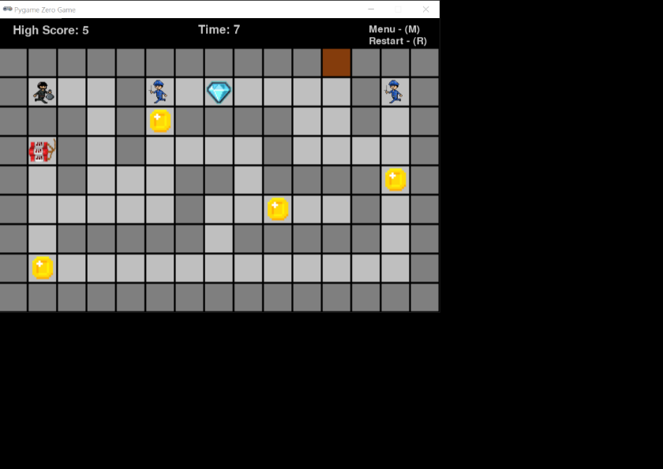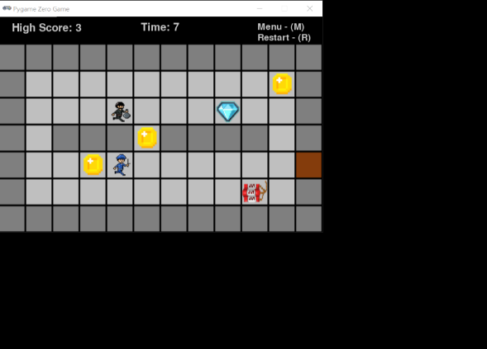

**4.**

**4.**

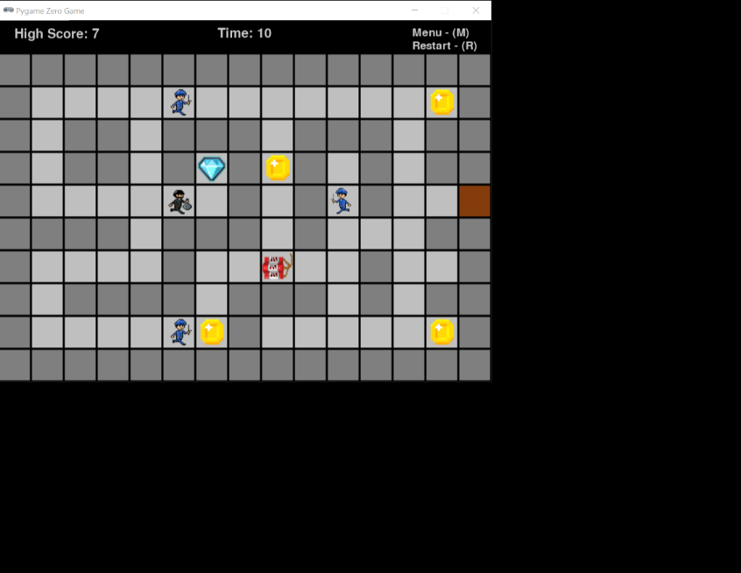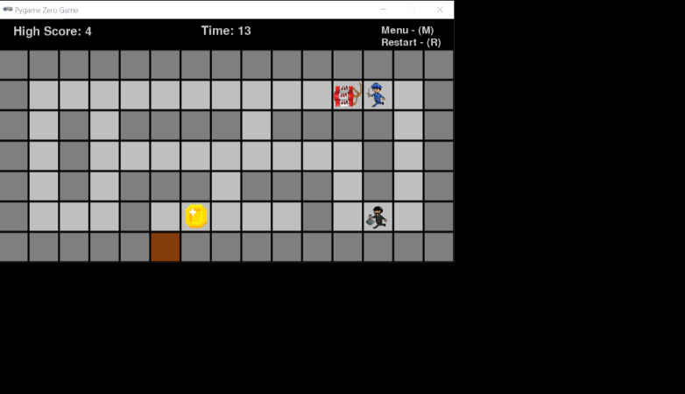

5 unique levels that vary in size

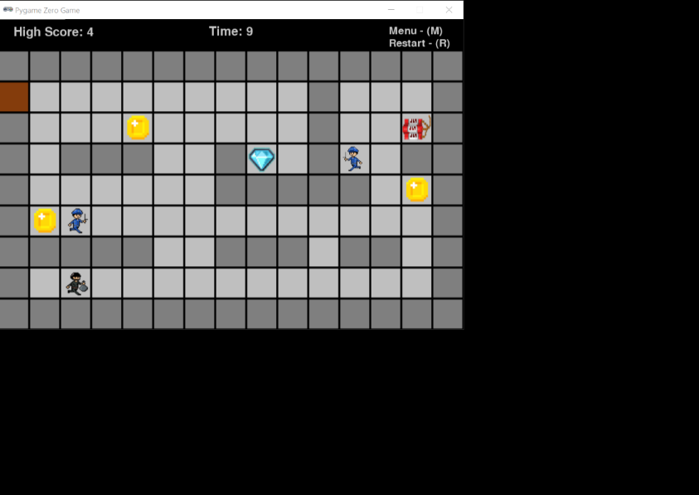

**5.**

The game only has 5 levels because it was difficult to add more features (add more guards, add more coins, make the maze bigger) without disrupting the gameplay experience. For example, too many security guards make the game too difficult for most of the target audience to complete and too many powerups makes the game too easy.

1. **Maze – Met:**

Criterion – The solution must include a unique Two-Dimensional maze layout for each level.

Each of the levels has its own unique Two-Dimensional maze layout stored within a function that is called when the user progresses through the game.

1. **Thief – Met:**

Criterion – The user should move the Thief around the map using either WASD or Arrow keys. The Thief must move to the desired location as intended by the user.



The user is ablet to move the thief around the map using WASD or the Arrow keys. Additionally, the user is not able to move off the maze (screen) as certain conditions act as input validation such as ‘if MAZE[new_y][new_x] == "W"’.

1. **Security Guard – Met:**

Criterion – The security guard character should move towards the player and signal the end of the game upon contact.



The security guard character moves towards the player and signals the game upon contact.

1. **Timer – Met:**

Criterion – There should be a timer displayed at the top of the screen in every level which counts down how long it took to complete the level, this will act as the high score system.

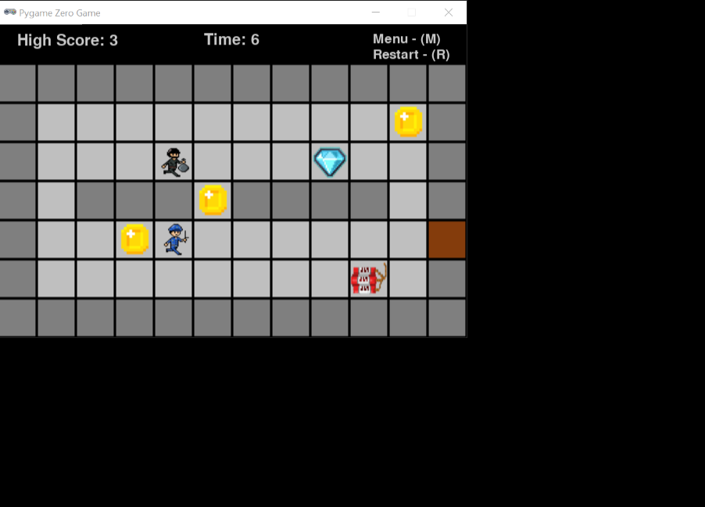

There is a timer that displays the user's time at the top of the screen which counts how long it took to complete the level. The user's time is saved to a file associated with the level and using a sorting algorithm, all times are retrieved and displayed as the high score if it is the shortest time.

1. **Dynamite – Met:**

Criterion – The powerup 'Dynamite' should randomly clear walls in the maze when interacted with by the player.

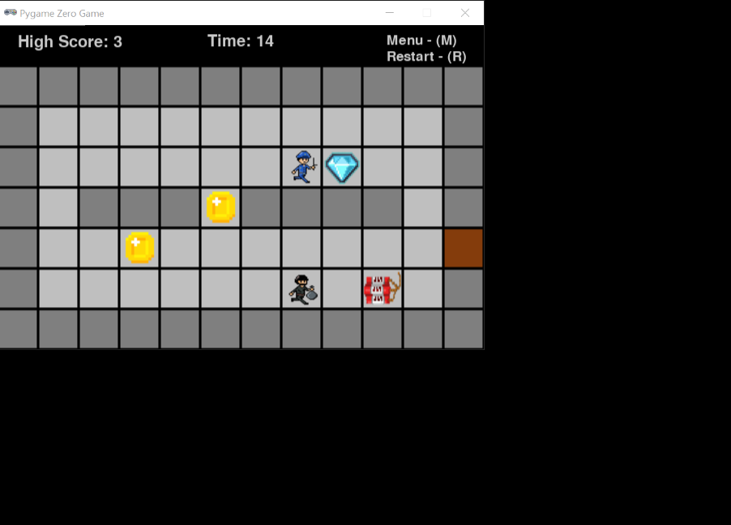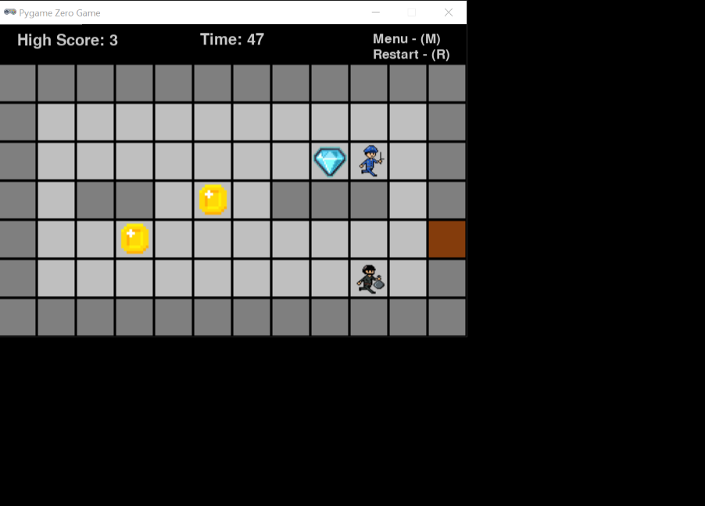

Random walls have been removed

After

Before

The dynamite powerup clears walls in the maze when the thief is on the same coordinate.

1. **Diamond – Not Met:**

Criterion – The power-up ‘Diamond’ should provide a boost to the character's speed for a short duration when interacted with by the player.

The Diamond powerup does not provide a temporary boost to the character’s speed. The final version provides a speed boost for the duration of the entire level. As I had some difficulties, implementing a time feature that would stop the powerups effect after a short while.

1. **Level Won Display - Met:**

Criterion – After the player has reached the exit after collecting all the coins there should be a display informing the player that they have won and that they can progress to the next level.

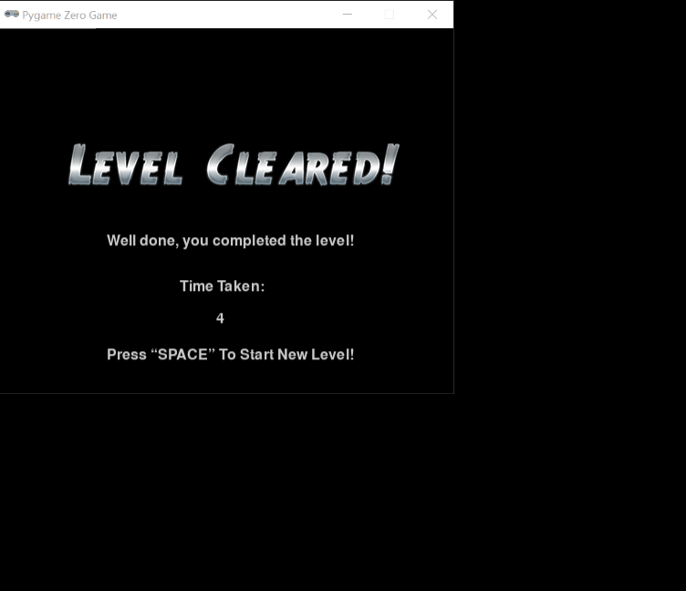

Informational Text

Spacebar Prompt

Time Achieved

After the player has reached the door after collecting all the coins a new screen is displayed informing the user that they have beaten the level, what time they achieved for the level and that they can progress to the next level by pressing the spacebar is included.

1. **Level Loss Display – Met:**

Criterion – If the player comes in contact with a security guard there should be a display informing the player that they have lost and will have to restart the level.



Informational Text

Spacebar Prompt

If the thief comes in contact with a security guard, there is a display informing the player that they have lost and have to restart the level by pressing space.

1. **End Game – Met:**

Criterion – Once the player has completed all available levels available there should be a display informing the player that they have completed all levels but can go through all the levels again and attain a new high score.

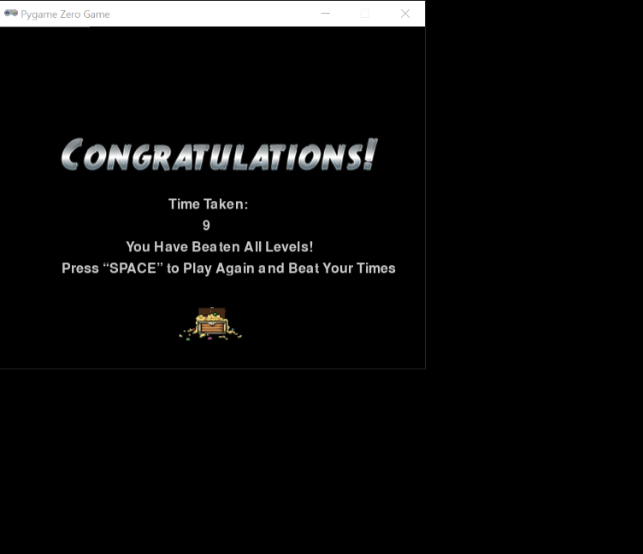

Once the user has completed all available levels, there is a screen that is called using a function that informs the user that they have completed all the levels but can go through all of the levels again and attain a new high score by pressing the spacebar.

Addressing Partially Met or Unmet Criteria:

**Levels:**

Criterion – The solution should have 10 levels which the player can progress through.

For future development, 10 levels can be successfully added by:

1. Decreasing the change in difficulty of the levels: Currently, there are 5 levels which get more challenging the more the user progresses. By decreasing the increase in difficulty of each level, the user has a gradual change in difficulty which does not interfere with user experience.
2. Adding Different Powerups: By adding different power-ups the game doesn’t seem repetitive. Furthermore, new powerups can be integrated 5 levels into the game. This adds a new refreshing experience to maintain user engagement.

In conclusion, using these two options the game can have 10 levels to play through which do not make the game seem repetitive and maintain user engagement.

**Diamond Powerup:**

Criterion – The power-up ‘Diamond’ should provide a boost to the character's speed for a short duration when interacted with by the player.

For future development, the Diamond Powerup can effectively boost the character's speed for a short duration.

* Use a clock mechanic: Similar to the clock mechanic in the game, the diamond powerup can adopt that feature to temporarily boost the characters speed for a short duration. This is because the clock mechanic uses a function called ‘update()’ to monitor the time. With this function, I could add an if statement that checks if 5 seconds have passed since the thief interacted with the powerup before returning the thief’s speed to normal.

I believe that this solution could help meet the success criteria.

# Limitations & Improvements

|  |  |  |
| --- | --- | --- |
| **Criteria:** | **Limitations:** | **Improvements:** |
| Security Guards | The security guard AI is very predictable and limited.  The security guards cannot track the thief through walls and are therefore stationary throughout most of the game if they get stuck.  Experienced players can use a trick to coerce the security guards to one side and then quickly change direction.  There is also a problem where the security guards merge into one another as they are on the same coordinate. This makes the level easier for the user to beat as there is now only “one” security guard to worry about. | To improve the security guards, I would add a segment of code which tracks the thief through walls and uses backtracking to ensure that when they get stuck, they can backtrack to get out.  Furthermore, I would have ensured that two security guards could not be on the same coordinate at the same time. |
| Timer | Users' times are only tracked and saved in seconds.  This is limiting as some users achieve the same time as the high score and are not rewarded as the time measurement is not precise enough. | To improve the timer feature, I would track and display the user's time in milliseconds. This allows more competitiveness as users can beat their high scores by finer margins. |
| Levels | There are not enough levels in my game which means experienced players may complete the game quite quickly without feeling satisfied. | I would add more levels to the game and more objects to collect such as coins or additional power-ups to make the game entertaining. |

# References:

Chris Cullion. (2017). *THE COMPLETE HISTORY OF BOMBERMAN*. [Online]. TiredOldHack. Last Updated: February 2017. Available at: <https://tiredoldhack.com/2017/02/26/the-complete-history-of-bomberman/> [Accessed 13 November 2023].

Haris Khan. (2023). Python Programming Essentials: Ideal Computer Specs for Python Programming and Top 5 Laptops for September 2023. [Online]. Ssiddique. Last Updated: September 2023. Available at: <https://ssiddique.info/ideal-computer-specs-for-python-programming#:~:text=Here%20are%20the%20detail> [Accessed 14 November 2023].

Kate Russell. (2020). *Beginner's Step-By-Step Coding Course*. London: DK. pp.178-202.

Kevuru Games. (2023). What are game metrics and why do they matter?. [Online]. kevurugames.com. Last Updated: 26 March 2023. Available at: <https://kevurugames.com/blog/what-are-game-metrics-and-why-do-they-matter/#:~:text=Interesting%20fac> [Accessed 23 December 2023].

Lionel Valdellon. (2023). User Retention: Lessons From the Top Gaming Companies. [Online]. Clevertap. Last Updated: 15 August 2023. Available at: <https://clevertap.com/blog/user-retention-lessons-from-the-top-gaming-companies/> [Accessed 23 December 2023].

Craig'n'Dave. (2020). 45. OCR A Level (H046-H446) SLR8 - 1.2 Introduction to programming part 6 file handling. [Online]. Youtube. Last Updated: 29 September 2020. Available at: <https://www.youtube.com/watch?v=6VADtK8X5UQ> [Accessed 13 March 2024].

Coding With Russ. (2021). PyGame Endless Vertical Platformer Beginner Tutorial in Python - PART 10 | Saving a High Score. [Online]. Youtube. Last Updated: 7 October 2021. Available at: <https://www.youtube.com/watch?v=DCqV1ARz-Yw> [Accessed 14 March 2024].

LovJak. (2022). How to make a timer that is counting seconds | pygame zero. [Online]. Youtube. Last Updated: 5 July 2022. Available at: <https://www.youtube.com/watch?v=s2y3V8aQECM&t=281s> [Accessed 14 March 2024]